Lesson 2: Características de los triángulos y los cuadriláteros

Standards Alignments
Addressing | 3.G.A.1, 3.NBT.A.3

Teacher-facing Learning Goals
- Sort triangles and quadrilaterals into subcategories.
- Understand that shared attributes of shapes can define a larger category, such as triangle or quadrilateral.

Student-facing Learning Goals
- Clasifiquemos figuras en categorías más específicas.

Lesson Purpose
The purpose of this lesson is for students to use attributes of triangles and quadrilaterals to sort them into more specific categories.
In the previous lesson, students learned that shapes could be sorted into more than one category depending on the attributes being considered. In this lesson, they learn that shapes with the same number of sides can be further sorted into subgroups based on other attributes. As students sort triangles and quadrilaterals into subgroups, they focus on attributes other than the number of sides, such as the length of the sides or the number of angles. Throughout the lesson, if students have trouble determining if sides have the same length, offer rulers to measure the side lengths.
The cards in this lesson will be used again in centers.

Access for:

Students with Disabilities
- Representation (Activity 1)

English Learners
- MLR2 (Activity 1)

Instructional Routines
Card Sort (Activity 1, Activity 2), True or False (Warm-up)

Materials to Gather
- Bags or envelopes: Activity 2

Materials to Copy
- Triangle Cards Grade 3 (groups of 2): Activity 1
- Quadrilateral Cards Grade 3 (groups of 2): Activity 2

Lesson Timeline
Warm-up | 10 min
Activity 1 | 15 min
Activity 2 | 20 min
Lesson Synthesis | 10 min
Cool-down | 5 min

Teacher Reflection Question
Today students sorted shapes for different attributes. What strategies for sorting the shapes did you anticipate? Which did you not anticipate?

Cool-down
(to be completed at the end of the lesson) 5min
Describe la figura

Standards Alignments
Addressing | 3.G.A.1

Student-facing Task Statement
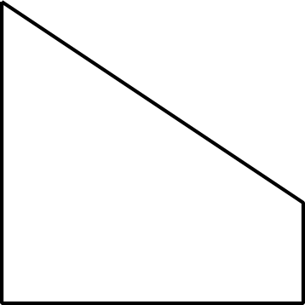
Di todas las características que puedas de la figura.

Student Responses
Sample response: It’s a quadrilateral because it has 4 sides. It has 2 sides the same length. It has 2 right angles. It has 2 sides that go in the same direction.

