Lesson 5: Circumference and Wheels
Let’s explore how far different wheels roll.

5.1: A Rope and a Wheel
Han says that you can wrap a 5-foot rope around a wheel with a 2-foot diameter because $\frac{5}{2}$ is less than pi. Do you agree with Han? Explain your reasoning.

5.2: Rolling, Rolling, Rolling
Your teacher will give you a circular object.
- Follow these instructions to create the drawing:
  - On a separate piece of paper, use a ruler to draw a line all the way across the page.
  - Roll your object along the line and mark where it completes one rotation.
  - Use your object to draw tick marks along the line that are spaced as far apart as the diameter of your object.
- What do you notice?
- Use your ruler to measure each distance. Record these values in the first row of the table:
  - the diameter of your object
  - how far your object rolled in one complete rotation
  - the quotient of how far your object rolled divided by the diameter of your object
- object | - diameter | - distance traveled  in one rotation | - $\text{distance}÷\text{diameter}$
- If you wanted to trace two complete rotations of your object, how long of a line would you need?
- Share your results with your group and record their measurements in the table.
- If each person in your group rolled their object along the entire length of the classroom, which object would complete the most rotations? Explain or show your reasoning.

5.3: Rotations and Distance
- A car wheel has a diameter of 20.8 inches.
  - About how far does the car wheel travel in 1 rotation? 5 rotations? 30 rotations?
  - Write an equation relating the distance the car travels in inches, $c$, to the number of wheel rotations, $x$.
  - About how many rotations does the car wheel make when the car travels 1 mile? Explain or show your reasoning.
- A bike wheel has a radius of 13 inches.
  - About how far does the bike wheel travel in 1 rotation? 5 rotations? 30 rotations?
  - Write an equation relating the distance the bike travels in inches, $b$, to the number of wheel rotations, $x$.
  - About how many rotations does the bike wheel make when the bike travels 1 mile? Explain or show your reasoning.

Are you ready for more?
Here are some photos of a spring toy.
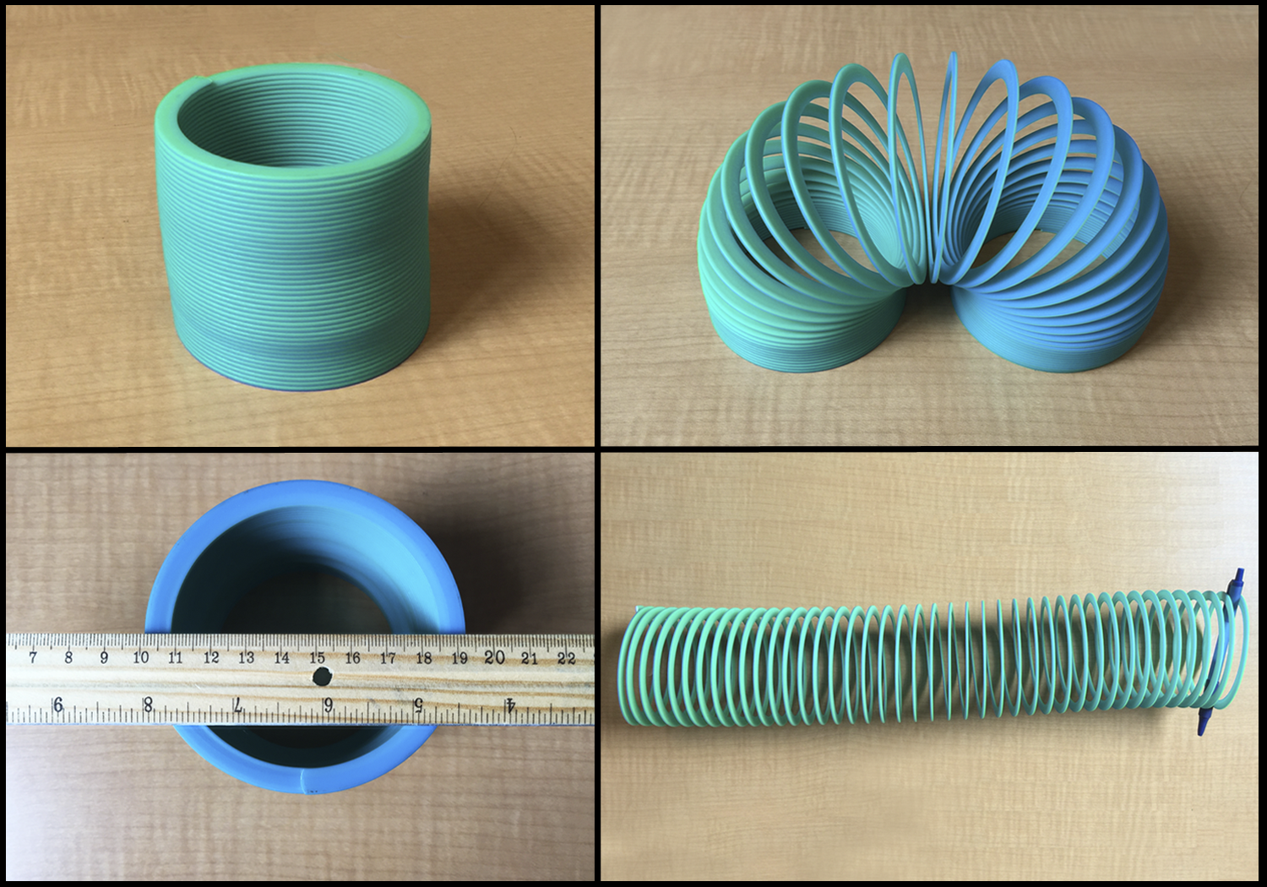
If you could stretch out the spring completely straight, how long would it be? Explain or show your reasoning.

5.4: Rotations and Speed
The circumference of a car wheel is about 65 inches.
- If the car wheel rotates once per second, how far does the car travel in one minute?
- If the car wheel rotates once per second, about how many miles does the car travel in one hour?
- If the car wheel rotates 5 times per second, about how many miles does the car travel in one hour?
- If the car is traveling 65 miles per hour, about how many times per second does the wheel rotate?

Lesson 5 Summary
The circumference of a circle is the distance around the circle. This is also how far the circle rolls on flat ground in one rotation. For example, a bicycle wheel with a diameter of 24 inches has a circumference of $24π$ inches and will roll $24π$ inches (or $2π$ feet) in one complete rotation. There is an equation relating the number of rotations of the wheel to the distance it has traveled. To see why, let’s look at a table showing how far the bike travels when the wheel makes different numbers of rotations.
number of rotations | distance traveled (feet)
1 | $2π$
2 | $4π$
3 | $6π$
10 | $20π$
50 | $100π$
$x$ | ?
In the table, we see that the relationship between the distance traveled and the number of wheel rotations is a proportional relationship. The constant of proportionality is $2π$.
To find the missing value in the last row of the table, note that each rotation of the wheel contributes $2π$ feet of distance traveled. So after $x$ rotations the bike will travel $2πx$ feet. If $d$ is the distance, in feet, traveled when this wheel makes $x$ rotations, we have the relationship: $d=2πx$
© CC BY Open Up Resources. Adaptations CC BY IM.

