Unit 7 Lesson 4: Quadrilaterals in Circles

1 Connecting the Dots (Warm up)

Student Task Statement
For each quadrilateral, use a compass to see if you can draw a circle that passes through all 4 of the quadrilateral’s vertices.

A
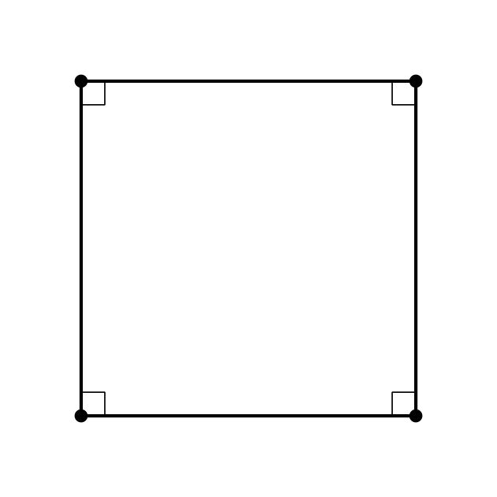

B
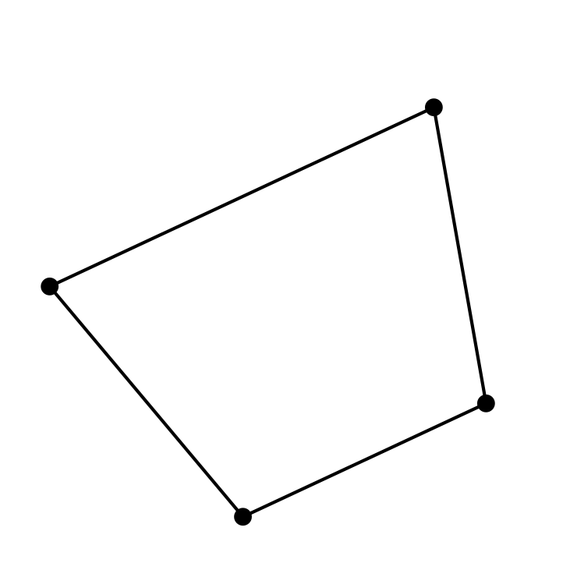

C
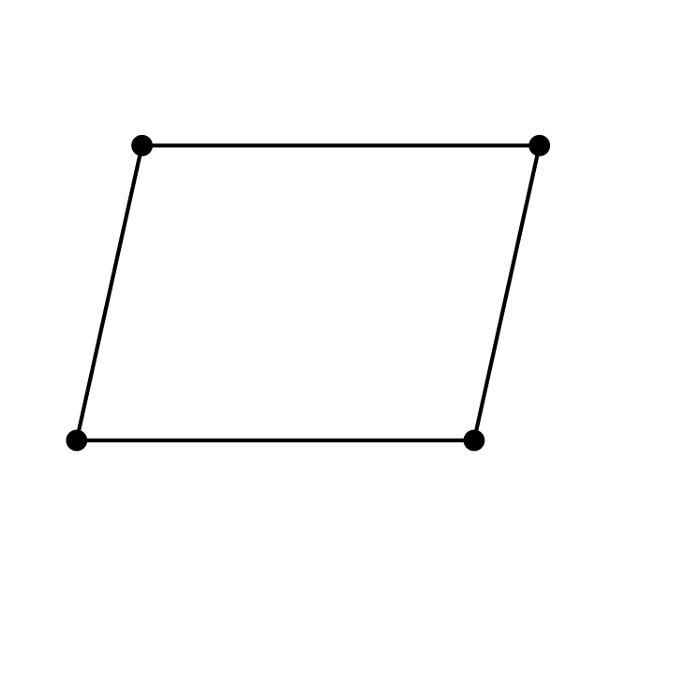

2 Inscribed Angles and Circumscribed Circles

Student Task Statement
- The images show 3 quadrilaterals with circumscribed circles.

- A
- 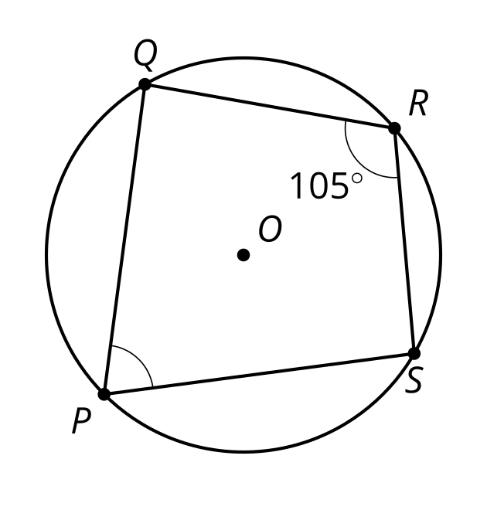

- B
- 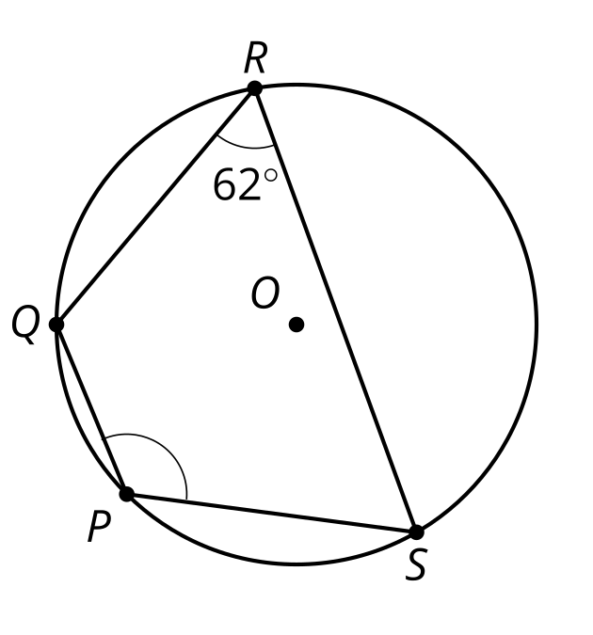

- C
- 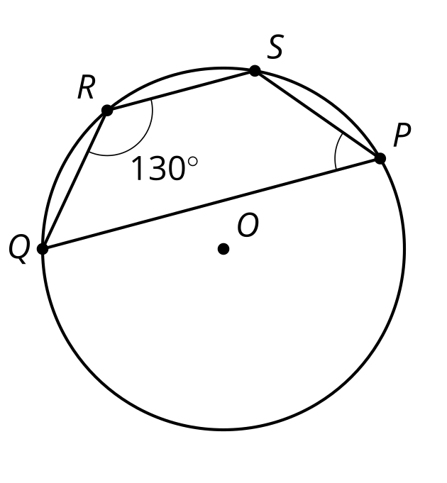
- For each one, highlight the arc from $S$ to $Q$ passing through $P$. Then, find the measures of:
  - the arc you highlighted
  - the other arc from $S$ to $Q$
  - angle $SPQ$
- Here is another quadrilateral with a circumscribed circle. What is the value of $α+β$? Explain or show your reasoning.
- 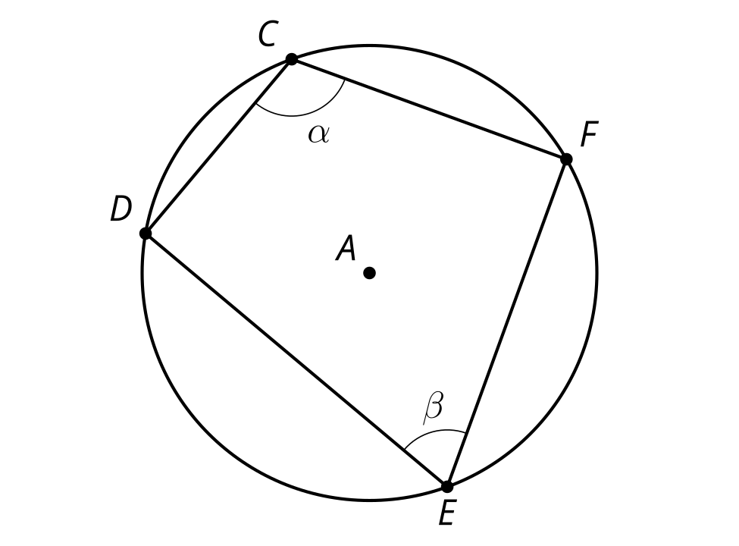

Activity Synthesis

A

B

C

3 Construction Ahead

Student Task Statement
Quadrilateral $ABCD$ is a cyclic quadrilateral.
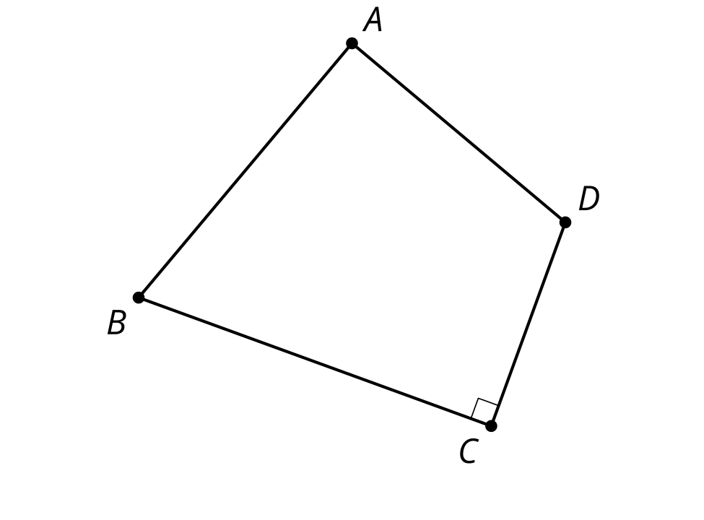
- Draw diagonal $BD$. How will this diagonal relate to the circumscribed circle? Explain your reasoning.
- Construct the center of the circumscribed circle for quadrilateral $ABCD$. Label this point $O$. Explain why your method worked.
- Construct the circumscribed circle for quadrilateral $ABCD$.
- Could we follow this procedure to construct a circumscribed circle for any cyclic quadrilaterals? Explain your reasoning.

Activity Synthesis
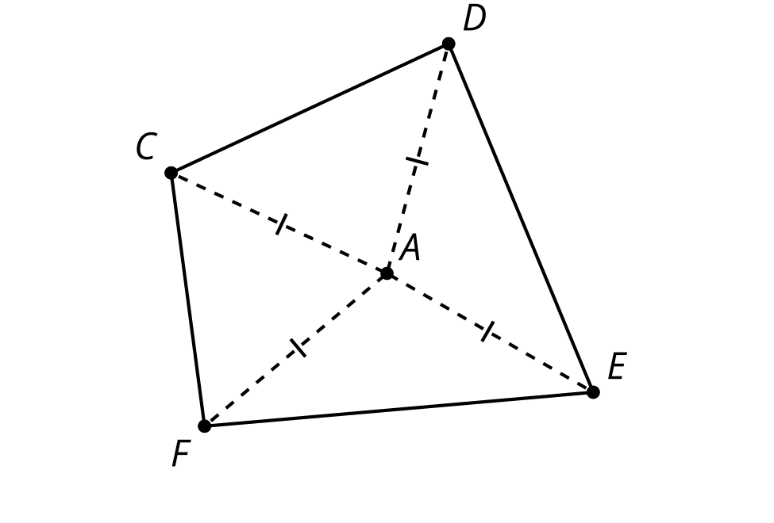

Images for Activity Synthesis
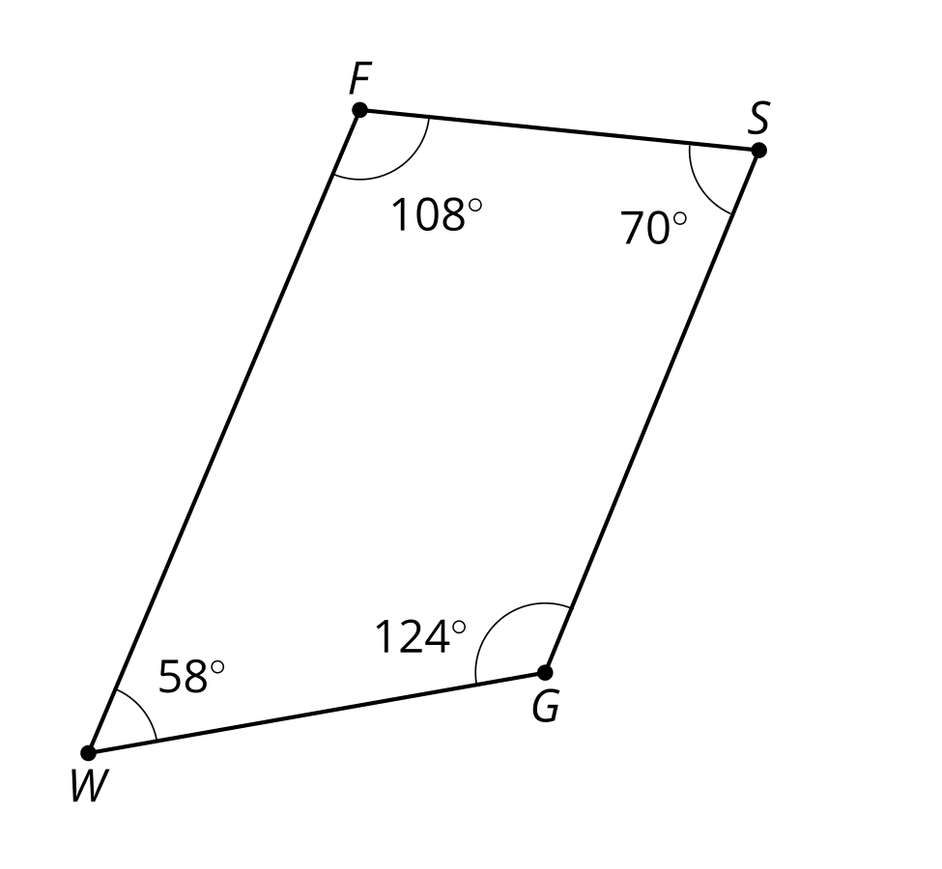
© CC BY 2019 by Illustrative Mathematics®

