## Unit 7 Lesson 7: Circles in Triangles

### 1 The Largest Circle (Warm up)

#### Student Task Statement

Use a compass to draw the largest circle you can find that fits inside each triangle.

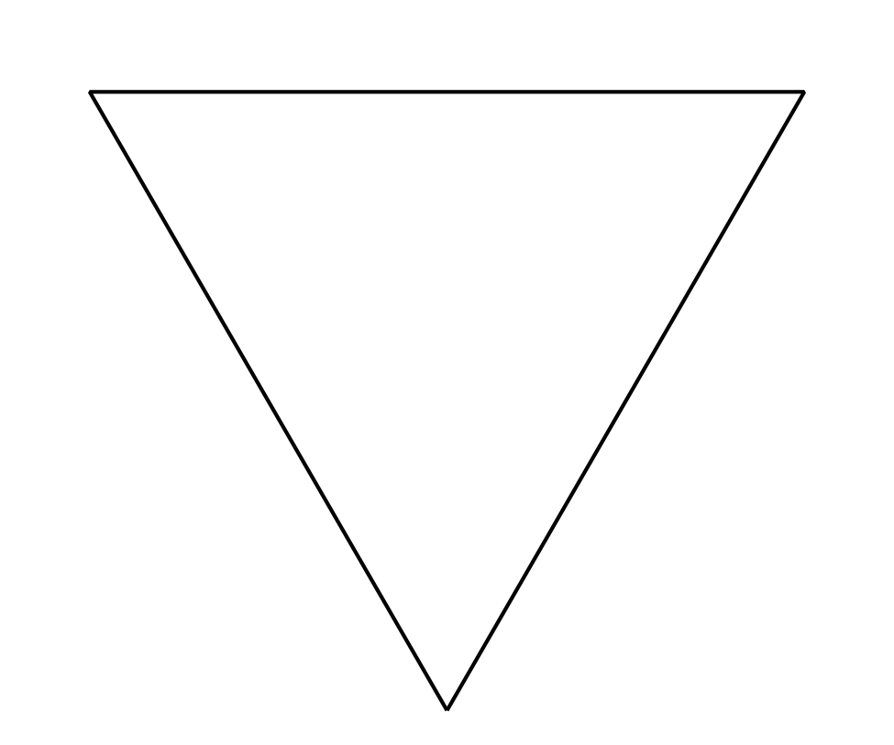

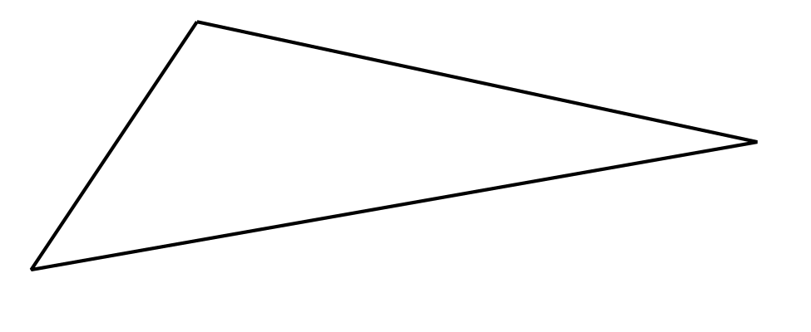

### 2 The Inner Circle

#### Student Task Statement

1. Mark 3 points and connect them with a straightedge to make a large triangle. The triangle should *not* be equilateral.
2. Construct the incenter of the triangle.
3. Construct the segments that show the distance from the incenter to the sides of the triangle.
4. Construct a circle centered at the incenter using one of the segments you just constructed as a radius.
5. Would it matter which of the three segments you use? Explain your thinking.

#### Activity Synthesis

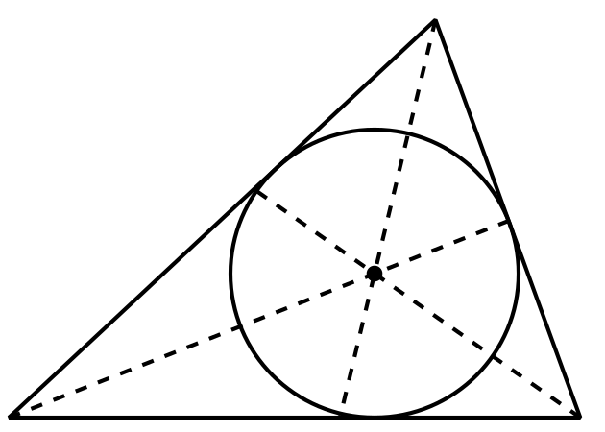

### 3 Equilateral Centers

#### Student Task Statement

The image shows an equilateral triangle . The angle bisectors are drawn. The incenter is plotted and labeled .

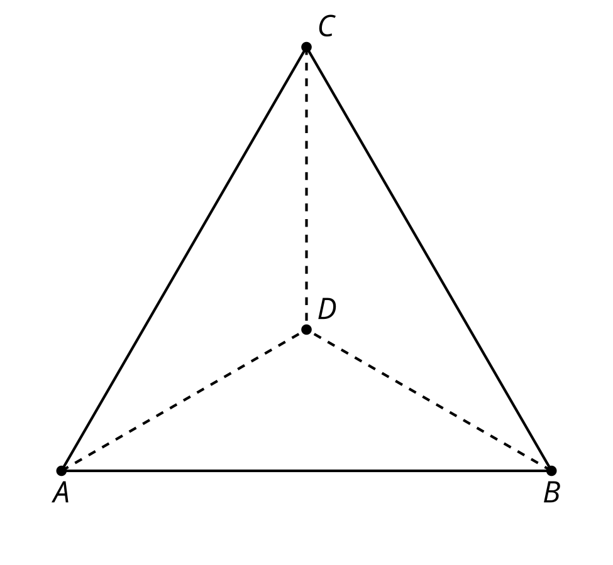

Prove that the incenter is also the circumcenter.



© CC BY 2019 by Illustrative Mathematics®