Lesson 3 Practice Problems
- Here is a graph of the proportional relationship between calories and grams of fish:
- 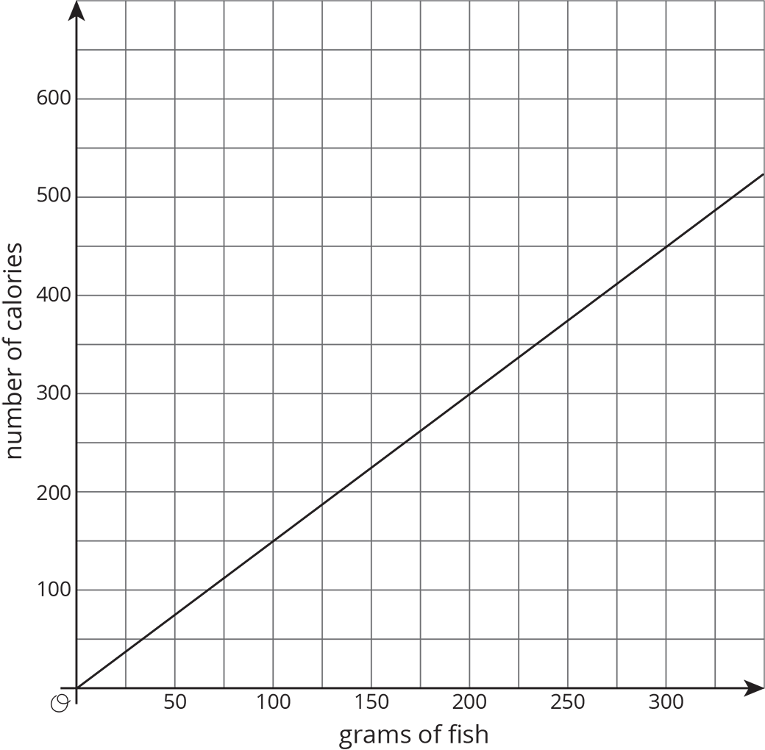
  - Write an equation that reflects this relationship using $x$ to represent the amount of fish in grams and $y$ to represent the number of calories.
  - Use your equation to complete the table:
- grams of fish | - number of calories
  - 1000
 | - 2001
  - 1
- Students are selling raffle tickets for a school fundraiser. They collect $24 for every 10 raffle tickets they sell.
  - Suppose $M$ is the amount of money the students collect for selling $R$ raffle tickets. Write an equation that reflects the relationship between $M$ and $R$.
  - Label and scale the axes and graph this situation with $M$ on the vertical axis and $R$ on the horizontal axis. Make sure the scale is large enough to see how much they would raise if they sell 1000 tickets.
- Describe how you can tell whether a line’s slope is greater than 1, equal to 1, or less than 1.
- (From Unit 2, Lesson 10.)
- A line is represented by the equation $\frac{y}{x−2}=\frac{3}{11}$. What are the coordinates of some points that lie on the line? Graph the line on graph paper.
- (From Unit 2, Lesson 12.)
© CC BY Open Up Resources. Adaptations CC BY IM.

