Unit 4 Lesson 6: Increasing and Decreasing

1 Improving Their Game (Warm up)

Student Task Statement
Here are the scores from 3 different sports teams from their last 2 games.
sports team | total points in game 1 | total points in game 2
football team | 22 | 30
basketball team | 100 | 108
baseball team | 4 | 12
- What do you notice about the teams’ scores? What do you wonder?
- Which team improved the most? Explain your reasoning.

2 More Cereal and a Discounted Shirt

Student Task Statement
- ​​
- A cereal box says that now it contains 20% more. Originally, it came with 18.5 ounces of cereal. How much cereal does the box come with now?
- ​​
- The price of a shirt is $18.50, but you have a coupon that lowers the price by 20%. What is the price of the shirt after using the coupon?
- 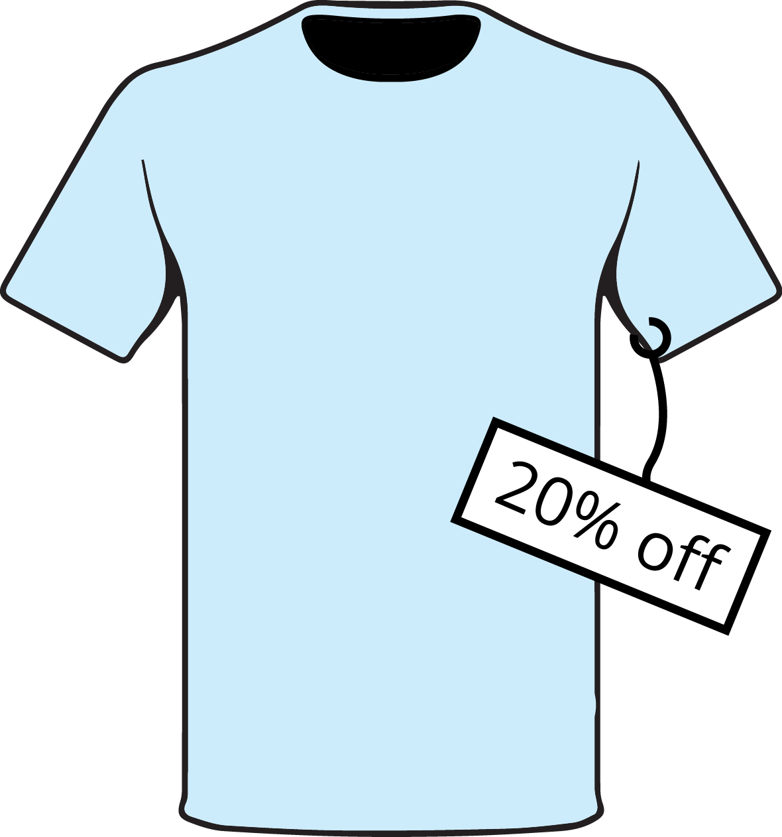

3 Using Tape Diagrams

Images for Launch
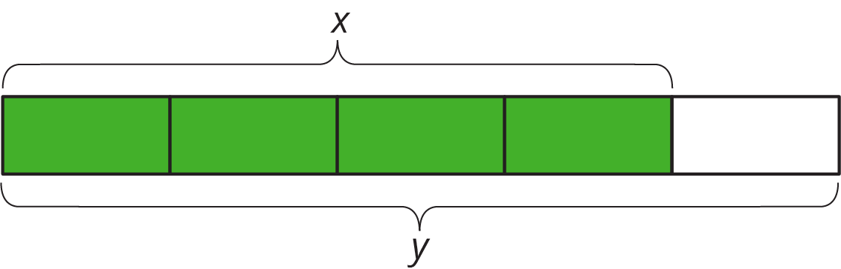

Student Task Statement
- Match each situation to a diagram. Be prepared to explain your reasoning.
  - Compared with last year’s strawberry harvest, this year’s strawberry harvest is a 25% increase.
  - This year’s blueberry harvest is 75% of last year’s.
  - Compared with last year, this year’s peach harvest decreased 25%.
  - This year’s plum harvest is 125% of last year’s plum harvest.
- 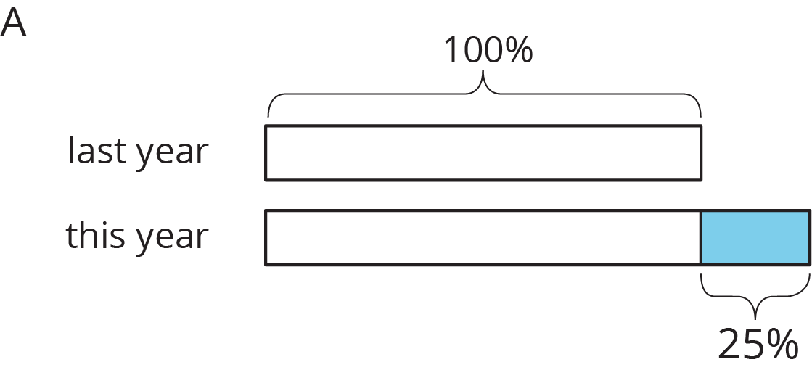
- 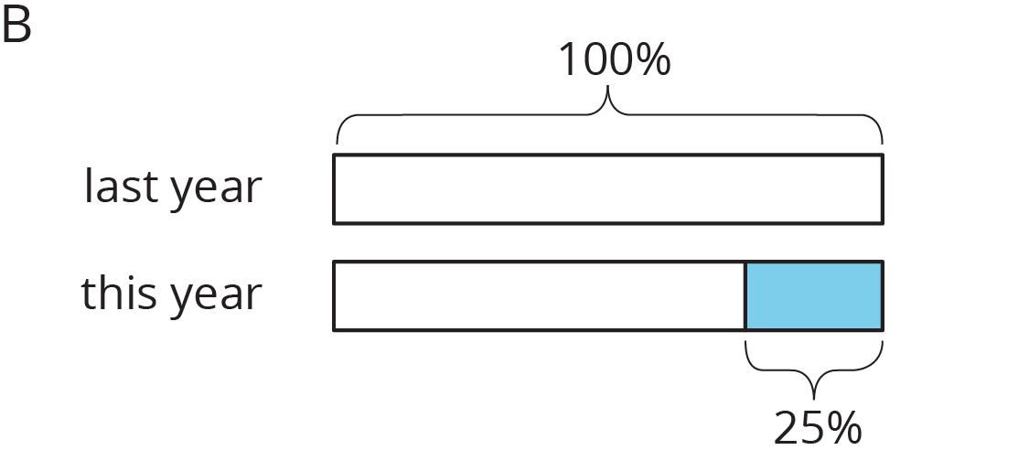
- Draw a diagram to represent these situations.
  - The number of ducks living at the pond increased by 40%.
  - The number of mosquitoes decreased by 80%.

4 Agree or Disagree: Percentages (Optional)

Student Task Statement
Do you agree or disagree with each statement? Explain your reasoning.
- Employee A gets a pay raise of 50%. Employee B gets a pay raise of 45%. So Employee A gets the bigger pay raise.
- Shirts are on sale for 20% off. You buy two of them. As you pay, the cashier says, “20% off of each shirt means 40% off of the total price.”
© CC BY Open Up Resources. Adaptations CC BY IM.

