Lesson 2 Practice Problems
- Select the unit from the list that you would use to measure each object.
  - The length of a pencil
  - The weight or mass of a pencil
  - The volume of a pencil
  - The weight or mass of a hippopotamus
  - The length of a hippopotamus
  - The length of a fingernail clipping
  - The weight or mass of a fingernail clipping
  - The volume of a sink
  - The volume of a bowl
  - The length of a chalkboard or whiteboard
  - The weight or mass of a chalkboard or whiteboard
  - The length of the border between the United States and Canada
  - centimeters
  - cups
  - feet
  - gallons
  - grams
  - inches
  - kilograms
  - kilometers
  - liters
  - meters
  - miles
  - milliliters
  - millimeters
  - ounces
  - pounds
  - quarts
  - tons
  - yards
- When this pet hamster is placed on a digital scale, the scale reads 1.5.
- 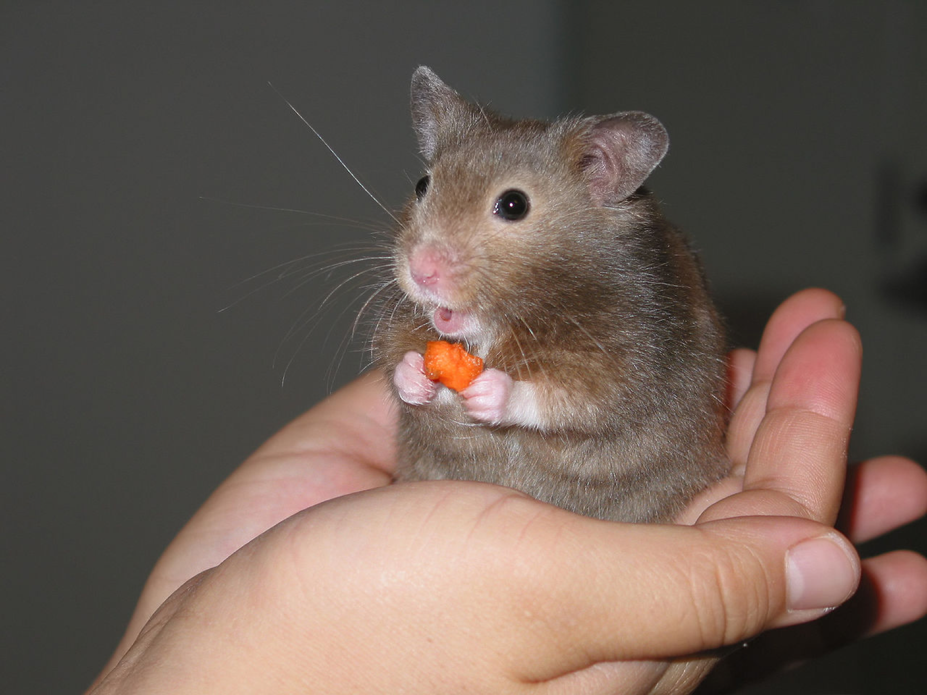
- What could be the units?
- Circle the larger unit of measure. Then, determine if the unit measures distance, volume, or weight (or mass).
  - meter or kilometer
  - yard or foot
  - cup or quart
  - pound or ounce
  - liter or milliliter
  - gram or kilogram
- Elena mixes 5 cups of apple juice with 2 cups of sparkling water to make sparkling apple juice. For a party, she wants to make 35 cups of sparkling apple juice. How much of each ingredient should Elena use? Explain or show your reasoning.
- (From Unit 2, Lesson 15.)
- Lin bought 3 hats for $22.50. At this rate, how many hats could she buy with $60.00? If you get stuck, consider using the table.
- number of hats | - price in dollars
- (From Unit 2, Lesson 12.)
- Light travels about 180 million kilometers in 10 minutes. How far does it travel in 1 minute? How far does it travel in 1 second? Show your reasoning.
- (From Unit 2, Lesson 9.)
© CC BY Open Up Resources. Adaptations CC BY IM.

