Unit 7 Lesson 1: Lines, Angles, and Curves

1 Notice and Wonder: Lines and Angles (Warm up)

Student Task Statement
What do you notice? What do you wonder?

2 The Defining Moment

Student Task Statement
- The images show some line segments that are chords and some segments that are not chords.

- chords
- 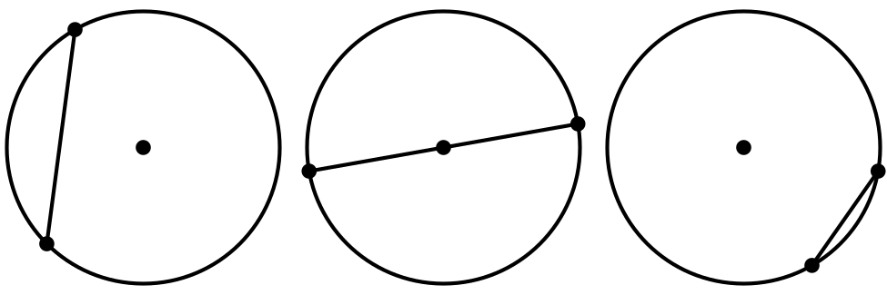

- not chords
- 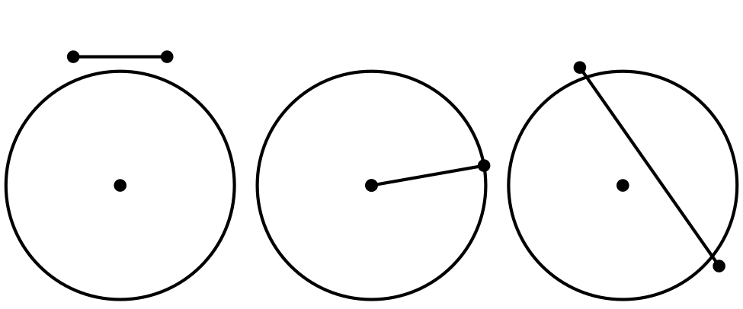
- Write a definition of a chord.
- The images show some highlighted objects that are arcs, and some highlighted objects that are not arcs.

- arcs
- 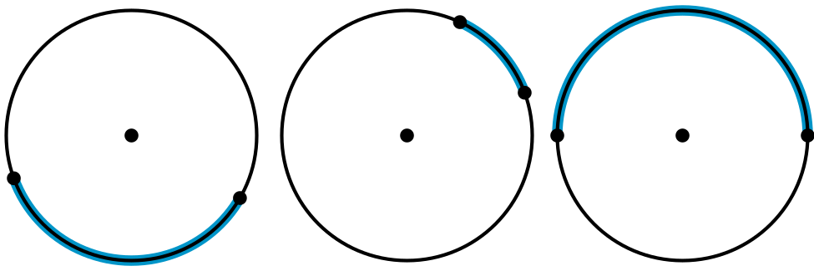

- not arcs
- 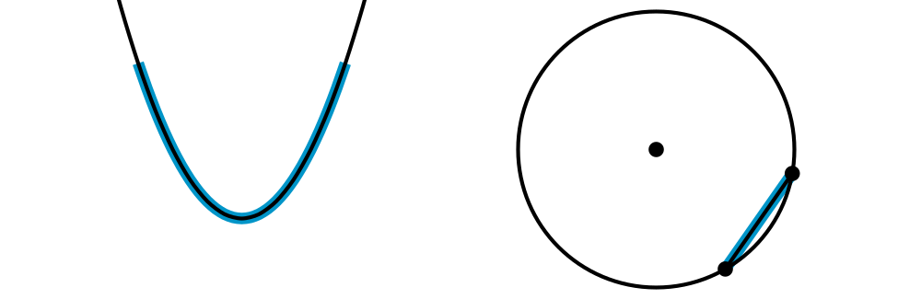
- Write a definition of an arc.
- The images show some angles that are central angles, and some that are not.

- central angles
- 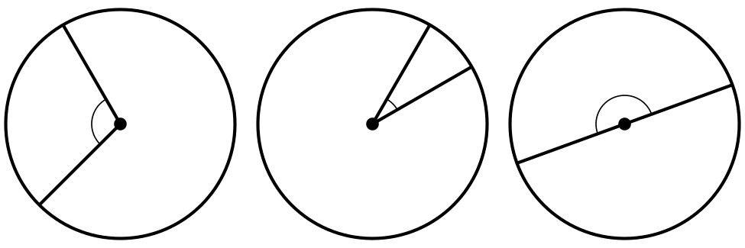

- not central angles
- 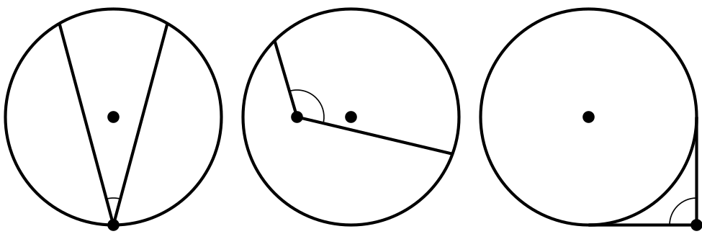
- Write a definition of a central angle.

3 Arcs, Chords, and Central Angles

Images for Launch
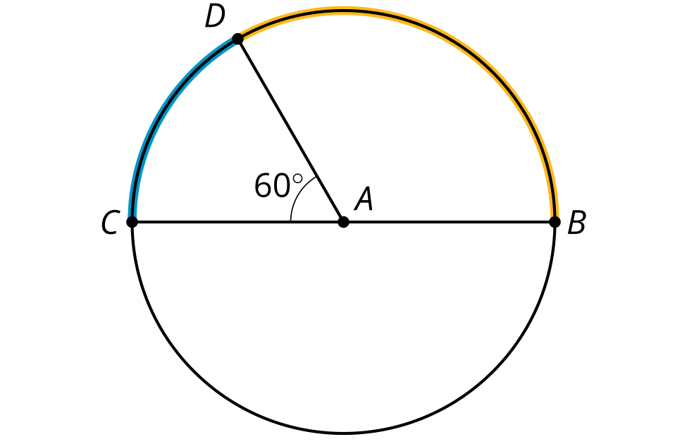

Student Task Statement
The image shows a circle with 2 congruent chords.
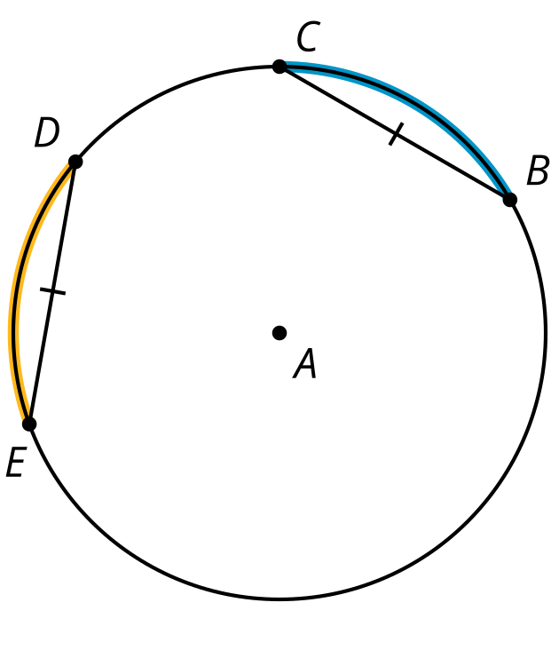
- Draw the central angles associated with the highlighted arcs from $D$ to $E$ and $B$ to $C$.
- How do the measures of the 2 central angles appear to compare? Prove that this observation is true.
- What does this tell you about the measures of the highlighted arcs from $D$ to $E$ and $B$ to $C$? Explain your reasoning.

Activity Synthesis
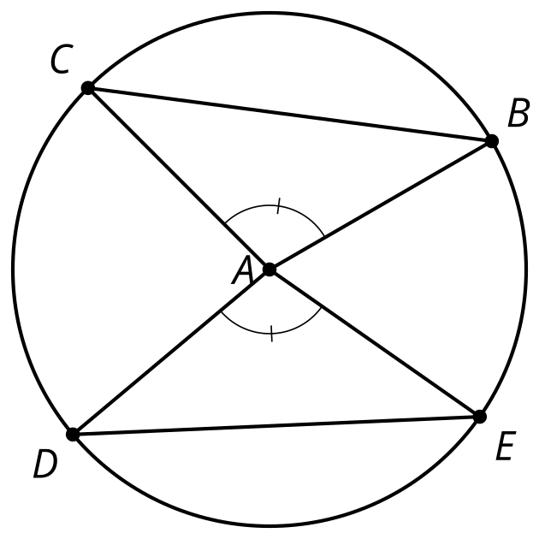

Images for Activity Synthesis
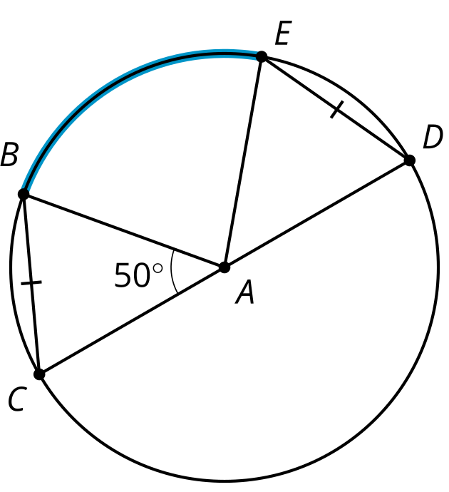
© CC BY 2019 by Illustrative Mathematics®

