Lesson 5: The Pythagorean Identity (Part 1)
- Let’s learn more about cosine and sine.

5.1: Circle Equations
Here is a circle centered at $\left(0,0\right)$ with a radius of 1 unit.
What are the exact coordinates of $P$ if $P$ is rotated counterclockwise $\frac{π}{3}$ radians from the point $\left(1,0\right)$? Explain or show your reasoning.
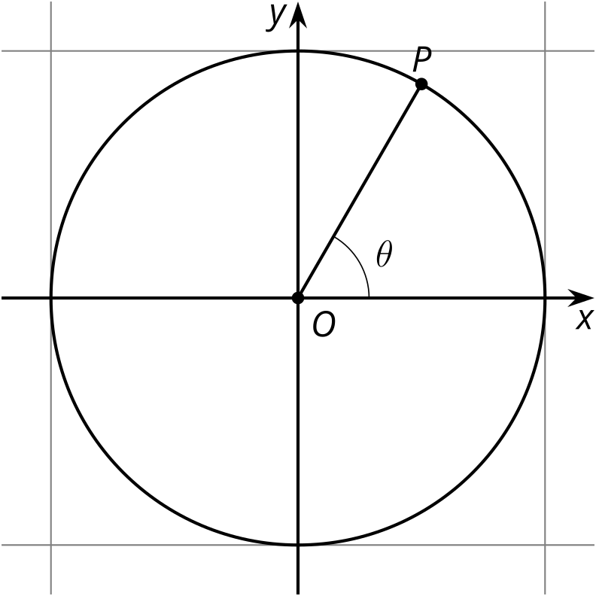

5.2: Cosine, Sine, and the Unit Circle
What are the exact coordinates of point $Q$ if it is rotated $\frac{2π}{3}$ radians counterclockwise from the point $\left(1,0\right)$? Explain or show your reasoning.
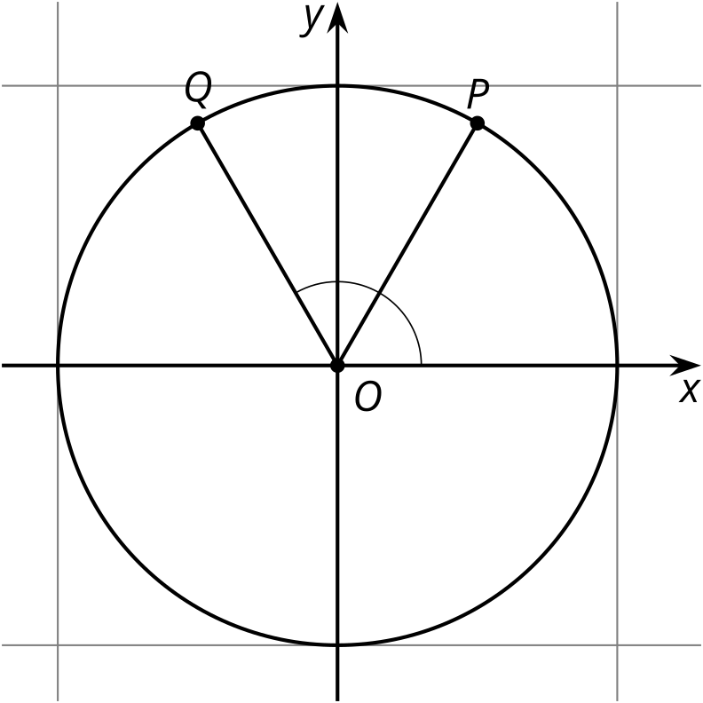

5.3: A New Identity
- Is the point $\left(\text{-}0.5,sin\left(\frac{4π}{3}\right)\right)$ on the unit circle? Explain or show your reasoning.
- Is the point $\left(\text{-}0.5,sin\left(\frac{5π}{6}\right)\right)$ on the unit circle? Explain or show your reasoning.
- Suppose that $sin\left(θ\right)=\text{-}0.5$ and that $θ$ is in quadrant 4. What is the exact value of $cos\left(θ\right)$? Explain or show your reasoning.

Are you ready for more?
Show that if $θ$ is an angle between 0 and $2π$ and neither $cos\left(θ\right)=0$ nor $sin\left(θ\right)=0$, then it is impossible for the sum of $cos\left(θ\right)$ and $sin\left(θ\right)$ to be equal to 1.

Lesson 5 Summary
Let’s say we have a point $P$ with coordinates $\left(a,b\right)$ on the unit circle, like the one shown here:
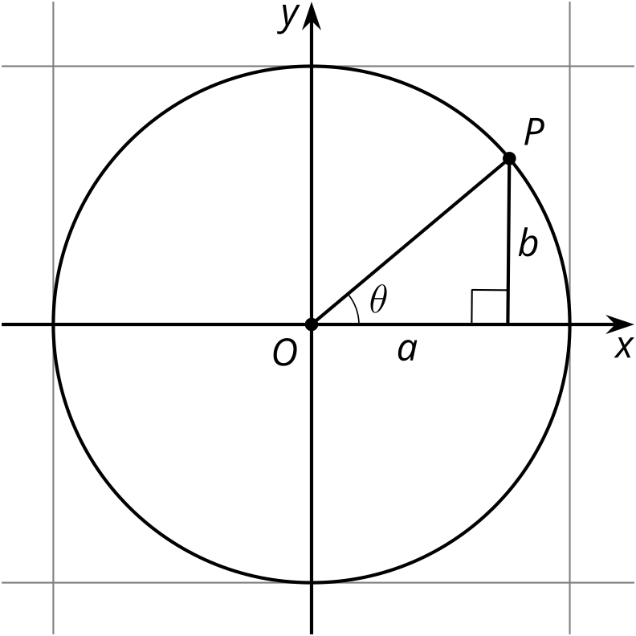
Using the Pythagorean Theorem, we know that $a^{2}+b^{2}=1$. We also know this is true using the equation for a circle with radius 1 unit, $x^{2}+y^{2}=1^{2}$, which is true for the point $\left(a,b\right)$ since it is on the circle.
Another way to write the coordinates of $P$ is using the angle $θ$, which gives the location of $P$ on the unit circle relative to the point $\left(1,0\right)$. Thinking of $P$ this way, its coordinates are $\left(cos\left(θ\right),sin\left(θ\right)\right)$. Since $a=cos\left(θ\right)$ and $b=sin\left(θ\right)$, we can return to the Pythagorean Theorem and say that $\cos^{2}\left(θ\right)+\sin^{2}\left(θ\right)=1$ is also true.
What if $θ$ were a different angle and $P$ wasn’t in quadrant 1? It turns out that no matter the quadrant, the coordinates of any point on the unit circle given by an angle $θ$ are $\left(cos\left(θ\right),sin\left(θ\right)\right)$. In fact, the definitions of $cos\left(θ\right)$ and $sin\left(θ\right)$ are the $x$- and $y$-coordinates of the point on the unit circle $θ$ radians counterclockwise from $\left(1,0\right)$. Up until today, we’ve only been using the quadrant 1 values for cosine and sine to find side lengths of right triangles, which are always positive.
This revised definition of cosine and sine means that $\cos^{2}\left(θ\right)+\sin^{2}\left(θ\right)=1$ is true for all values of $θ$ defined on the unit circle and is known as the Pythagorean Identity.
© CC BY 2019 by Illustrative Mathematics®

