Unit 7 Lesson 3: Tangent Lines

1 Swim to Shore (Warm up)

Student Task Statement
Line $ℓ$ represents a straight part of the shoreline at a beach. Suppose you are in the ocean at point $C$ and you want to get to the shore as fast as possible. Assume there is no current. Segments $CJ$ and $CD$ represent 2 possible paths.
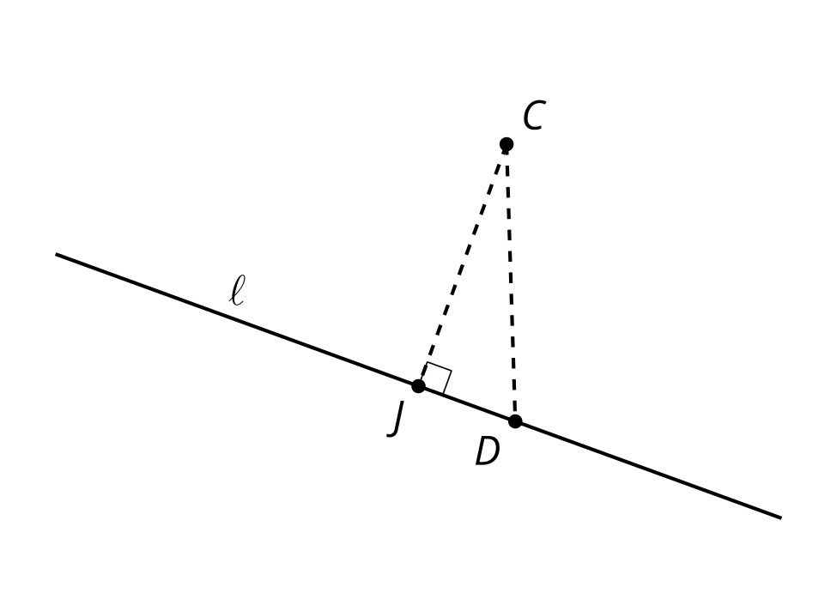
Diego says, “No matter where we put point $D$, the Pythagorean Theorem tells us that segment $CJ$ is shorter than segment $CD$. So, segment $CJ$ represents the shortest path to shore.”
Do you agree with Diego? Explain your reasoning.

Activity Synthesis

2 A Particular Perpendicular

Images for Launch
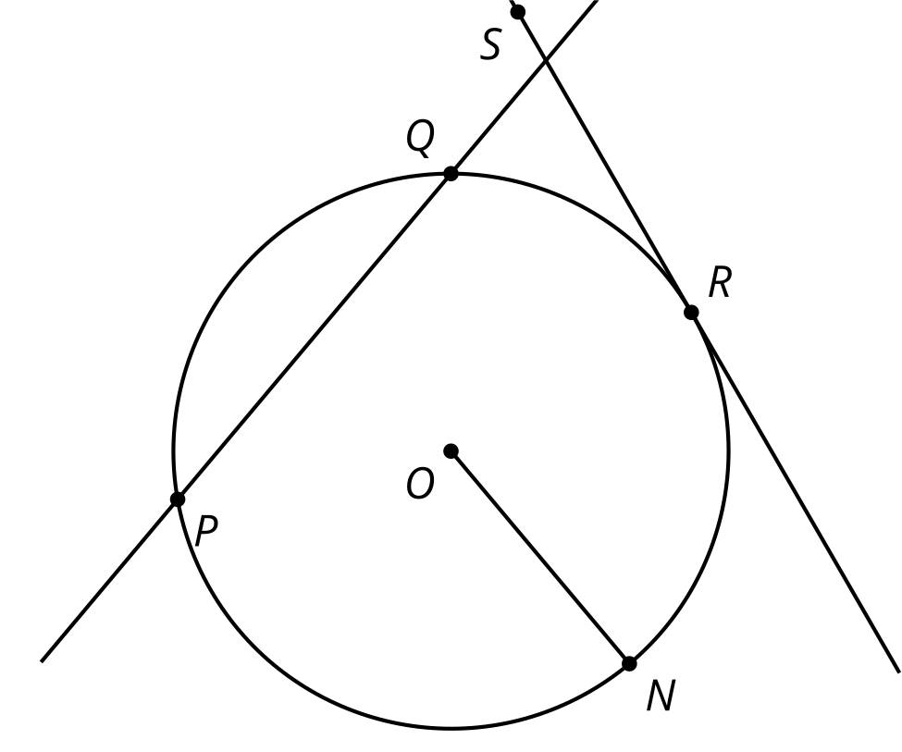

Student Task Statement
- Draw a radius in the circle. Mark the point where the radius intersects the circle and label it $A$.
- Construct a line perpendicular to the radius that goes through point $A$. Label this line $n$.
- Line $n$ intersects the circle in exactly 1 point, $A$. Why is it impossible for line $n$ to intersect the circle in more than 1 point?
- What kind of line, then, is $n$?

Activity Synthesis
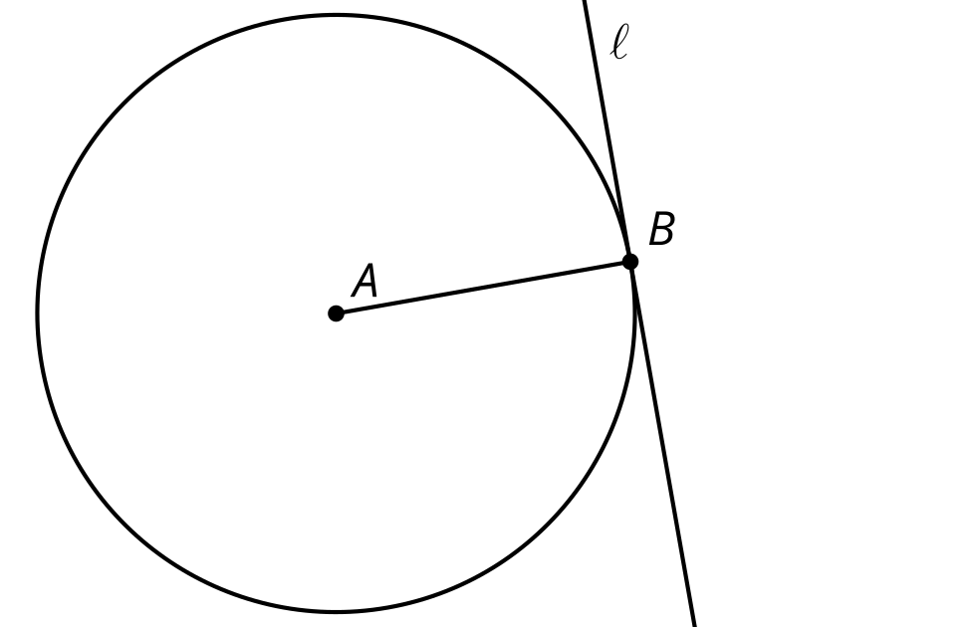
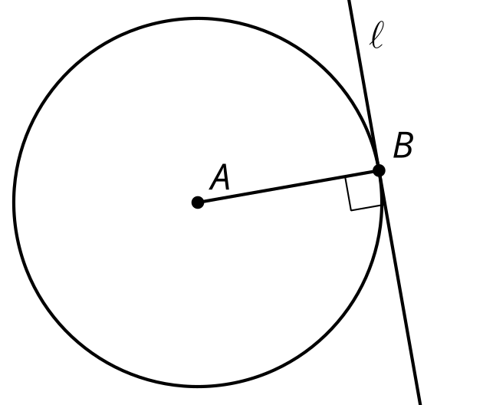

3 Another Angle

Images for Launch
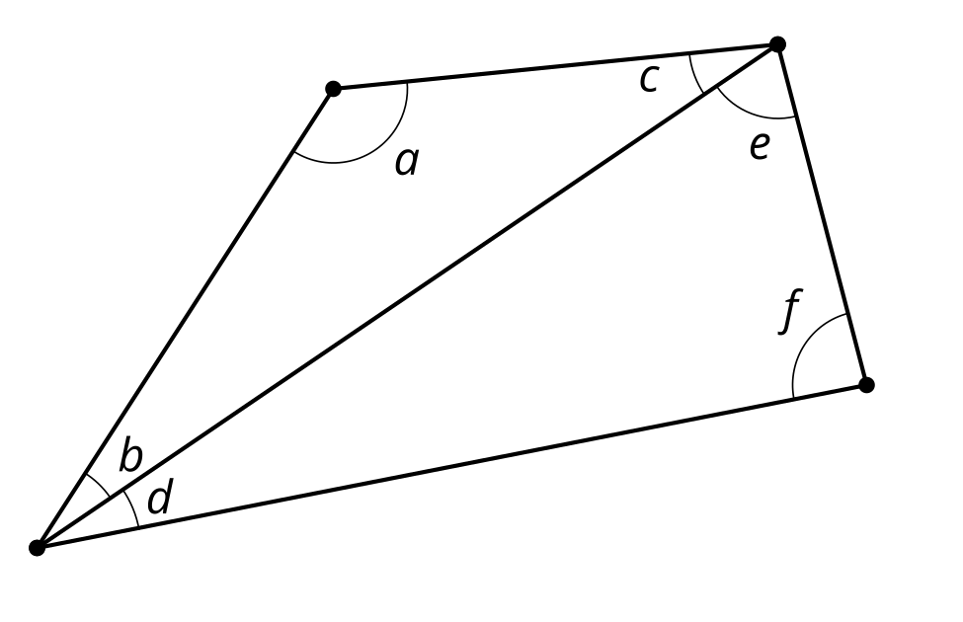

Student Task Statement
The image shows an angle whose rays are tangent to a circle.
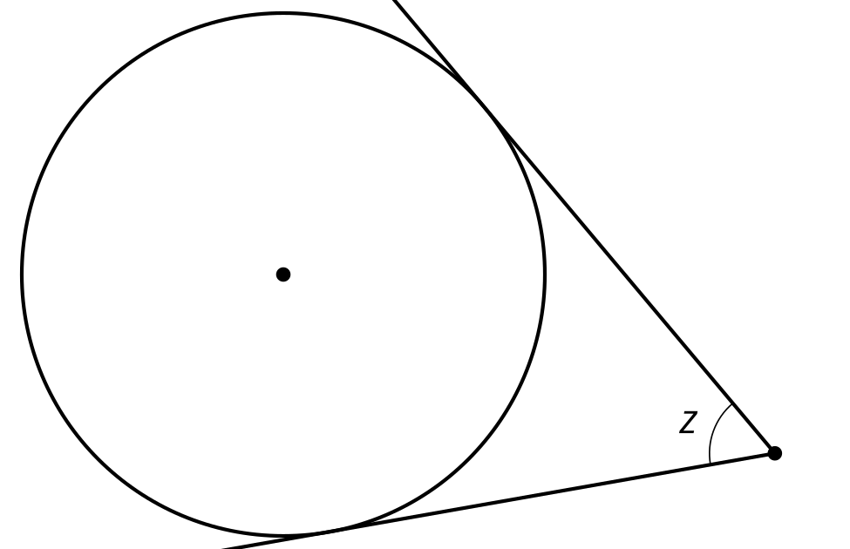
- Mark the approximate points of tangency.
- Draw the 2 radii that intersect these points of tangency. Label the measure of the central angle that is formed $w$.
- What is the value of $w+z$? Explain or show your reasoning.

Images for Activity Synthesis
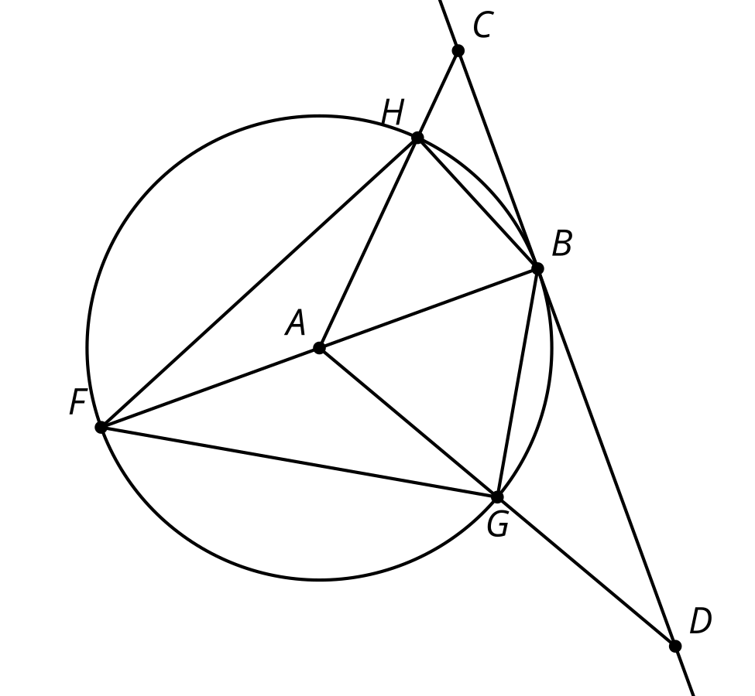
© CC BY 2019 by Illustrative Mathematics®

