Lesson 11: All About Tape Diagrams

Standards Alignments
Addressing | 2.NBT.B.5, 2.OA.A.1

Teacher-facing Learning Goals
- Write and interpret story problems using diagrams and equations.

Student-facing Learning Goals
- Let’s match diagrams, story problems, and equations.

Lesson Purpose
The purpose of this lesson is for students to make connections between story problems, equations, and tape diagrams.
In previous lessons, students analyzed and solved story problems.
In this lesson, students match story problems with tape diagrams and equations and write stories based on a tape diagram (MP2). The words in each story need to be interpreted carefully in order to decide which equation is the best match. For most problems, there is a choice for students to make because the problems can be represented and solved with either addition or subtraction. Likewise, tape diagrams can often be interpreted in multiple ways, either as showing addition or showing subtraction.
The lesson synthesis highlights how a tape diagram can help to students make sense of a story problem and decide on a method to solve the problem.

Access for:

Students with Disabilities
- Action and Expression (Activity 2)

English Learners
- MLR8 (Activity 1)

Instructional Routines
Number Talk (Warm-up)

Materials to Copy
- Represent Story Problem Cards (groups of 2): Activity 1

Lesson Timeline
Warm-up | 10 min
Activity 1 | 20 min
Activity 2 | 15 min
Lesson Synthesis | 10 min
Cool-down | 5 min

Teacher Reflection Question
Students have used tape diagrams to interpret different situations. How have these diagrams helped your students interpret story problems? How can you leverage the connections students make between story problems, diagrams, and equations when they solve problems in upcoming lessons?

Cool-down
(to be completed at the end of the lesson) 5min
What’s the Story?

Standards Alignments
Addressing | 2.NBT.B.5, 2.OA.A.1

Student-facing Task Statement
Write and solve a story problem that the diagram could represent.
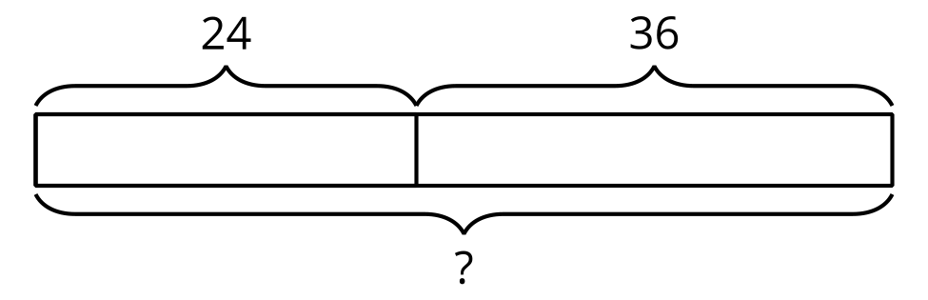

Student Responses
Sample response:
- Jada has 24 red beads and 36 blue beads. How many beads does Jada have altogether?
- Jada has 60 beads in all. I know that 20 and 30 are 50. 6 and 4 make 10.

