Lesson 10: What Influences Temperature?
Let’s see if we can predict the weather.

10.1: Temperature Changes
What factors or variables can influence the outside temperature?
- Make a list of different factors.
- Write a sentence for each factor describing how changing it could change the temperature.
Example: One factor is time of day. Often, after sunrise, the temperature increases, reaches a peak in the early afternoon, and then decreases.

10.2: Is Temperature a Function of Latitude?
- Andre and Lin are wondering if temperature is a function of latitude.
- Andre says, “I think it is, as long as we fix the time when we are measuring the temperature.”
- Lin says, “But what if you have two places with the same latitude? Look at this weather map for Washington State. Seattle and Spokane have the same latitude but different temperatures right now.”
- What do Andre and Lin mean?
- 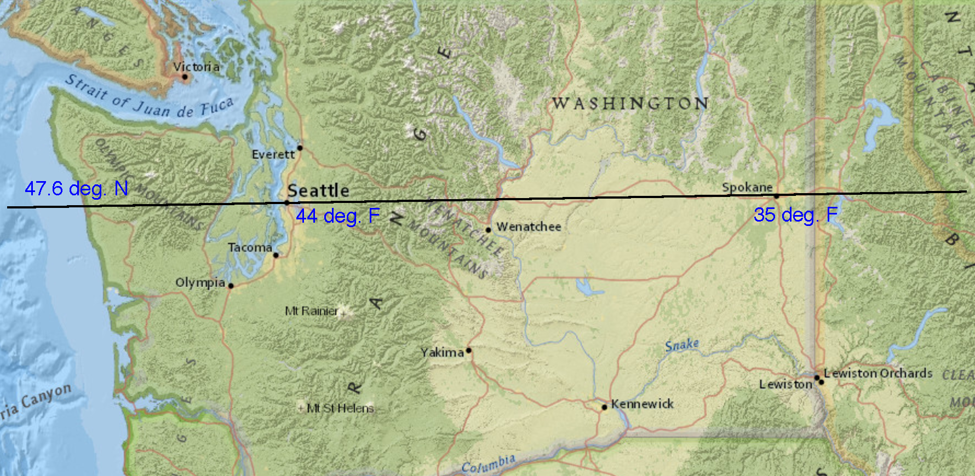
- Andre and Lin are discussing whether it is possible to define latitude and temperature in a way that makes sense to talk about temperature as a function of latitude. They are considering different options. What are some advantages and disadvantages of each option?
- Here are the options:
  - Finding the temperature right now in cities with different latitudes.
  - Finding the daily high temperature in cities that have different latitudes.
  - Finding the average high temperature in a specific month, for example, September in cities that have different latitudes.
  - Finding the average yearly temperature in cities that have have different latitudes.

10.3: Is There an Association Between Latitude and Temperature?
Lin and Andre decided that modeling temperature as a function of latitude doesn’t really make sense. They realized that they can ask whether there is an association between latitude and temperature.
- What information could they gather to determine whether temperature is related to latitude?

- What should they do with that information to answer the question?
© CC BY Open Up Resources. Adaptations CC BY IM.

