Lesson 7 Practice Problems
- For the figure shown here,
  - Rotate segment $CD$ ${180}^{∘}$ around point $D$.
  - Rotate segment $CD$ ${180}^{∘}$ around point $E$.
  - Rotate segment $CD$ ${180}^{∘}$ around point $M$.
- 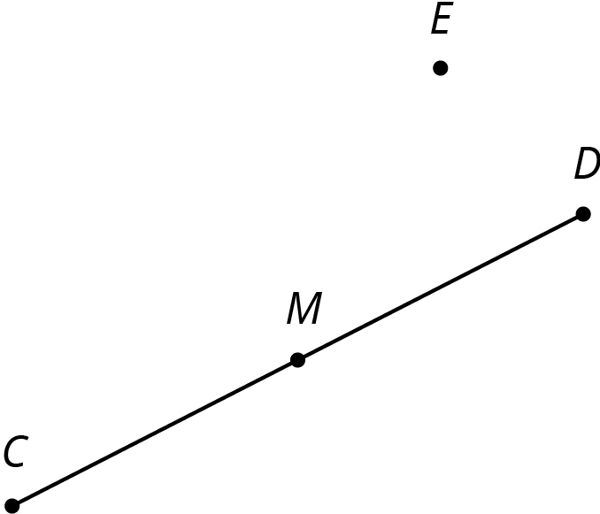

- Here is an isosceles right triangle:
- Draw these three rotations of triangle $ABC$ together.
  - Rotate triangle $ABC$ 90 degrees clockwise around $A$.
  - Rotate triangle $ABC$ 180 degrees around $A$.
  - Rotate triangle $ABC$ 270 degrees clockwise around $A$.
- 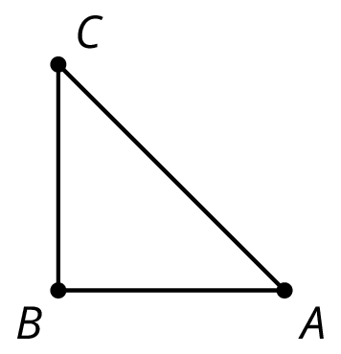
- Each graph shows two polygons $ABCD$ and $A^{′}B^{′}C^{′}D^{′}$. In each case, describe a sequence of transformations that takes $ABCD$ to $A^{′}B^{′}C^{′}D^{′}$.

  - 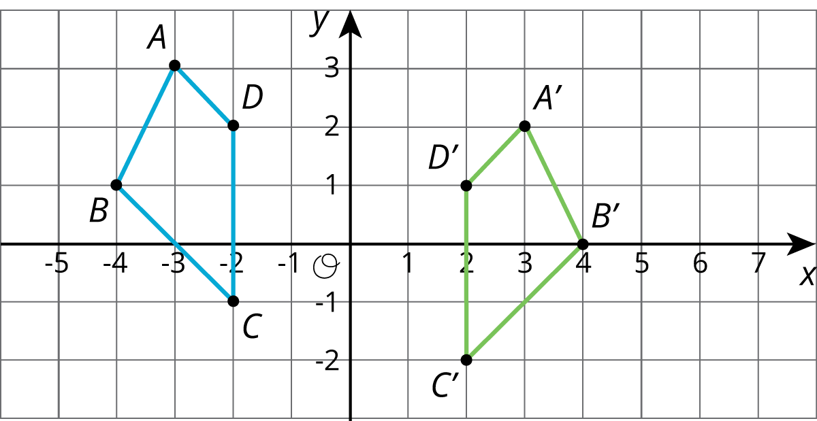

  - 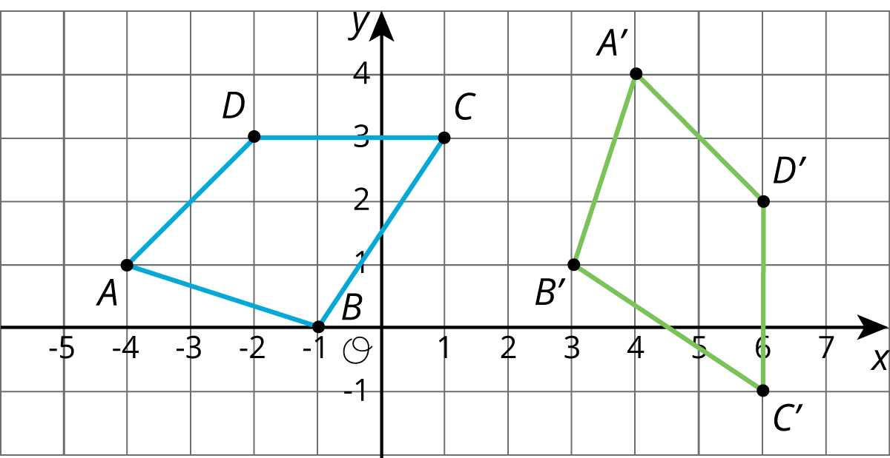
- (From Unit 1, Lesson 4.)
- Lin says that she can map Polygon A to Polygon B using only reflections. Do you agree with Lin? Explain your reasoning.
- 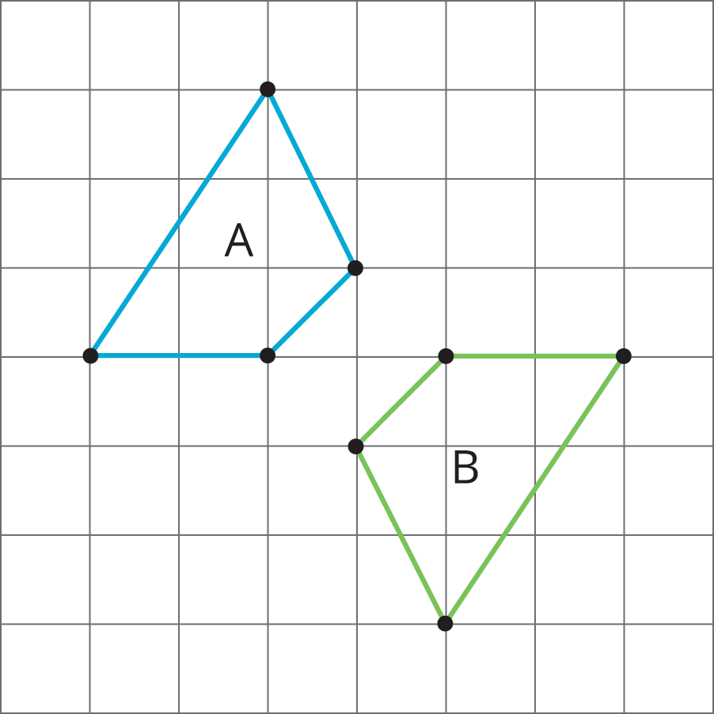
- (From Unit 1, Lesson 3.)
© CC BY Open Up Resources. Adaptations CC BY IM.

