Unit 1 Lesson 17: Squares and Cubes

1 Perfect Squares (Warm up)

Images for Launch
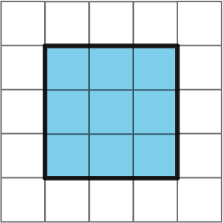
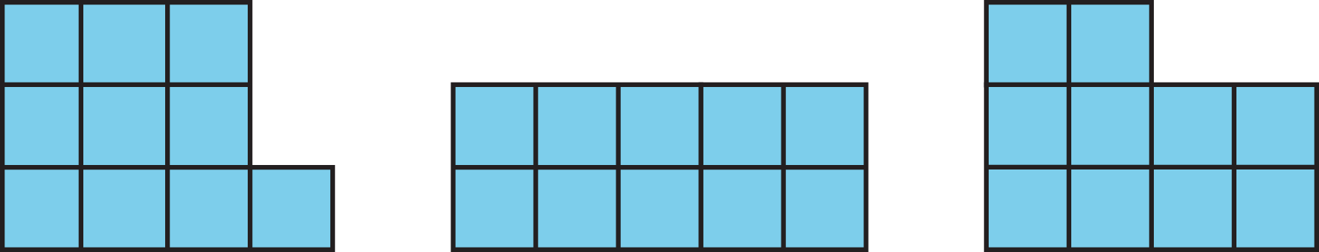

Student Task Statement
- The number 9 is a perfect square. Find four numbers that are perfect squares and two numbers that are not perfect squares.
- A square has side length 7 in. What is its area?
- The area of a square is 64 sq cm. What is its side length?

2 Building with 32 Cubes (Optional)

Student Task Statement
Your teacher will give you 32 snap cubes. Use them to build the largest single cube you can. Each small cube has an edge length of 1 unit.
- How many snap cubes did you use?
- What is the edge length of the cube you built?
- What is the area of each face of the built cube? Be prepared to explain your reasoning.
- What is the volume of the built cube? Be prepared to explain your reasoning.

3 Perfect Cubes

Images for Launch
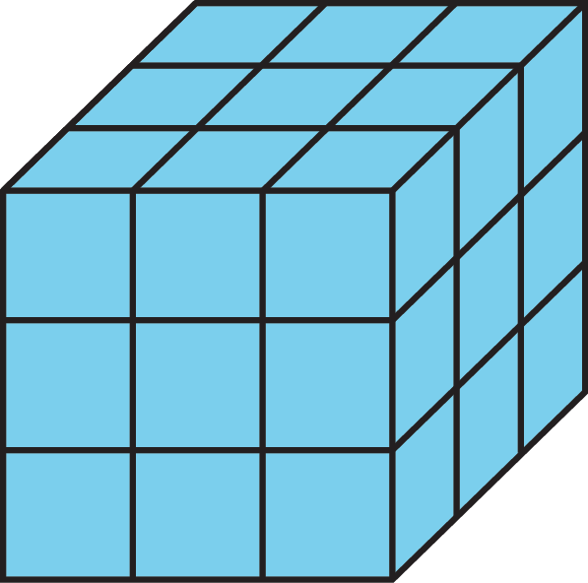

Student Task Statement
- The number 27 is a perfect cube. Find four other numbers that are perfect cubes and two numbers that are not perfect cubes.
- A cube has side length 4 cm. What is its volume?
- A cube has side length 10 inches. What is its volume?
- A cube has side length $s$ units. What is its volume?

4 Introducing Exponents

Student Task Statement
Make sure to include correct units of measure as part of each answer.
- A square has side length 10 cm. Use an exponent to express its area.
- The area of a square is $7^{2}$ sq in. What is its side length?
- The area of a square is 81 m². Use an exponent to express this area.
- A cube has edge length 5 in. Use an exponent to express its volume.
- The volume of a cube is $6^{3}$ cm³. What is its edge length?
- A cube has edge length $s$ units. Use an exponent to write an expression for its volume.
© CC BY Open Up Resources. Adaptations CC BY IM.

