Lesson 3: The Unit Circle (Part 1)
- Let’s learn about the unit circle.

3.1: Finding Coordinates of Points on the Unit Circle
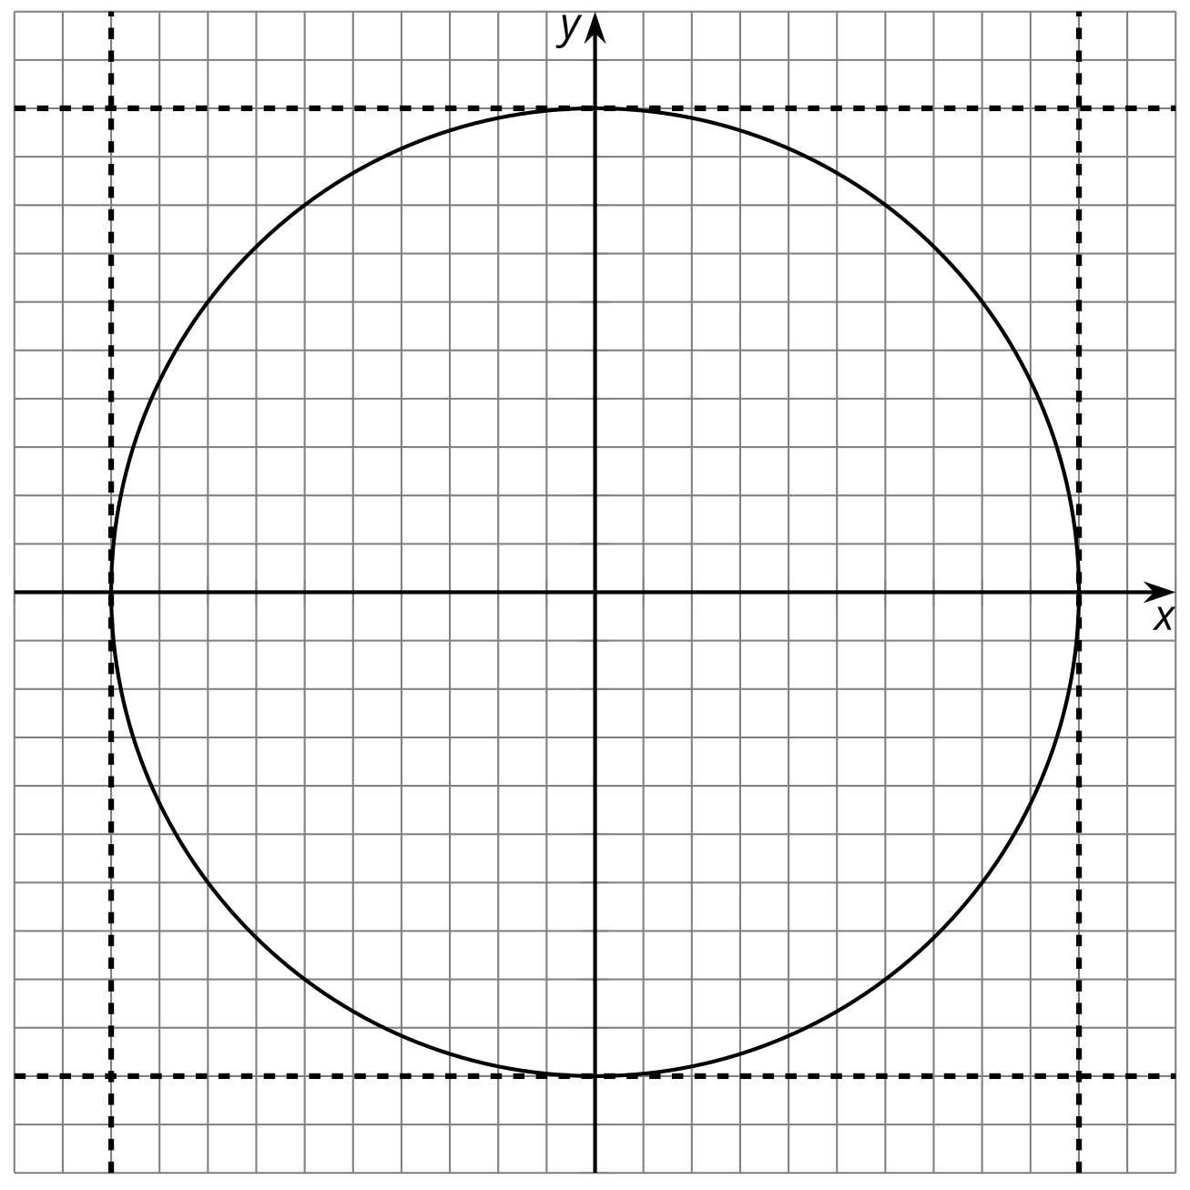
- The $x$-coordinate of a point on the unit circle is $\frac{3}{5}$. What does this tell you about where the point might lie on the unit circle? Find any possible $y$-coordinates of the point and plot them on the unit circle.
- The $y$-coordinate of a point on the unit circle is $\text{-}0.4$. What does this tell you about where the point might lie on the unit circle? Find any possible $x$-coordinates of the point and plot them on the unit circle.

3.2: Which Point?
All points are 1 unit from the origin.
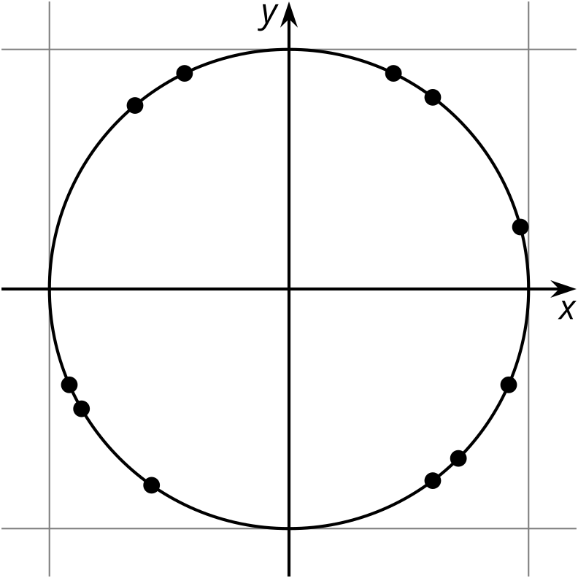
Choose one of the points. Be prepared to describe its location using only words.

3.3: Measuring Circles
- Your teacher will give you a circular object.
  - About how many radii does it take to go halfway around the circle?
  - About how many radii does it take to go all the way around the circle?
  - Compare your answers to the previous two questions with your partners.
- What is the exact number of radii that fit around the circumference of the circle? Explain how you know.
- Why doesn’t the number of radii that fit around the circumference of a circle depend on the radius of the circle? Explain how you know.

3.4: Around a Bike Wheel
A bicycle wheel has a 1 foot radius. The wheel rolls to the left (counterclockwise).
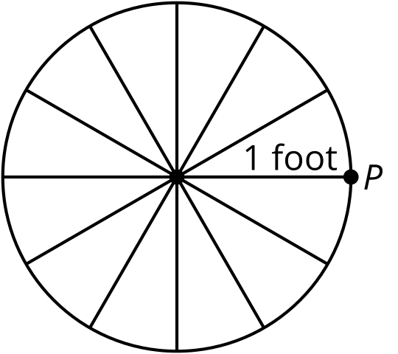
- What is the circumference of this wheel?
- Mark the point $Q$ where $P$ will be after the wheel has rolled 1 foot to the left. Be prepared to explain your reasoning.
- Mark the point $R$ where $P$ will be after the wheel has rolled 3 feet to the left. What angle, in radians, does $P$ rotate through to get to $R$? Explain your reasoning.
- Where will point $P$ be after the bike has traveled $π$ feet to the left? What about $10π$ feet? $100π$ feet? Mark these points on the circle. Explain your reasoning.
- After traveling some distance to the left, the point $P$ is at the lowest location in its rotation. How far might the bike have traveled? Explain your reasoning.

Are you ready for more?
Picture the bicycle with a bright light at point $P$ and moving now from left to right. As the bike passes in front of you going left to right, what shape do you think the light would trace in the air?

Lesson 3 Summary
One way to define a circle centered at $\left(0,0\right)$ is by the equation $x^{2}+y^{2}=r^{2}$, where $r$ is the radius of the circle. A unit circle has $r=1$, so the equation for this unit circle with center $O$ must be $x^{2}+y^{2}=1$. Points on the unit circle have several interesting properties, such as having matching points on opposite sides of the axes due to symmetry. Another feature of points on a unit circle is that they can be defined solely by an angle of rotation which is measured in radians.
Radians are a natural tool to use to measure the distance traveled on a circle. Let’s say that the wheels on a bike have a radius of 1 foot. When the bike starts to move to the left, rotating the wheel counterclockwise, let’s think about what happens to point $P$.
The point $P$ will return to its starting location when the wheel has rotated through an angle of $2π$ radians. During this rotation, the bike will move a length equal to the circumference of the wheel, which is $2π$ feet. In general, the angle of rotation of the wheel with radius 1 foot, in radians, is the same as the number of feet this bike has traveled. So what do we do when a wheel doesn’t have a radius of 1 unit? Since all circles are similar, we can use the same type of thinking but scaled up or down to match the size of the wheel, which is something we’ll do in future lessons.
Thinking about the wheel as a unit circle, as shown in this image, the arc length of the circle from $P$ to $Q$ has length equal to 1 unit, the radius of the unit circle. Because of this, the angle $POQ$ is said to measure one radian. If we continue to measure off radian lengths around the circle, it takes a little more than 6 to measure the entire circumference.
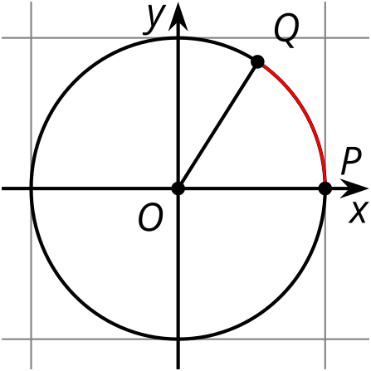
This makes sense because the ratio of the circumference to the diameter for a circle is $π$, and so the circumference is $2π$ times the radius, or about 6.3 radii.
Let’s think about some other angles on the unit circle. Here, angle $POR$ measures $π$ radians because its arc is $\frac{1}{2}$ of a full circle (counterclockwise) or $\frac{1}{2}$ of $2π$. Angle $POU$ is three quarters of a full circle (counterclockwise), so that’s $\frac{3π}{2}$ radians.
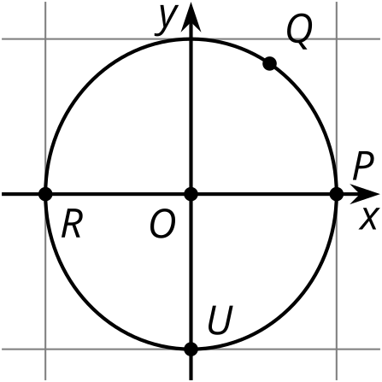
© CC BY 2019 by Illustrative Mathematics®

