Unit 4 Lesson 13: Number Line Distances

1 Math Talk: How Far? (Warm up)

Student Task Statement
Evaluate mentally: How far away is each house from the school?
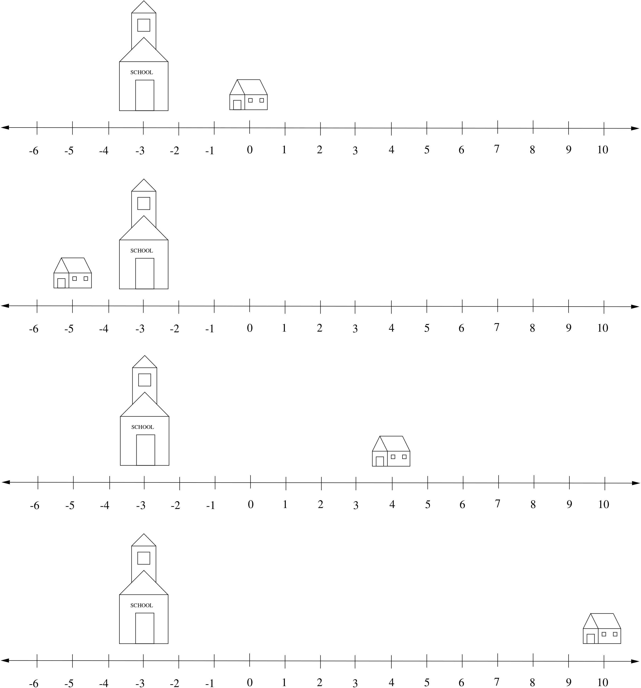

2 $a$ and $b$

Student Task Statement
- For each pair of values, find $b−a$. Be prepared to explain your reasoning.
  - $a=28,b=57$
  - $a=\frac{4}{5},b=\frac{1}{2}$
  - $a=27,b=\text{-}17$
  - $a=\text{-}35,b=\text{-}19$
  - $a=19,b=35$
  - $a=\text{-}106,b=43$
- For which pairs of values does the subtraction give the distance between the numbers on the number line?
  - What do you notice about these pairs of numbers?
- Given 2 numbers, how can you find the distance between them on the number line?

3 It’s That Far Away

Student Task Statement
- Find 2 numbers that are $d$ away from $a$ on the number line.
  - $a=14,d=6$
  - $a=\text{-}7,d=16$
  - $a=103,d=56$
  - $a=4,d=138$
- Use $d$ and $a$ to write 2 expressions that find the values that are $d$ away from $a$.
- Kiran is looking at some old work where he did problems like this and found an answer that was marked correct. The answer is -18 and 46. Could Kiran figure out the values of $a$ and $d$ from the problem based on these values? If so, what are the values? If not, what additional information would help? Explain or show your reasoning.
- In a planned neighborhood along Stepford Street, all of the houses are identical and equally distant from one another. The house at 102 Stepford Street is 2,250 feet from the house at 84 Stepford Street. Is there enough information to find the address of another house that is that same distance away from 84 Stepford Street? Explain your reasoning.
© CC BY 2019 by Illustrative Mathematics®

