Lesson 22 Practice Problems
- There are many cylinders with a height of 18 meters. Let $r$ represent the radius in meters and $V$ represent the volume in cubic meters.
  - Write an equation that represents the volume $V$ as a function of the radius $r$.
  - Complete this table, giving three possible examples.
- $r$ | - $V$
  - 1
  - If the radius of a cylinder is doubled, does the volume double? Explain how you know.
  - Is the graph of this function a line? Explain how you know.
- As part of a competition, Diego must spin around in a circle 6 times and then run to a tree. The time he spends on each spin is represented by $s$ and the time he spends running is $r$. He gets to the tree 21 seconds after he starts spinning.
  - Write an equation showing the relationship between $s$ and $r$.
  - Rearrange the equation so that it shows $r$ as a function of $s$.
  - If it takes Diego 1.2 seconds to spin around each time, how many seconds did he spend running?
- (From Unit 6, Lesson 3.)
- The table and graph represent two functions. Use the table and graph to answer the questions.
- 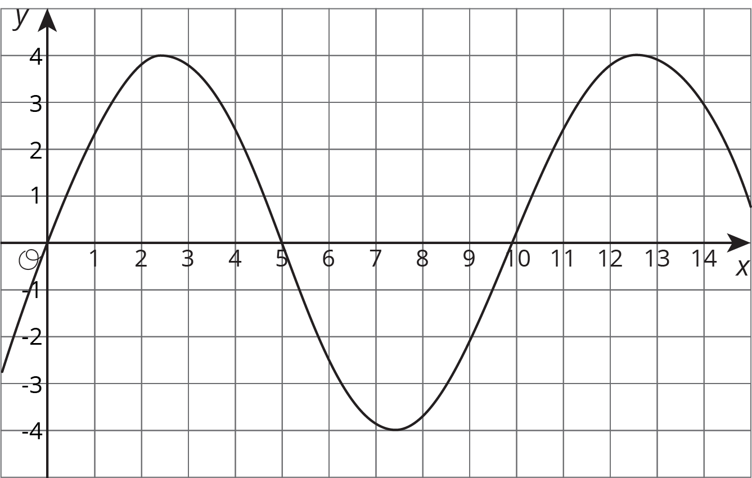
- $x$ | - 1 | - 2 | - 3 | - 4 | - 5 | - 6
- $y$ | - 3 | - -1 | - 0 | - 4 | - 5 | - -1
  - For which values of $x$ is the output from the table less than the output from the graph?
  - In the graphed function, which values of $x$ give an output of 0?
- (From Unit 6, Lesson 7.)
- A cone has a radius of 3 units and a height of 4 units.
  - What is this volume of this cone?
  - Another cone has quadruple the radius, and the same height. How many times larger is the new cone’s volume?
© CC BY Open Up Resources. Adaptations CC BY IM.

