Lesson 15: Multiplying Rational Numbers
Let’s get more practice multiplying signed numbers.

15.1: Which One Doesn’t Belong: Expressions
Which expression doesn’t belong?
$7.9x$
$7.9⋅\left(\text{-}10\right)$
$7.9+x$
$\text{-}79$

15.2: Rational Numbers Multiplication Grid
- Complete the shaded boxes in the multiplication square.
- 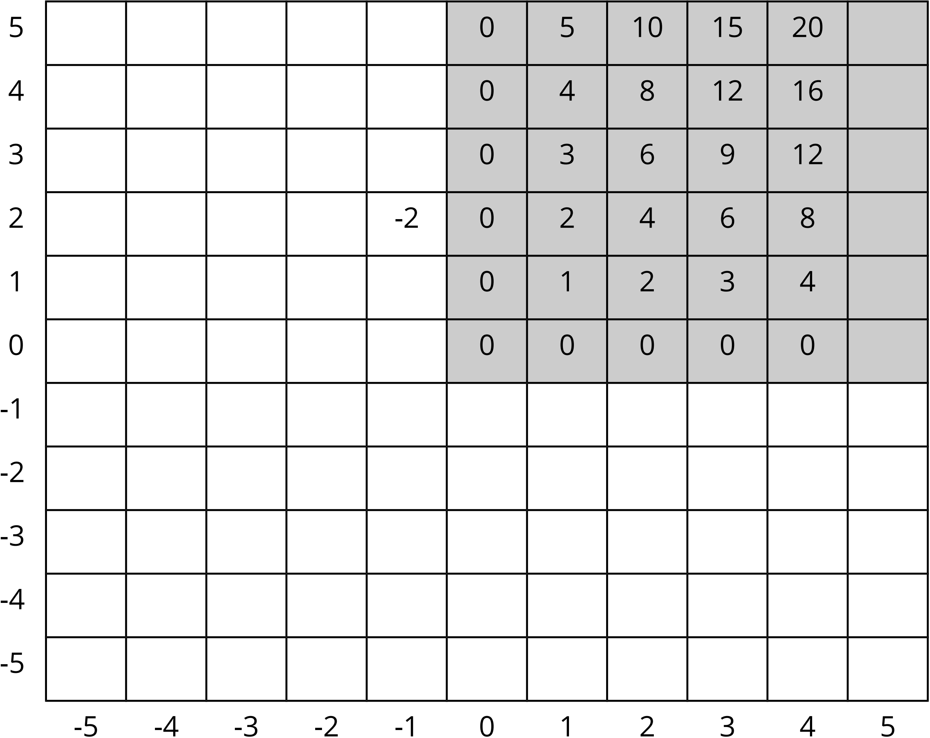
- Look at the patterns along the rows and columns. Continue those patterns into the unshaded boxes.
- Complete the whole table.
- What does this tell you about multiplication with negative numbers?

15.3: Card Sort: Matching Expressions
Your teacher will give you cards with multiplication expressions on them. Match the expressions that are equal to each other. There will be 3 cards in each group.

15.4: Row Game: Multiplying Rational Numbers
Evaluate the expressions in one of the columns. Your partner will work on the other column. Check in with your partner after you finish each row. Your answers in each row should be the same. If your answers aren’t the same, work together to find the error.
column A | column B
$790÷10$ | $\left(7.9\right)⋅10$
$\text{-}\frac{6}{7}⋅7$ | $\left(0.1\right)⋅\text{-}60$
$\left(2.1\right)⋅\text{-}2$ | $\left(\text{-}8.4\right)⋅\frac{1}{2}$
$\left(2.5\right)⋅\left(\text{-}3.25\right)$ | $\text{-}\frac{5}{2}⋅\frac{13}{4}$
$\text{-}10⋅\left(3.2\right)⋅\left(\text{-}7.3\right)$ | $5⋅\left(\text{-}1.6\right)⋅\left(\text{-}29.2\right)$

Are you ready for more?
A sequence of rational numbers is made by starting with 1, and from then on, each term is one more than the reciprocal of the previous term. Evaluate the first few expressions in the sequence. Can you find any patterns? Find the 10th term in this sequence.
$1 1+\frac{1}{1} 1+\frac{1}{1+1} 1+\frac{1}{1+\frac{1}{1+1}} 1+\frac{1}{1+\frac{1}{1+\frac{1}{1+1}}} …$

Lesson 15 Summary
We can think of $3⋅5$ as $5+5+5$, which has a value of 15.
We can think of $3⋅\left(\text{-}5\right)$ as $\text{-}5+\text{-}5+\text{-}5$, which has a value of -15.
We know we can multiply positive numbers in any order: $3⋅5=5⋅3$
If we can multiply signed numbers in any order, then $\left(\text{-}5\right)⋅3$ would also equal -15.
Now let’s think about multiplying two negatives.
We can find $\text{-}5⋅\left(3+\text{-}3\right)$ in two ways:
- Applying the distributive property:
$\text{-}5⋅3+\text{-}5⋅\left(\text{-}3\right)$
- Adding the numbers in parentheses:
$\text{-}5⋅\left(0\right)=0$
This means that these expressions must be equal.
$\text{-}5⋅3+\text{-}5⋅\left(\text{-}3\right)=0$
Multiplying the first two numbers gives
$\text{-}15+\text{-}5⋅\left(\text{-}3\right)=0$
Which means that
$\text{-}5⋅\left(\text{-}3\right)=15$
There was nothing special about these particular numbers. This always works!
- A positive times a positive is always positive.
- For example, $\frac{3}{5}⋅\frac{7}{8}=\frac{21}{40}$.
- A negative times a negative is also positive.
- For example, $\text{-}\frac{3}{5}⋅\text{-}\frac{7}{8}=\frac{21}{40}$.
- A negative times a positive or a positive times a negative is always negative.
- For example, $\frac{3}{5}⋅\text{-}\frac{7}{8}=\text{-}\frac{3}{5}⋅\frac{7}{8}=\text{-}\frac{21}{40}$.
- A negative times a negative times a negative is also negative.
- For example, $\text{-}3⋅\text{-}4⋅\text{-}5=\text{-}60$.
© CC BY Open Up Resources. Adaptations CC BY IM.

