Unit 4 Lesson 12: Functions with Multiple Parts

1 Notice and Wonder: Ticket Price (Warm up)

Student Task Statement
What do you notice? What do you wonder?
age | ticket cost
0–2 | FREE
2–5 | $2.00
5–12 | $5.00
13–16 | $7.50
17–50 | $10.00
55 and up | $5.00

2 Group Ticket Cost

Student Task Statement
A community orchestra charges different amounts for tickets to shows based on the age of the person attending. A sign in front of the box office where tickets are sold shows the prices.
age | ticket cost
0–2 | FREE
3–13 | $4.00
14–18 | $6.00
19–25 | $9.00
26–54 | $10.00
55 and up | $6.00
- How much does each group need to pay for their tickets?
  - 2 adults aged 40 and 36, and 2 kids aged 4 and 1
  - 3 adults aged 74, 37, and 36
  - 5 adults in their 30s and 25 students aged 15 and 16
  - 1 adult aged 25 and 4 kids aged 1, 9, 13, and 16
- A mother arrives and tells the box office clerk that her child is 35 months old. How much should the clerk charge for the child?
- If there is a rule that uses the age of a person attending the orchestra concert as the input and outputs the ticket price for that person, is that rule a function? Explain your reasoning.
  - What is the domain for the rule?
  - What is the range for the rule?

3 A Light Trip

Student Task Statement
- Noah leaves his home, sometimes running, sometimes walking, sometimes stopping until he remembers that he doesn’t have his wallet, then he goes back home. A graph representing his journey is shown in the graph.
- 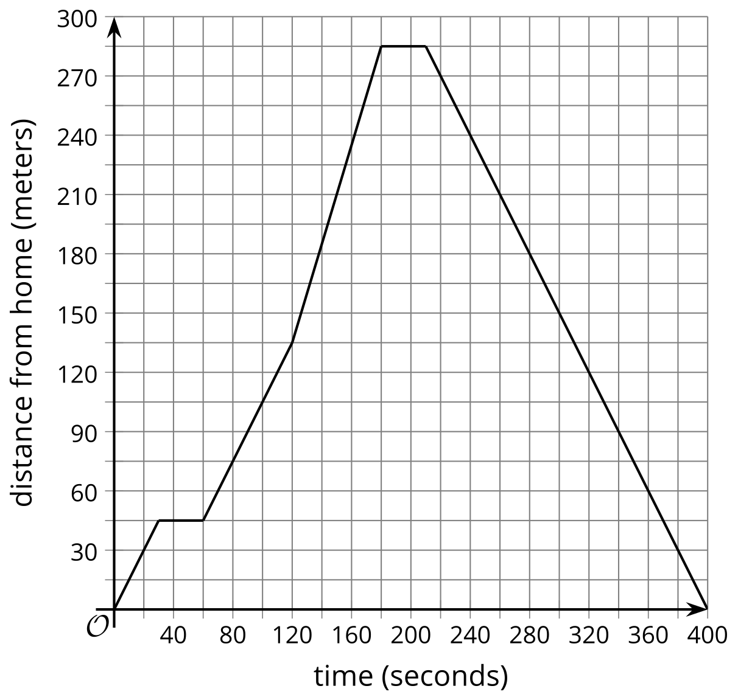
  - Describe what is happening on the domain $210<x<400$.
  - What are the domain intervals that represent the times when Noah was running?
  - What are the domain intervals that represent the times when Noah was stopped?
  - What are the domain intervals that represent the times when Noah was walking away from home?
- The amount of light in a room is shown as a function of the number of hours after midnight. Describe what might be happening in the room. Be sure to use intervals within the domain in your description.
- 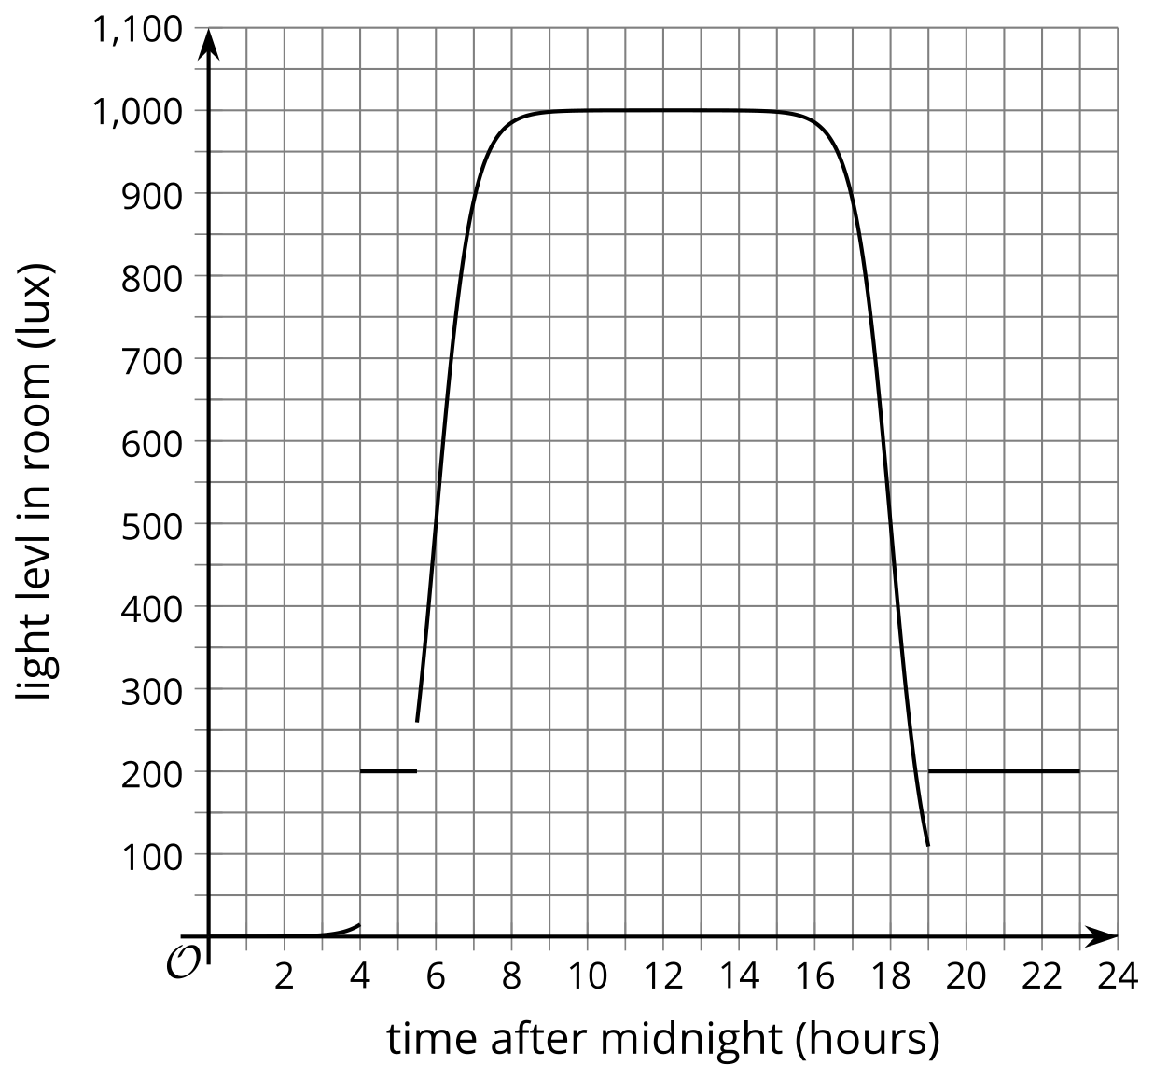
© CC BY 2019 by Illustrative Mathematics®

