Lesson 5 Practice Problems
- Here is Trapezoid A in the coordinate plane:
- 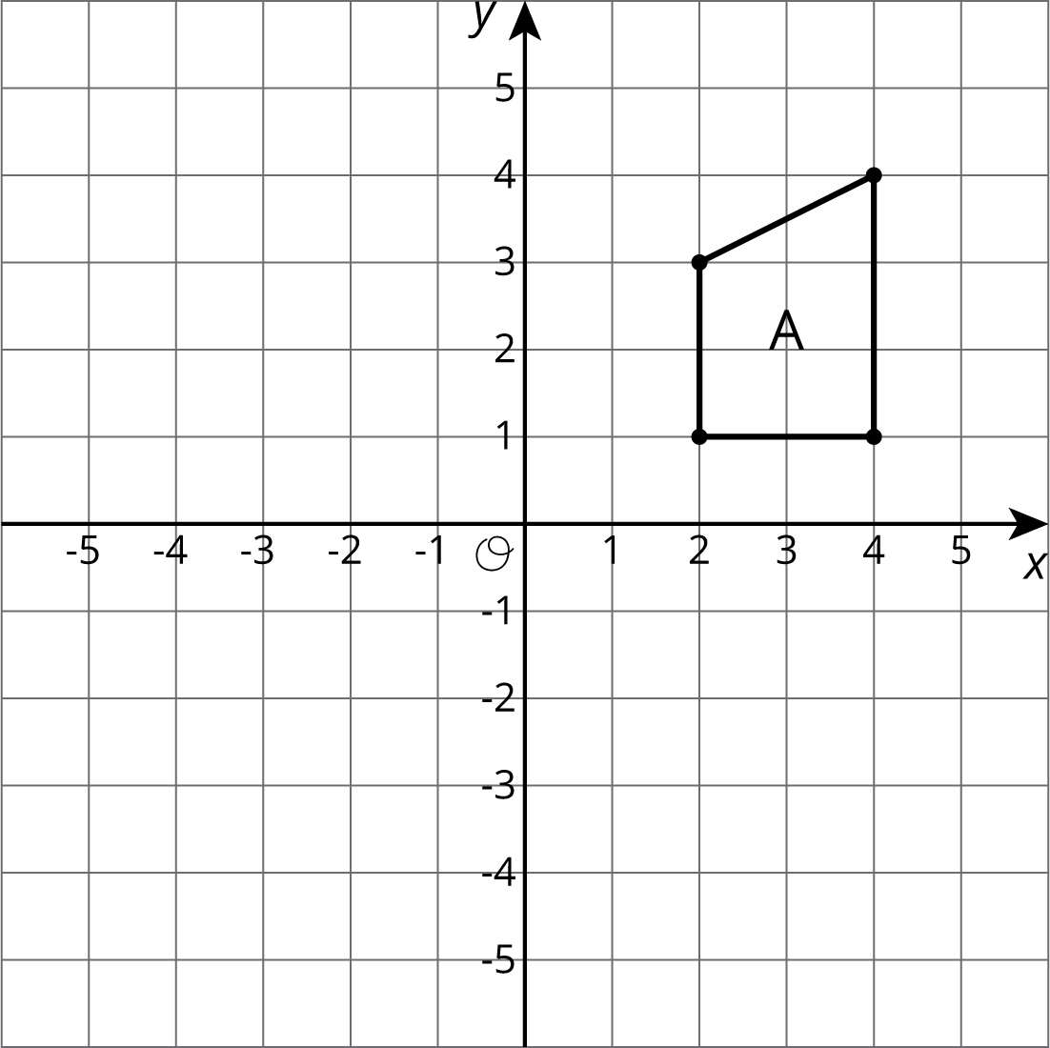
  - Draw Polygon B, the image of A, using the $y$-axis as the line of reflection.
  - Draw Polygon C, the image of B, using the $x$-axis as the line of reflection.
  - Draw Polygon D, the image of C, using the $x$-axis as the line of reflection.
- The point $\left(\text{-}4,1\right)$ is rotated 180 degrees counterclockwise using center $\left(\text{-}3,0\right)$. What are the coordinates of the image?
  - $\left(\text{-}5,\text{-}2\right)$
  - $\left(\text{-}4,\text{-}1\right)$
  - $\left(\text{-}2,\text{-}1\right)$
  - $\left(4,\text{-}1\right)$
- Describe a sequence of transformations for which Triangle B is the image of Triangle A.
- 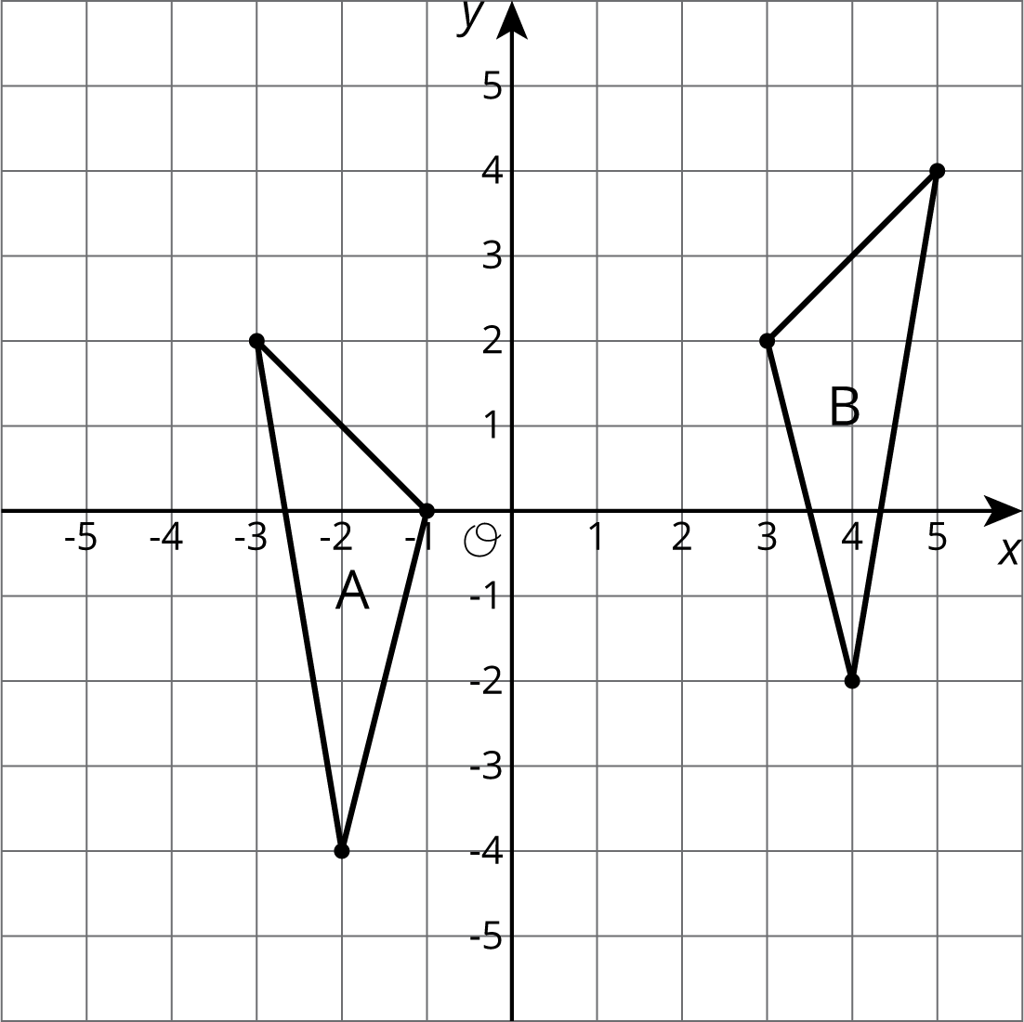
- Here is quadrilateral $ABCD$.
- 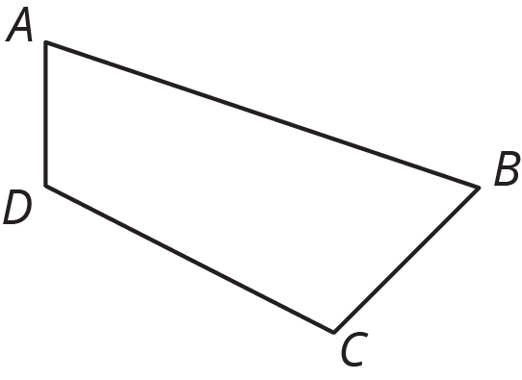

- Draw the image of quadrilateral $ABCD$ after each transformation.
  - The translation that takes $B$ to $D$.
  - The reflection over segment $BC$.
  - The rotation about point $A$ by angle $DAB$, counterclockwise.
- (From Unit 1, Lesson 2.)
© CC BY Open Up Resources. Adaptations CC BY IM.

