Lesson 7: Restaurant Floor Plan
Let’s design the floor plan for a restaurant.

7.1: Dining Area
- Restaurant owners say it is good for each customer to have about 300 in² of space at their table. How many customers would you seat at each table?
- 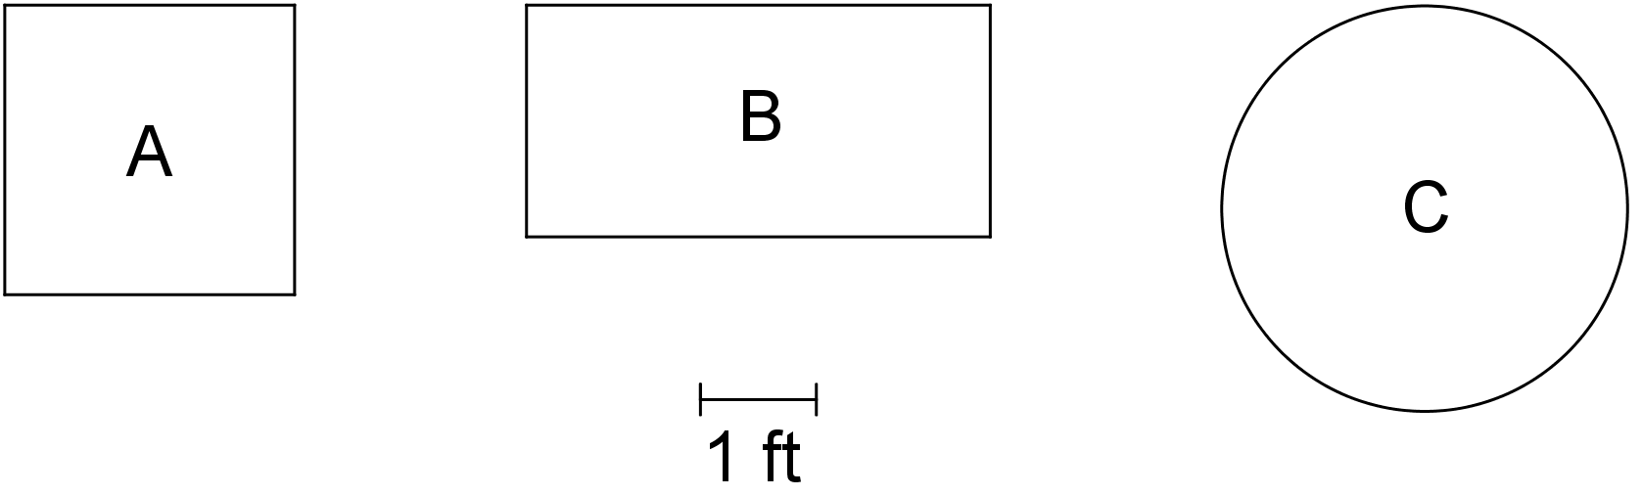
- It is good to have about 15 ft² of floor space per customer in the dining area.
  - How many customers would you like to be able to seat at one time?
  - What size and shape dining area would be large enough to fit that many customers?
  - Select an appropriate scale, and create a scale drawing of the outline of your dining area.
- Using the same scale, what size would each of the tables from the first question appear on your scale drawing?
- To ensure fast service, it is good for all of the tables to be within 60 ft of the place where the servers bring the food out of the kitchen. Decide where the food pickup area will be, and draw it on your scale drawing. Next, show the limit of how far away tables can be positioned from this place.
- It is good to have at least $1\frac{1}{2}$ ft between each table and at least $3\frac{1}{2}$ ft between the sides of tables where the customers will be sitting. On your scale drawing, show one way you could arrange tables in your dining area.

Are you ready for more?
The dining area usually takes up about 60% of the overall space of a restaurant because there also needs to be room for the kitchen, storage areas, office, and bathrooms. Given the size of your dining area, how much more space would you need for these other areas?

7.2: Cold Storage
Some restaurants have very large refrigerators or freezers that are like small rooms. The energy to keep these rooms cold can be expensive.
- A standard walk-in refrigerator (rectangular, 10 feet wide, 10 feet long, and 7 feet tall) will cost about $150 per month to keep cold.
- A standard walk-in freezer (rectangular, 8 feet wide, 10 feet long, and 7 feet tall) will cost about $372 per month to keep cold.
Here is a scale drawing of a walk-in refrigerator and freezer. About how much would it cost to keep them both cold? Show your reasoning.
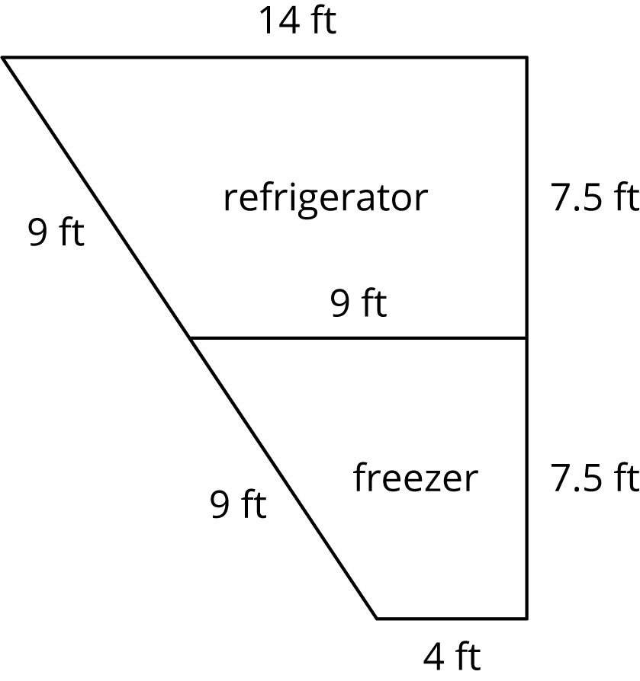
© CC BY Open Up Resources. Adaptations CC BY IM.

