Lesson 9: Una suma de sumandos iguales

Standards Alignments
Addressing | 2.OA.B.2, 2.OA.C.3, 2.OA.C.4
Building Towards | 3.OA.A.1

Teacher-facing Learning Goals
- Represent the number of objects in an array as a sum of equal addends.

Student-facing Learning Goals
- Asociemos expresiones con arreglos.

Lesson Purpose
The purpose of this lesson is for students to make connections between the structure of an array and expressions that represent the sum of the number of objects in each row or column in an array.
In this lesson, students match expressions with equal addends to arrays and find the total number of objects in an array by finding the value of these sums. The primary focus of the lesson is on relating sums with equal addends to the structure of the rows and columns in an array to build foundations for using arrays to represent multiplication in grade 3.
The arrays in the lesson also invite students to decompose the array in ways that make sense to them and it is important to recognize other ways students may use expressions to represent arrays.
For example, students might find the total number in the array by adding $6+6$. Although this expression does not directly match the structure of the rows and columns, it would be important to invite students to share why they chose this expression and how they may have used the rows or columns.
When students compare this expression to the sum of the number of counters in each column ($3+3+3+3$) or the sum of the counters in each row ($4+4+4$), it helps build conceptual foundations for multiplication and the properties of operations that will be explored in future grades.
For arrays that don’t have the same number of rows as columns, there are 2 expressions that can represent the number of objects in the array.
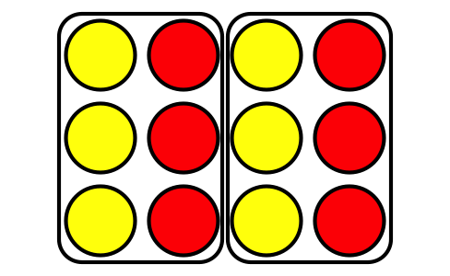
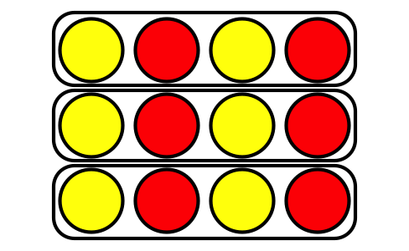
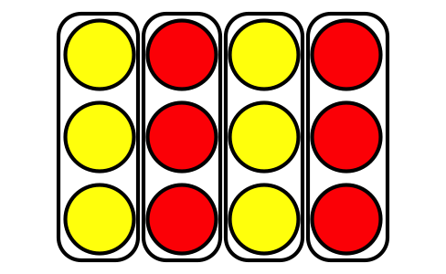

Access for:

Students with Disabilities
- Representation (Activity 3)

English Learners
- MLR2 (Activity 2)

Instructional Routines
Card Sort (Activity 2), Estimation Exploration (Warm-up)

Materials to Gather
- Counters: Activity 1, Activity 3

Materials to Copy
- Match Arrays to Expressions Card Sort, Spanish (groups of 2): Activity 2

Lesson Timeline
Warm-up | 10 min
Activity 1 | 10 min
Activity 2 | 15 min
Activity 3 | 10 min
Lesson Synthesis | 10 min
Cool-down | 5 min

Teacher Reflection Question
As students worked in their small groups today, whose ideas were heard, valued, and accepted? How can you adjust the group structure tomorrow to ensure each student's ideas are a part of the collective learning?

Cool-down
(to be completed at the end of the lesson) 5min
Asocia expresiones con arreglos

Standards Alignments
Addressing | 2.OA.C.4

Student-facing Task Statement
- Marca las 2 expresiones que representan las filas y las columnas del arreglo.
- 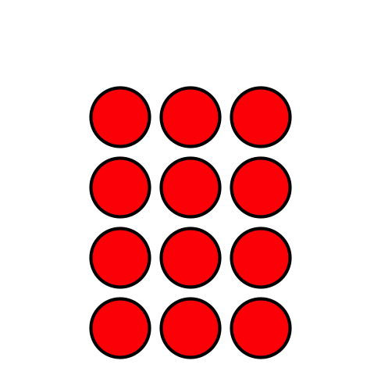
- $4+4+4$
- $4+4+4+4$
- $3+3+3$
- $3+3+3+3$
- ¿Cuántas fichas hay en total?

Student Responses
- $3+3+3+3$ and $4+4+4$
- 12 counters

