Unit 4 Lesson 10: On or Off the Line?

1 Which One Doesn’t Belong: Lines in the Plane (Warm up)

Student Task Statement
Which one doesn’t belong? Explain your reasoning.
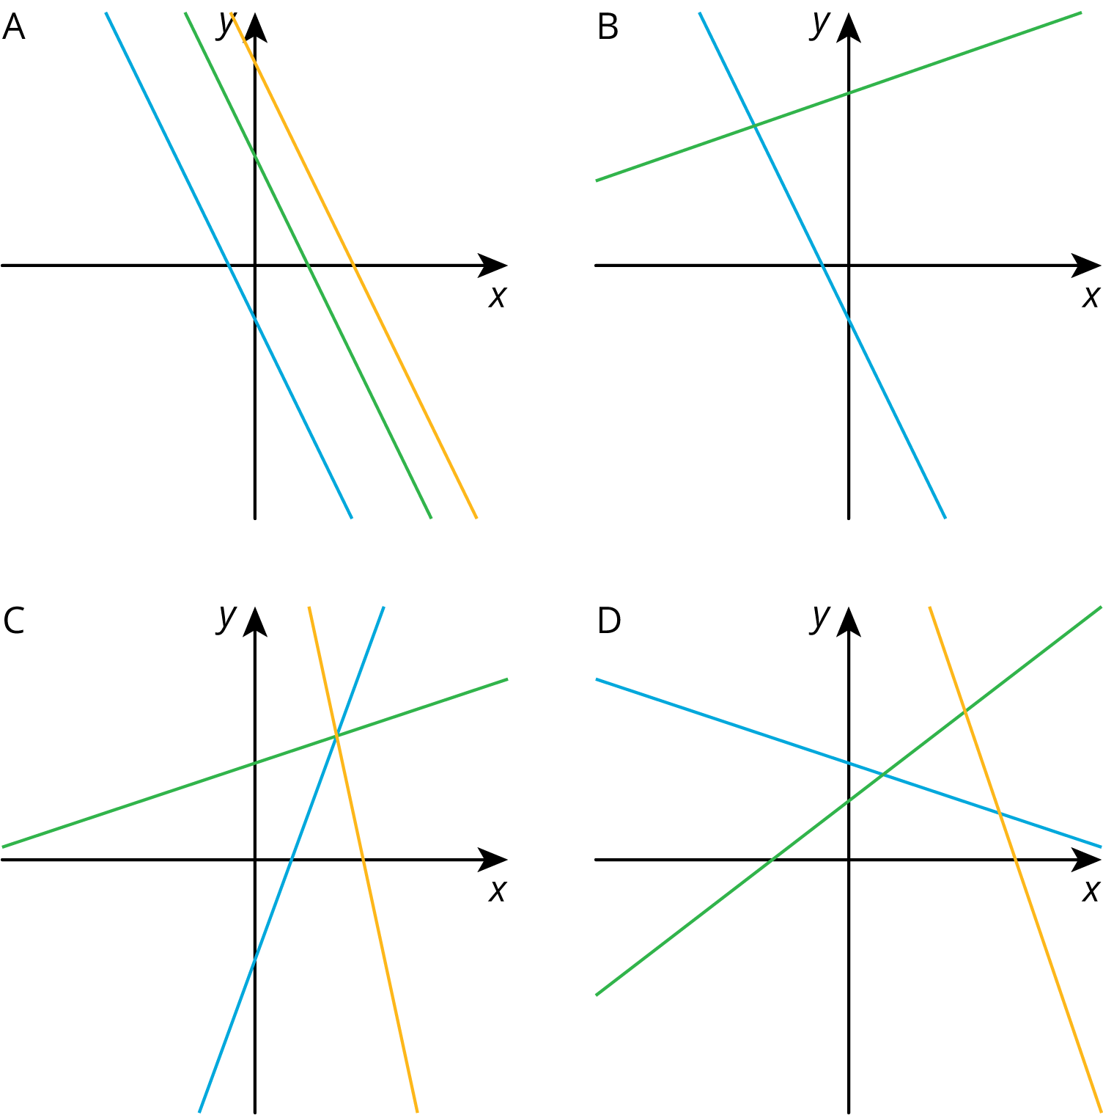

2 Pocket Full of Change

Student Task Statement
Jada told Noah that she has $2 worth of quarters and dimes in her pocket and 17 coins all together. She asked him to guess how many of each type of coin she has.
- Here is a table that shows some combinations of quarters and dimes that are worth $2. Complete the table.
- number of quarters | - number of dimes
- 0 | - 20
- 4
 | - 0
 | - 5
- Here is a graph of the relationship between the number of quarters and the number of dimes when there are a total of 17 coins.
  - What does Point $A$ represent?
  - How much money, in dollars, is the combination represented by Point $A$ worth?
  - 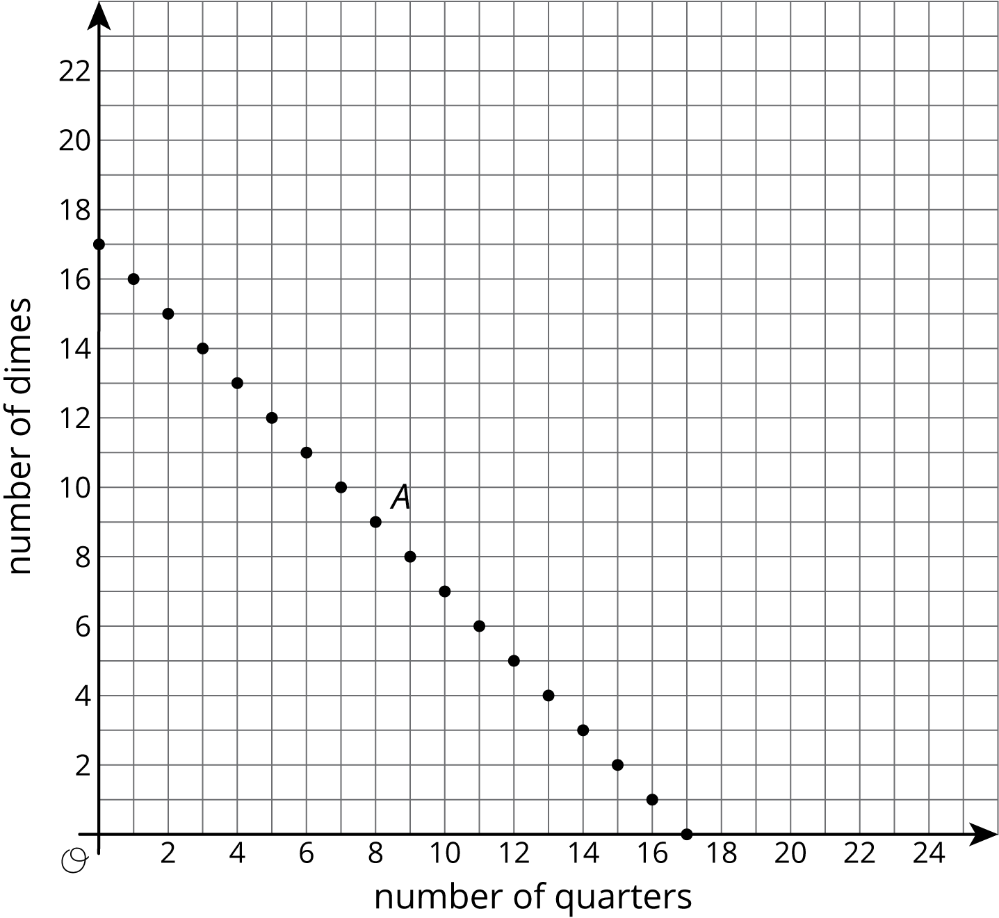
- Is it possible for Jada to have 4 quarters and 13 dimes in her pocket? Explain how you know.
- How many quarters and dimes must Jada have? Explain your reasoning.

3 Making Signs

Student Task Statement
Clare and Andre are making signs for all the lockers as part of the decorations for the upcoming spirit week. Yesterday, Andre made 15 signs and Clare made 5 signs. Today, they need to make more signs. Each person's progress today is shown in the coordinate plane.
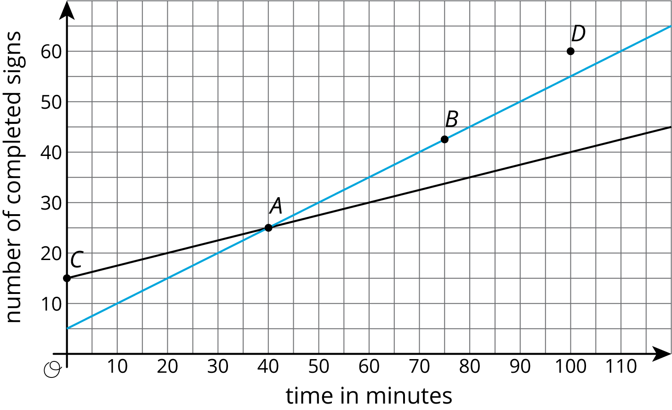
Based on the lines, mark the statements as true or false for each person.
point | what it says | Clare | Andre
$A$ | At 40 minutes, I have 25 signs completed.
$B$ | At 75 minutes, I have 42 and a half signs completed.
$C$ | At 0 minutes, I have 15 signs completed.
$D$ | At 100 minutes, I have 60 signs completed.

© CC BY Open Up Resources. Adaptations CC BY IM.

