Unit 2 Lesson 14: Bisect It

1 Why Does This Construction Work? (Warm up)

Student Task Statement
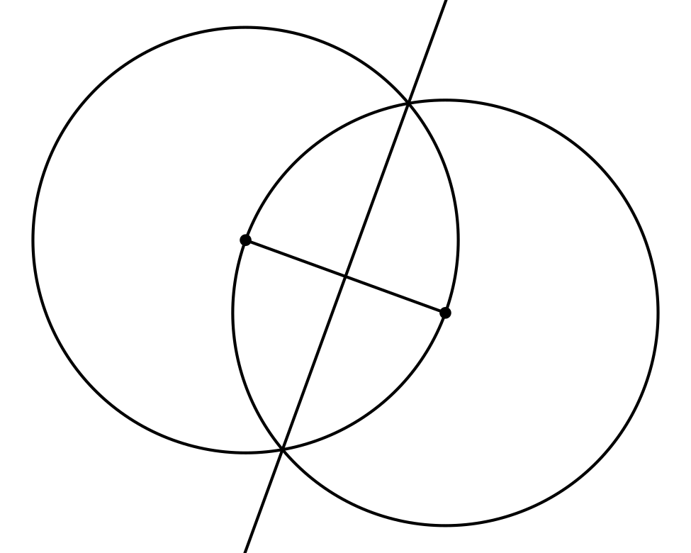
If you are Partner A, explain to your partner what steps were taken to construct the perpendicular bisector in this image.
If you are Partner B, listen to your partner’s explanation, and then explain to your partner why these steps produce a line with the properties of a perpendicular bisector.
Then, work together to make sure the main steps in Partner A’s explanation have a reason from Partner B’s explanation.

2 Construction from Definition

Student Task Statement
Han, Clare, and Andre thought of a way to construct an angle bisector. They used a circle to construct points $D$ and $E$ the same distance from $A$. Then they connected $D$ and $E$ and found the midpoint of segment $DE$. They thought that ray $AF$ would be the bisector of angle $DAE$. Mark the given information on the diagram:
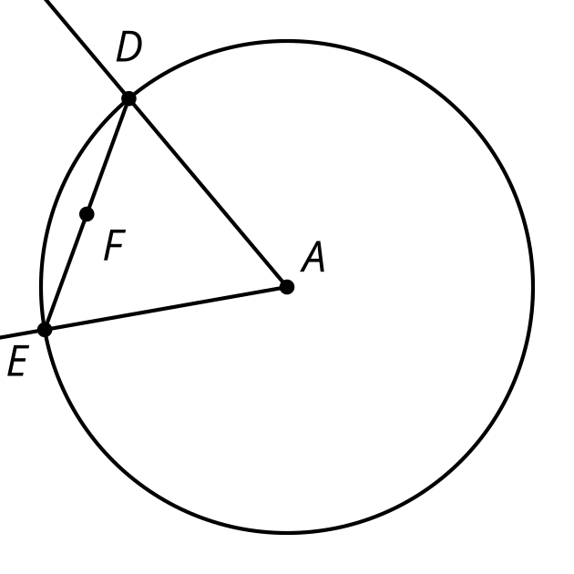
Han’s rough-draft justification: $F$ is the midpoint of segment $DE$. I noticed that $F$ is also on the perpendicular bisector of angle $DAE$.
Clare’s rough-draft justification: Since segment $DA$ is congruent to segment $EA$, triangle $DEA$ is isosceles. $DF$ has to be congruent to $EF$ because they are the same length. So, $AF$ has to be the angle bisector.
Andre’s rough-draft justification: What if you draw a segment from $F$ to $A$? Segments $DF$ and $EF$ are congruent. Also, angle $DAF$ is congruent to angle $EAF$. Then both triangles are congruent on either side of the angle bisector line.
- Each student tried to justify why their construction worked. With your partner, discuss each student’s approach.
  - What do you notice that this student understands about the problem?
  - What question would you ask them to help them move forward?
- Using the ideas you heard and the ways that each student could make their explanation better, write your own explanation for why ray $AF$ must be an angle bisector.

3 Reflecting on Reflection (Optional)

Student Task Statement
- Here is a diagram of an isosceles triangle $APB$ with segment $AP$ congruent to segment $BP$.
Here is a valid proof that the angle bisector of the vertex angle of an isosceles triangle is a line of symmetry.
- 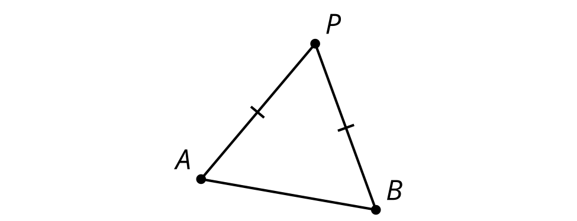
  - Read the proof and annotate the diagram with each piece of information in the proof.
  - Write a summary of how this proof shows the angle bisector of the vertex angle of an isosceles triangle is a line of symmetry.
  - Segment $AP$ is congruent to segment $BP$ because triangle $APB$ is isosceles.
  - The angle bisector of $APB$ intersects segment $AB$. Call that point $Q$.
  - By the definition of angle bisector, angles $APQ$ and $BPQ$ are congruent.
  - Segment $PQ$ is congruent to itself.
  - By the Side-Angle-Side Triangle Congruence Theorem, triangle $APQ$ must be congruent to triangle $BPQ$.
  - Therefore the corresponding segments $AQ$ and $BQ$ are congruent and corresponding angles $AQP$ and $BQP$ are congruent.
  - Since angles $AQP$ and $BQP$ are both congruent and supplementary angles, each angle must be a right angle.
  - So $PQ$ must be the perpendicular bisector of segment $AB$.
  - Because reflection across perpendicular bisectors takes segments onto themselves and swaps the endpoints, when we reflect the triangle across $PQ$ the vertex $P$ will stay in the same spot and the 2 endpoints of the base, $A$ and $B$, will switch places.
  - Therefore the angle bisector $PQ$ is a line of symmetry for triangle $APB$.
- Here is a diagram of parallelogram $ABCD$.
Here is an invalid proof that a diagonal of a parallelogram is a line of symmetry. ​​​
- 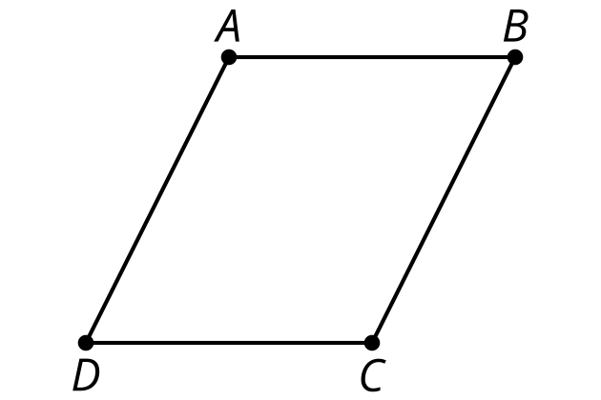
  - Read the proof and annotate the diagram with each piece of information in the proof.
  - Find the errors that make this proof invalid. Highlight any lines that have errors or false assumptions.
  - The diagonals of a parallelogram intersect. Call that point $M$.
  - The diagonals of a parallelogram bisect each other, so $MB$ is congruent to $MD$.
  - By the definition of parallelogram, the opposite sides $AB$ and $CD$ are parallel.
  - Angles $ABM$ and $ADM$ are alternate interior angles of parallel lines so they must be congruent.
  - Segment $AM$ is congruent to itself.
  - By the Side-Angle-Side Triangle Congruence Theorem, triangle $ABM$ is congruent to triangle $ADM$.
  - Therefore the corresponding angles $AMB$ and $AMD$ are congruent.
  - Since angles $AMB$ and $AMD$ are both congruent and supplementary angles, each angle must be a right angle.
  - So $AC$ must be the perpendicular bisector of segment $BD$.
  - Because reflection across perpendicular bisectors takes segments onto themselves and swaps the endpoints, when we reflect the parallelogram across $AC$ the vertices $A$ and $C$ will stay in the same spot and the 2 endpoints of the other diagonal, $B$ and $D$, will switch places.
  - Therefore diagonal $AC$ is a line of symmetry for parallelogram $ABCD$.

Images for Activity Synthesis
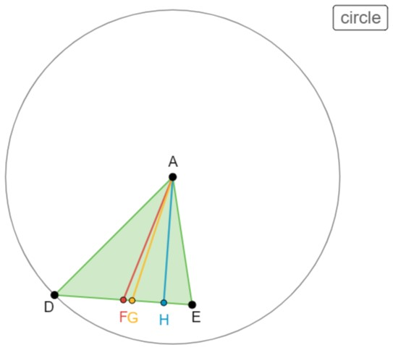
© CC BY 2019 by Illustrative Mathematics®

