Lesson 6: More Costs of Running a Restaurant
Let’s explore how much it costs to run a restaurant.

6.1: Are We Making Money?
- Restaurants have many more expenses than just the cost of the food.
  - Make a list of other items you would have to spend money on if you were running a restaurant.
  - Identify which expenses on your list depend on the number of meals ordered and which are independent of the number of meals ordered.
  - Identify which of the expenses that are independent of the number of meals ordered only have to be paid once and which are ongoing.
  - Estimate the monthly cost for each of the ongoing expenses on your list. Next, calculate the total of these monthly expenses.
- Tell whether each restaurant is making a profit or losing money if they have to pay the amount you predicted in ongoing expenses per month. Organize your thinking so it can be followed by others.
  - Restaurant A sells 6,000 meals in one month, at an average price of $17 per meal and an average cost of $4.60 per meal.
  - Restaurant B sells 8,500 meals in one month, at an average price of $8 per meal and an average cost of $2.20 per meal.
  - Restaurant C sells 4,800 meals in one month, at an average price of $29 per meal and an average cost of $6.90 per meal.

  - Predict how many meals your restaurant would sell in one month.
  - How much money would you need to charge for each meal to be able to cover all the ongoing costs of running a restaurant?
- What percentage of the cost of the ingredients is the markup on your meal?

6.2: Disposable or Reusable?
A sample of full service restaurants and a sample of fast food restaurants were surveyed about the average number of customers they serve per day.
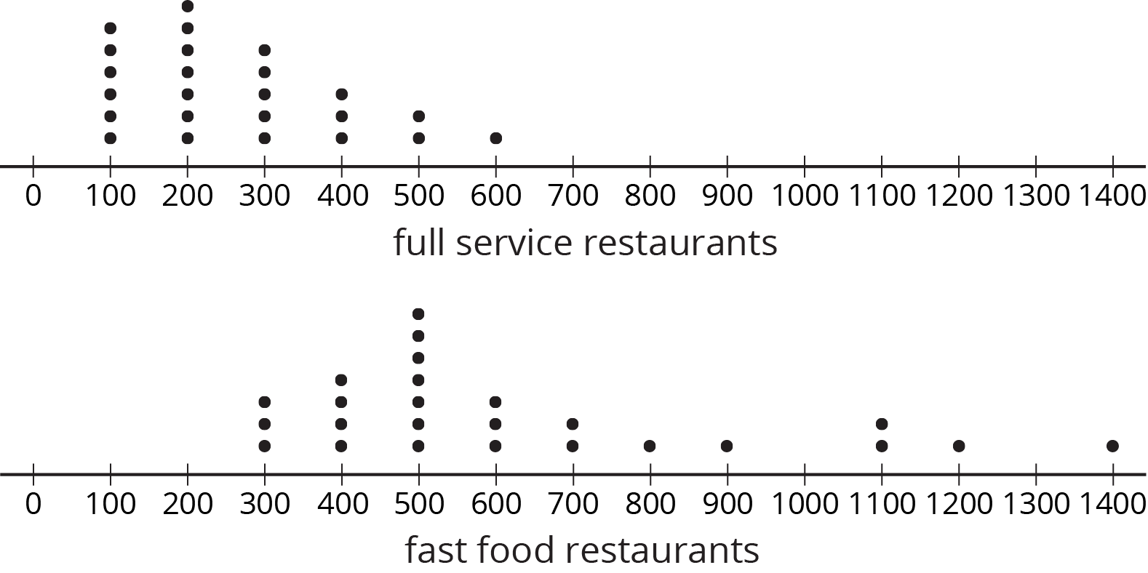
- How does the average number of customers served per day at a full service restaurant generally compare to the number served at a fast food restaurant? Explain your reasoning.
- About how many customers do you think your restaurant will serve per day? Explain your reasoning.
- Here are prices for plates and forks:
 | - plates | - forks
- disposable | - 165 paper plates for $12.50 | - 600 plastic forks for $10
- reusable | - 12 ceramic plates for $28.80 | - 24 metal forks for $30
  - Using your predicted number of customers per day from the previous question, write an equation for the total cost, $d$, of using disposable plates and forks for every customer for $n$ days.
  - Is $d$ proportional to $n$? Explain your reasoning.
  - Use your equation to predict the cost of using disposable plates and forks for 1 year. Explain any assumptions you make with this calculation.

  - How much would it cost to buy enough reusable plates and forks for your predicted number of customers per day?
  - If it costs $10.75 a day to wash the reusable plates and forks, write an expression that represents the total cost, $r$, of buying and washing reusable plates and forks after $n$ days.
  - Is $r$ proportional to $n$? Explain your reasoning.
  - How many days can you use the reusable plates and forks for the same cost that you calculated for using disposable plates and forks for 1 year?
© CC BY Open Up Resources. Adaptations CC BY IM.

