Unit 1 Lesson 13: Polyhedra

1 What are Polyhedra? (Warm up)

Student Task Statement
Here are pictures that represent polyhedra:
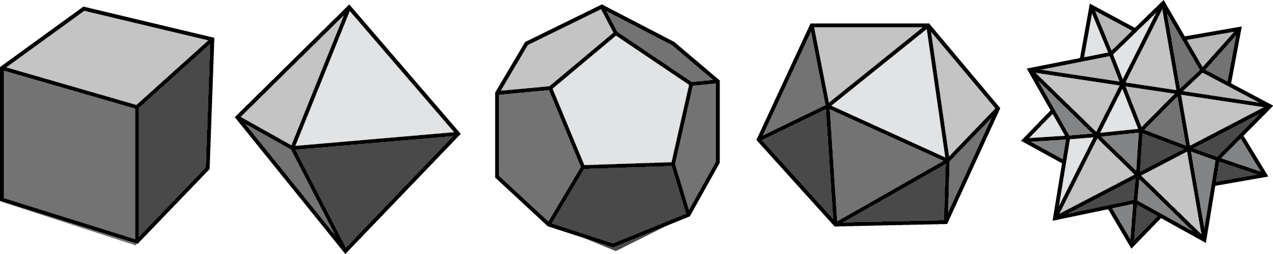
Here are pictures that do not represent polyhedra:
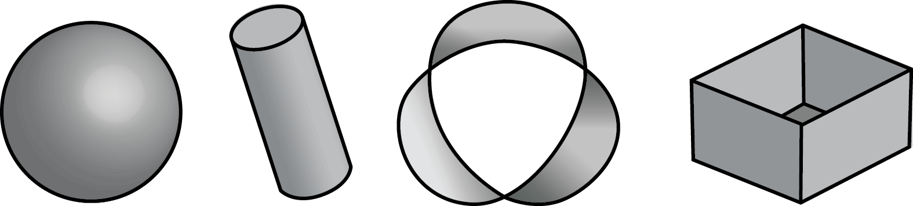

- Your teacher will give you some figures or objects. Sort them into polyhedra and non-polyhedra.
- What features helped you distinguish the polyhedra from the other figures?

Activity Synthesis
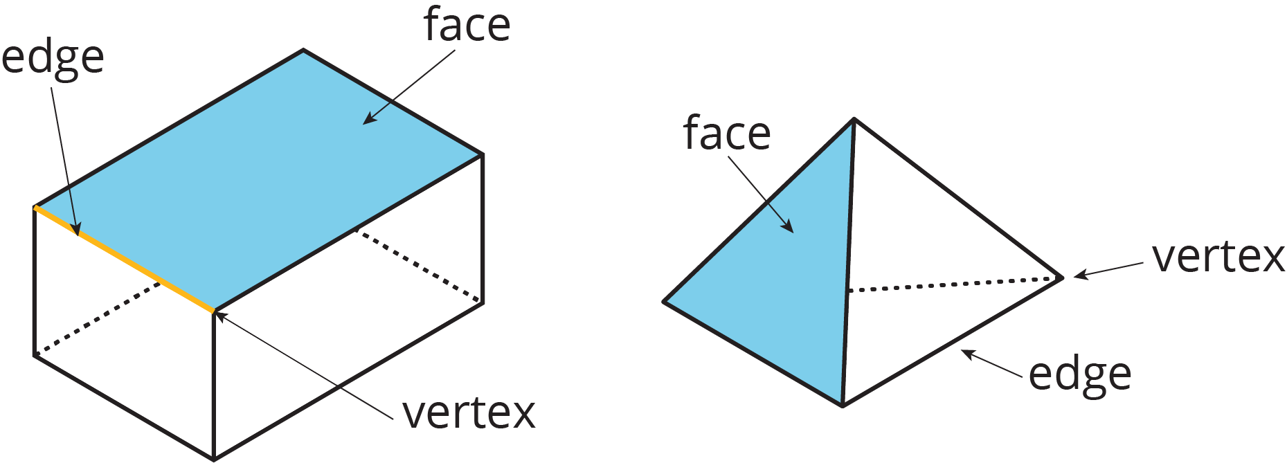

2 Prisms and Pyramids

Student Task Statement
- Here are some polyhedra called prisms.
- 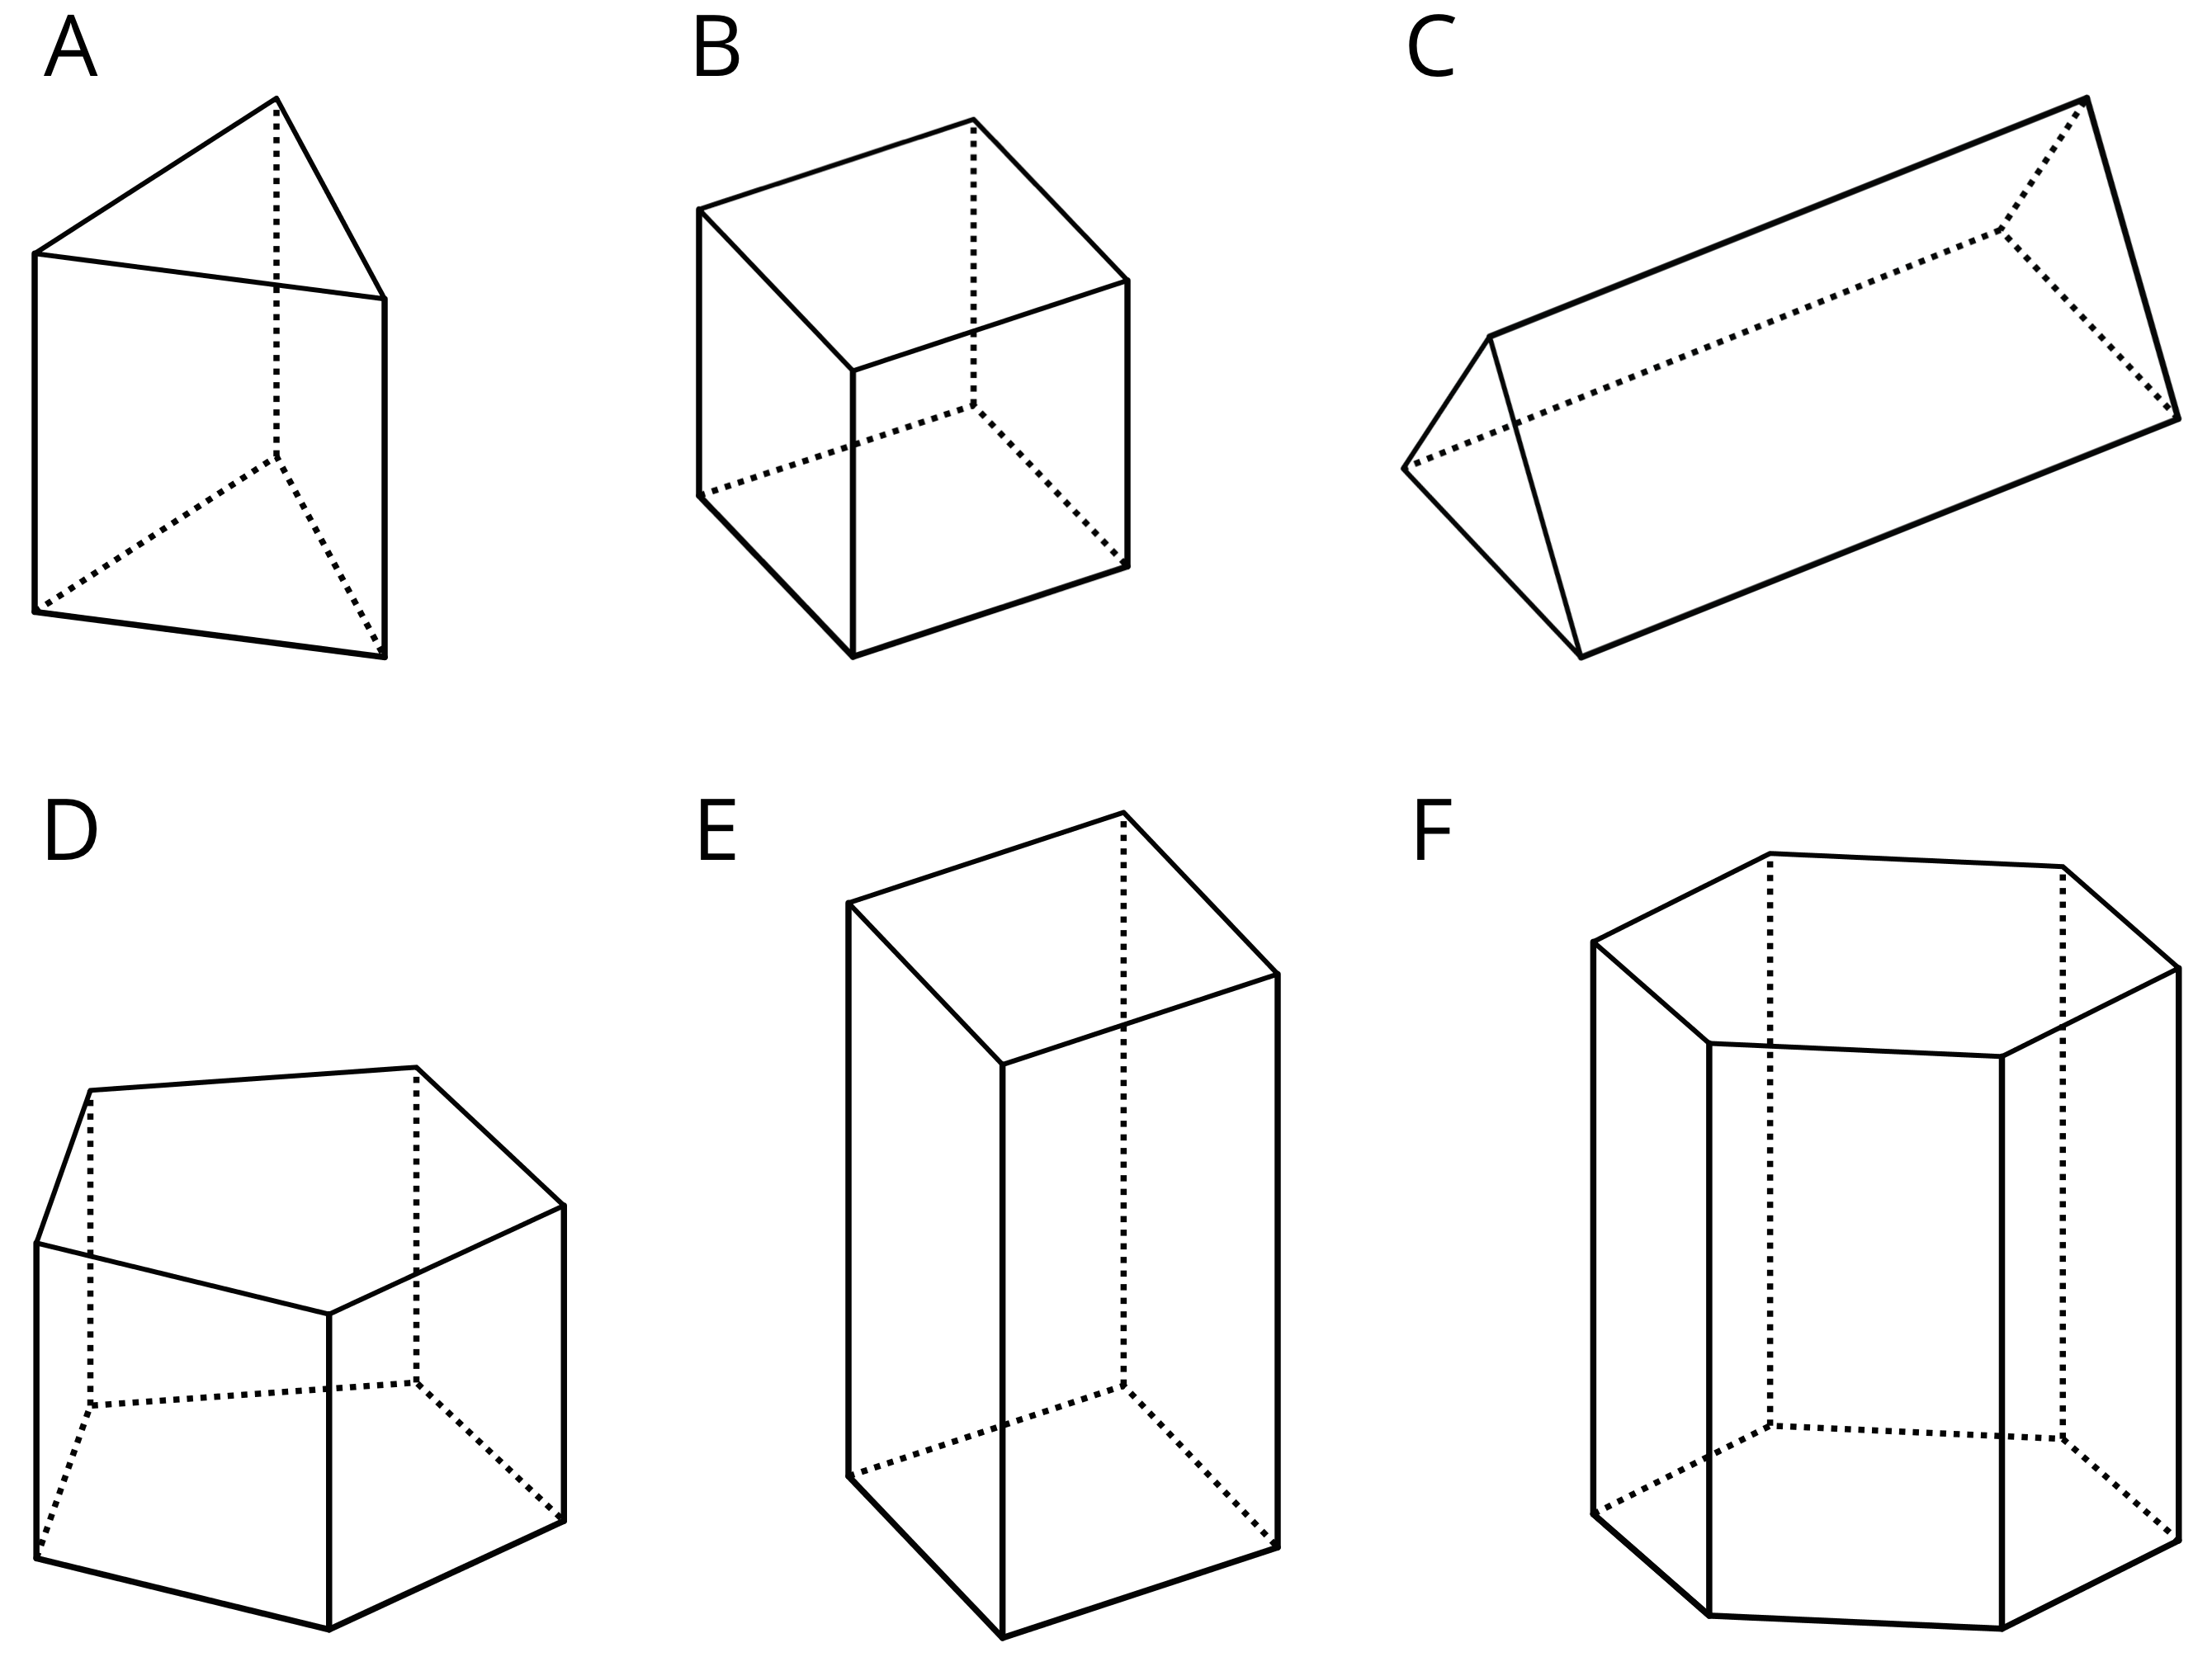
- Here are some polyhedra called pyramids.
- 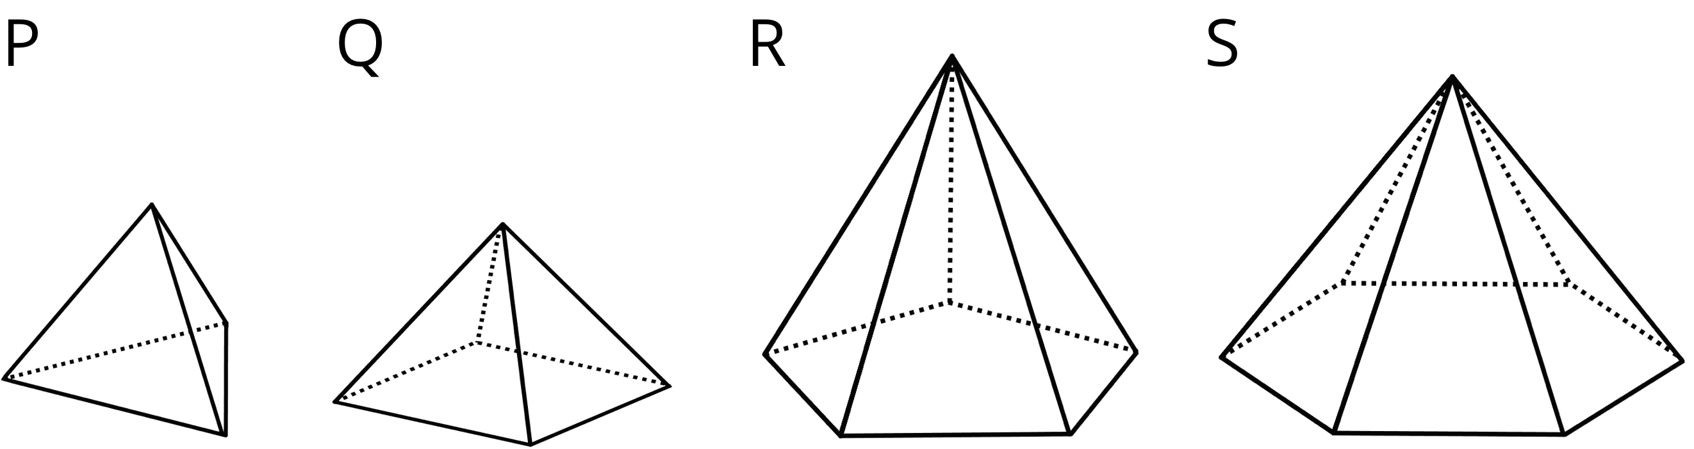
  - Look at the prisms. What are their characteristics or features?
  - Look at the pyramids. What are their characteristics or features?
- Which of these nets can be folded into Pyramid P? Select all that apply.
- 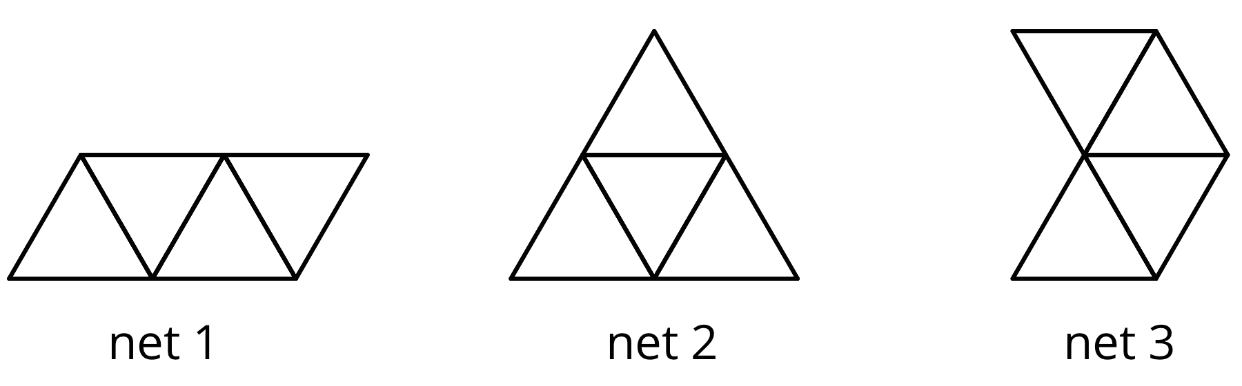
- Your teacher will give your group a set of polygons and assign a polyhedron.
  - Decide which polygons are needed to compose your assigned polyhedron. List the polygons and how many of each are needed.
  - Arrange the cut-outs into a net that, if taped and folded, can be assembled into the polyhedron. Sketch the net. If possible, find more than one way to arrange the polygons (show a different net for the same polyhedron).

3 Assembling Polyhedra (Optional)

Student Task Statement
- Your teacher will give you the net of a polyhedron. Cut out the net, and fold it along the edges to assemble a polyhedron. Tape or glue the flaps so that there are no unjoined edges.
- How many vertices, edges, and faces are in your polyhedron?
© CC BY Open Up Resources. Adaptations CC BY IM.

