Lesson 7: ¿Qué es un arreglo?

Standards Alignments
Addressing | 2.OA.B.2, 2.OA.C.3, 2.OA.C.4

Teacher-facing Learning Goals
- Describe an array as an arrangement of objects into rows with an equal number of objects in each row.

Student-facing Learning Goals
- Aprendamos sobre arreglos.

Lesson Purpose
The purpose of this lesson is for students to learn that an array is an arrangement of objects into rows with an equal number of objects in each row.
In the first section of this unit, students determined whether a group of objects was odd or even by organizing them in pairs or putting them into 2 equal groups.
In this lesson, students describe the structure of an array. They describe the number of objects in each row of an array and learn that the total number of objects in an array can be determined by finding the sum of the number of objects in each row. Although students may describe many features of the arrays in the lesson, the focus is on describing the rows of the array. They attend to the number of rows, the number in each row, and the total number of objects. In the next lesson, students will be encouraged to describe the columns of an array and will use this term in future lessons.

Access for:

Students with Disabilities
- Engagement (Activity 2)

Instructional Routines
MLR8 Discussion Supports (Activity 2), Which One Doesn’t Belong? (Warm-up)

Materials to Gather
- Counters: Activity 1, Activity 2

Lesson Timeline
Warm-up | 10 min
Activity 1 | 20 min
Activity 2 | 15 min
Lesson Synthesis | 10 min
Cool-down | 5 min

Teacher Reflection Question
In previous lessons, students explained why an a number of objects was even or odd using diagrams and by skip-counting by 2. In this lesson, how did students use the structure of arrays to make sense of skip counting and finding total amounts without counting by 1?

Cool-down
(to be completed at the end of the lesson) 5min
Cuenta las fichas

Standards Alignments
Addressing | 2.OA.C.4

Student-facing Task Statement
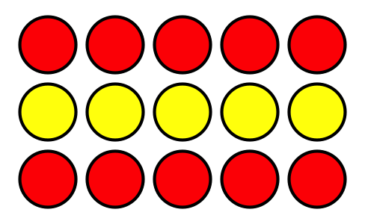
- ¿Cuántas filas hay en este arreglo?
- ¿Cuántas fichas hay en cada fila?
- ¿Cuántas fichas hay en total?

Student Responses
- There are 3 rows.
- There are 5 counters in each row.
- There are 15 counters in all.

