Lesson 2: Exploremos expresiones y sumas

Standards Alignments
Building On | K.CC.A.1
Addressing | 1.OA.C.5, 1.OA.C.6

Teacher-facing Learning Goals
- Write addition expressions within 10 based on images and add in a way that makes sense to them.

Student-facing Learning Goals
- Escribamos expresiones de suma y encontremos la suma de dos números.

Lesson Purpose
The purpose of this lesson is to write addition expressions within 10 and find the sums.
This lesson builds on the previous lesson as students were asked to determine the sum of two dot cubes. It also builds on the work of kindergarten, where students wrote addition expressions to represent images and situations. In this lesson, students match expressions to dot images before they are asked to write addition expressions (MP2). Students also continue to build their math language related to the sums, addition expressions, and mathematical community (MP6).
Math Community
Tell students they will have an opportunity to revise their math community ideas at the end of this lesson, so as they work today they should think about actions that may be missing from the current list.

Access for:

Students with Disabilities
- Engagement (Activity 2)

English Learners
- MLR8 (Activity 2)

Instructional Routines
Choral Count (Warm-up)

Materials to Gather
- 10-frames: Activity 2
- Two-color counters: Activity 2

Materials to Copy
- Check It Off Stage 1 Recording Sheet Grade 1, Spanish (groups of 1): Activity 2
- Number Cards (0-10) (groups of 2): Activity 2

Lesson Timeline
Warm-up | 10 min
Activity 1 | 15 min
Activity 2 | 20 min
Lesson Synthesis | 10 min
Cool-down | 5 min

Teacher Reflection Question
How are you facilitating the creation of a productive Mathematical Community? Where can you point to evidence of this for students to see?

Cool-down
(to be completed at the end of the lesson) 5min
Expresiones y sumas

Standards Alignments
Addressing | 1.OA.C.5, 1.OA.C.6

Student-facing Task Statement
- Escribe una expresión de suma que corresponda a las tarjetas de puntos.
- 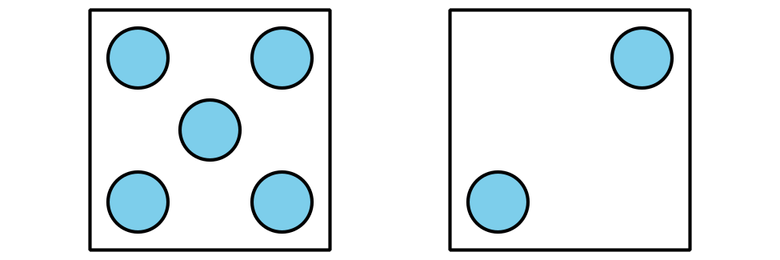
- __________ + __________
- Encuentra la suma de los números. __________

Student Responses
- $5+2$ or $2+5$
- 7

