Unit 2 Lesson 15: Congruence for Quadrilaterals

1 True or . . . Sometimes True?: Parallelograms (Warm up)

Student Task Statement
Given that $ABCD$ is a parallelogram.
- What must be true?
- What could possibly be true?
- What definitely can’t be true?

2 Floppy Quadrilaterals

Student Task Statement
Jada is learning about the triangle congruence theorems: Side-Side-Side, Angle-Side-Angle, and Side-Angle-Side. She wonders if there are any theorems like these for parallelograms.
- If 2 parallelograms have all 4 pairs of corresponding sides congruent, do the parallelograms have to be congruent? If so, explain your reasoning. If not, use the tools available to show that it doesn’t work.
- In parallelograms $ABCD$ and $EFGH$, segment $AB$ is congruent to segment $EF$, segment $BC$ is congruent to segment $FG$, and angle $ABC$ is congruent to angle $EFG$. Are $ABCD$ and $EFGH$ congruent? If so, explain your reasoning. If not, use the tools available to show that it doesn’t work.

Activity Synthesis
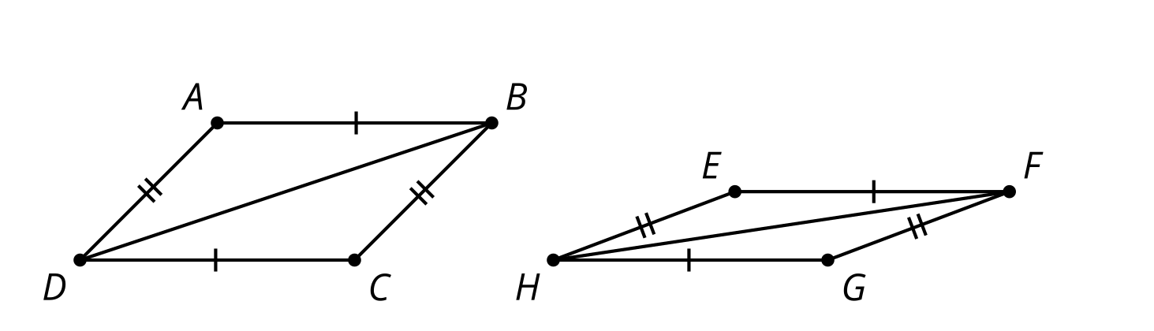

3 Make Your Own Congruence Theorem

Student Task Statement
Come up with another criteria that is enough to be sure that 2 parallelograms are congruent. Try to use as few measurements as you can. Be prepared to convince others that your shortcut works.
© CC BY 2019 by Illustrative Mathematics®

