Lesson 17 Practice Problems
- A landscape architect is designing a pool that has this top view:
- 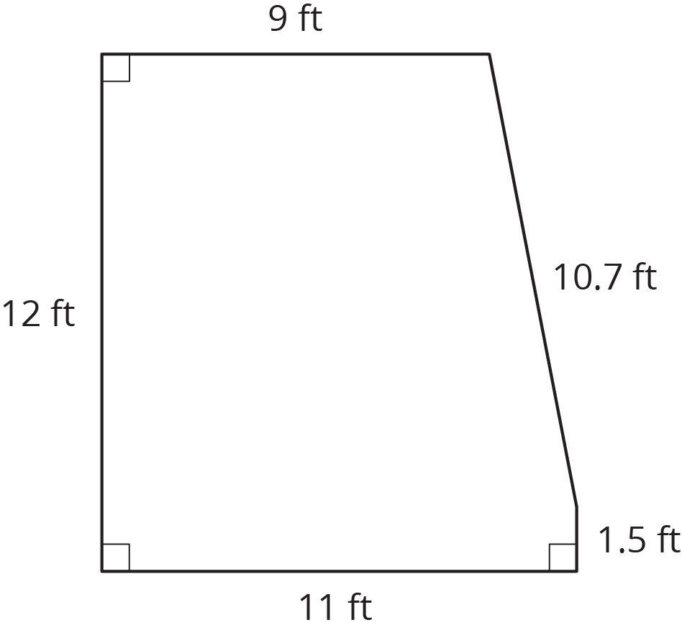
  - How much water will be needed to fill this pool 4 feet deep?
  - Before filling up the pool, it gets lined with a plastic liner. How much liner is needed for this pool?
  - Here are the prices for different amounts of plastic liner. How much will all the plastic liner for the pool cost?
- plastic liner (ft²) | - cost ($)
- 25 | - 3.75
- 50 | - 7.50
- 75 | - 11.25
- Shade in a base of the trapezoidal prism. (The base is not the same as the bottom.)
  - Find the area of the base you shaded.
  - Find the volume of this trapezoidal prism.
- 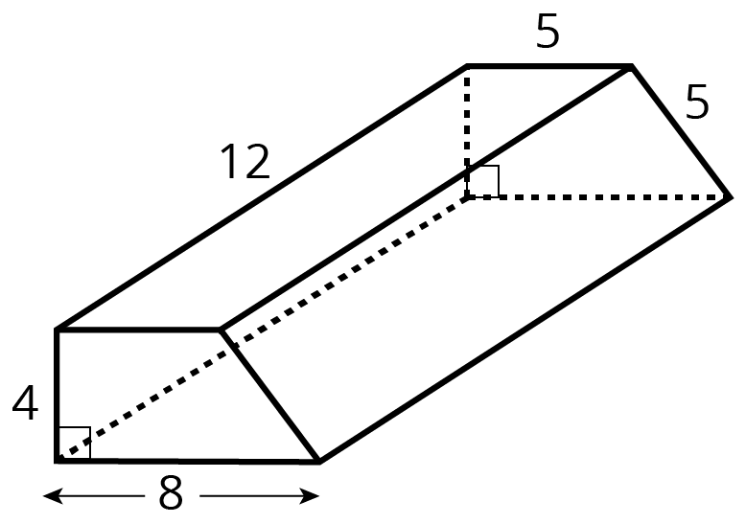
- (From Unit 6, Lesson 15.)
- Han draws a triangle with a ${50}^{∘}$ angle, a ${40}^{∘}$ angle, and a side of length 4 cm as shown. Can you draw a different triangle with the same conditions?
- 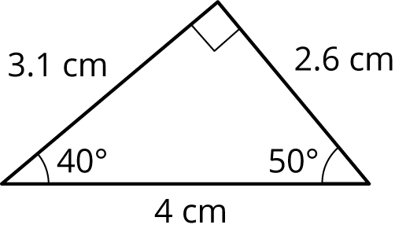

- (From Unit 1, Lesson 17.)
© CC BY Open Up Resources. Adaptations CC BY IM.

