Lesson 4 Practice Problems
- A bacteria population is tripling every hour. By what factor does the population change in $\frac{1}{2}$ hour? Select all that apply.
  - $\sqrt{3}$
  - $\frac{3}{2}$
  - $\sqrt[3]{2}$
  - $3^{\frac{1}{2}}$
  - $3^{2}$
- A medication has a half-life of 4 hours after it enters the bloodstream. A nurse administers a dose of 225 milligrams to a patient at noon.
  - Write an expression to represent the amount of medication, in milligrams, in the patient’s body at:
    - 1 p.m. on the same day
    - 7 p.m. on the same day
  - The expression $225⋅{\left(\frac{1}{2}\right)}^{\frac{5}{2}}$ represents the amount of medicine in the body some time after it is administered. What is that time?
- The number of employees in a company has been growing exponentially by 10% each year. By what factor does the number of employees change:
  - Each month?
  - Every 3 months?
  - Every 20 months?
- The value of a truck decreases exponentially since its purchase. The two points on the graph shows the truck’s initial value and its value a decade afterward.
- 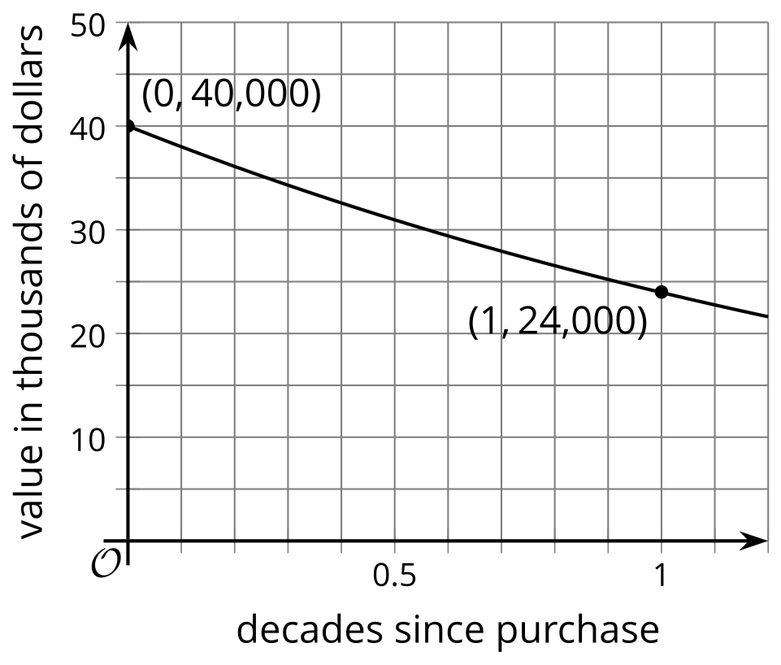
  - Express the car’s value, in dollars, as a function of time $d$, in decades, since purchase.
  - Write an expression to represent the car’s value 4 years after purchase.
  - By what factor is the value of the car changing each year? Show your reasoning.
- The value of a stock increases by 8% each year.
  - Explain why the stock value does not increase by 80% each decade.
  - Does the value increase by more or less than 80% each decade?
- Decide if each statement is true or false.
  - ${50}^{\frac{1}{2}}=25$
  - $\sqrt{30}$ is a solution to $y^{2}=30$.
  - ${243}^{\frac{1}{3}}$ is equivalent to $\sqrt[3]{243}$.
  - $\sqrt{20}$ is a solution to $m^{4}=20$.
- (From Unit 4, Lesson 3.)
- Lin is saving $300 per year in an account that pays 4.5% interest per year, compounded annually. About how much money will she have 20 years after she started?
  - $545.45
  - $3,748.78
  - $9,411.43
  - $1,124,634.54
- (From Unit 2, Lesson 26.)
© CC BY 2019 by Illustrative Mathematics®

