Unit 4 Lesson 7: Slopes of Segments

1 Math Talk: Evaluating Fractions (Warm up)

Student Task Statement
Evaluate mentally.
$\frac{102−96}{45−42}$
$\frac{\text{-}8−4}{6−2}$
$\frac{31−18}{5−10}$
$\frac{4−9}{12−18}$

2 Connect the Dots

Student Task Statement
- Find the slope of the line that connects the given points.
  - $\left(0,0\right)$ and $\left(3,2\right)$
  - $\left(4,2\right)$ and $\left(10,7\right)$
  - $\left(1,\text{-}2\right)$ and $\left(2,5\right)$
  - $\left(\text{-}3,4\right)$ and $\left(\text{-}5,\text{-}2\right)$
  - $\left(8,3\right)$ and $\left(10,\text{-}9\right)$
- For each pair of points, find the slope of the line that goes through the 2 points.
- 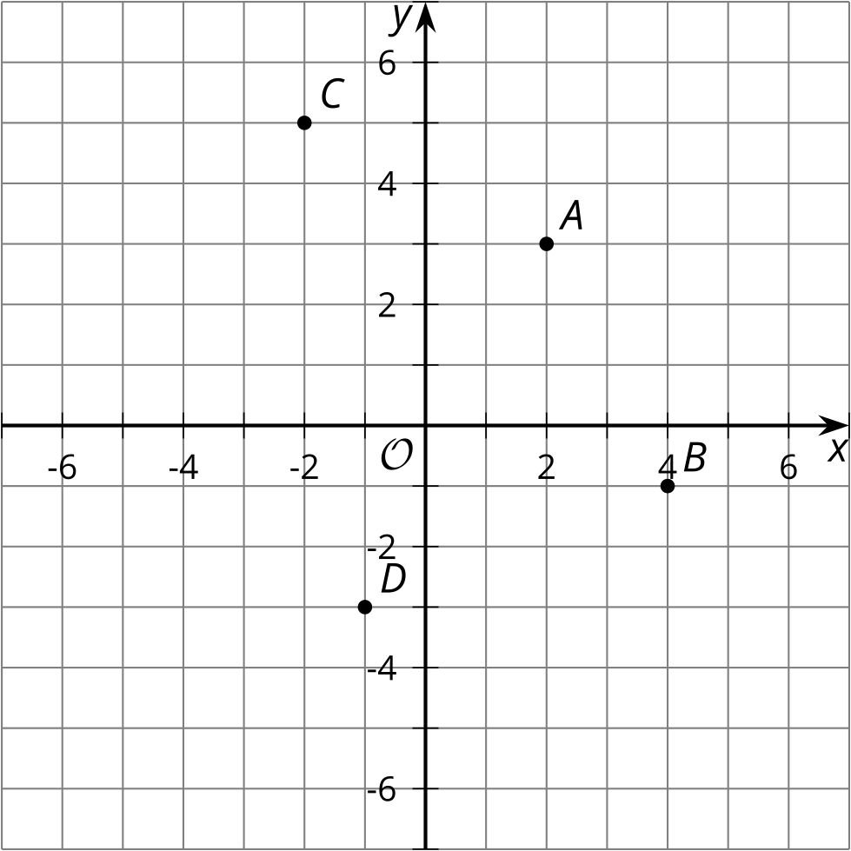
  - $A$ and $B$
  - $A$ and $D$
  - $B$ and $C$
  - $C$ and $D$

3 Ups and Downs

Student Task Statement
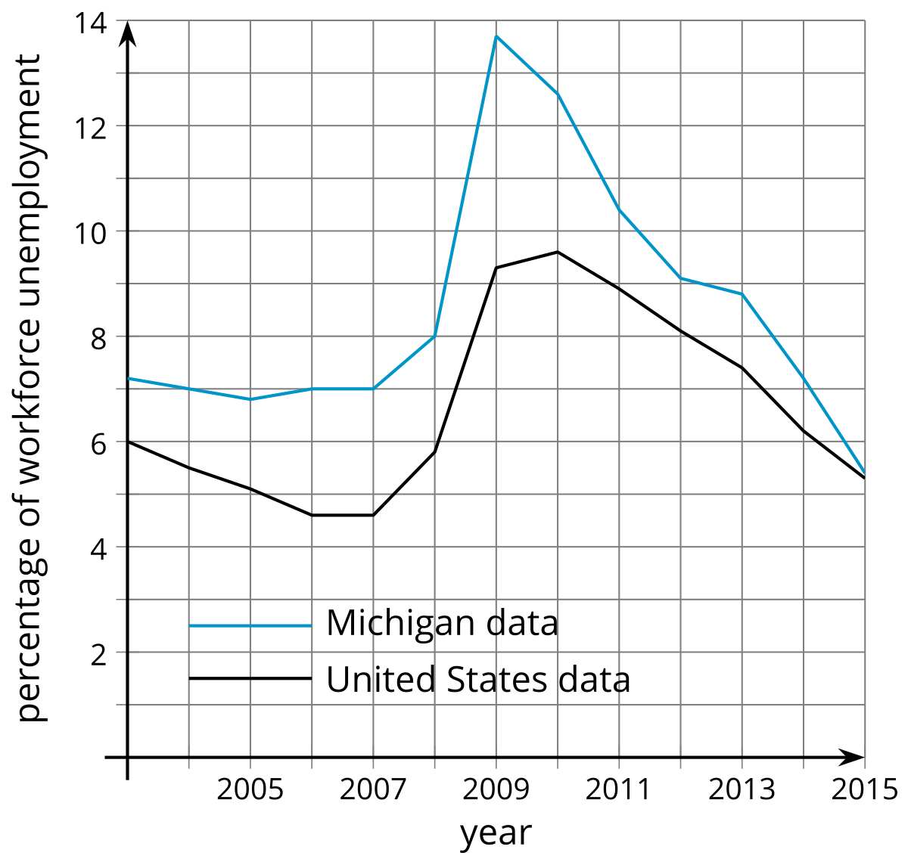
Year | Michigan | United States
2003 | 7.2 | 6
2004 | 7 | 5.5
2005 | 6.8 | 5.1
2006 | 7 | 4.6
2007 | 7 | 4.6
2008 | 8 | 5.8
2009 | 13.7 | 9.3
2010 | 12.6 | 9.6
2011 | 10.4 | 8.9
2012 | 9.1 | 8.1
2013 | 8.8 | 7.4
2014 | 7.2 | 6.2
2015 | 5.4 | 5.3
- What do the slopes of the segments mean?
- Find the slope of the segment between 2004 and 2005 for unemployment in Michigan.
- Between what 2 years is the slope for the United States unemployment percentage greatest?
  - Explain your reasoning using the graph.
  - Explain your reasoning using the table.
- Between what 2 years is the slope for the United States unemployment percentage the least? Explain or show your reasoning.
© CC BY 2019 by Illustrative Mathematics®

