Lesson 26: Painting a Room
Let’s see what it takes to paint a room.

26.1: Getting Ready to Paint
What are some tools that are helpful when painting a room?

26.2: How Much It Costs to Paint
Here is the floor plan for a bedroom:
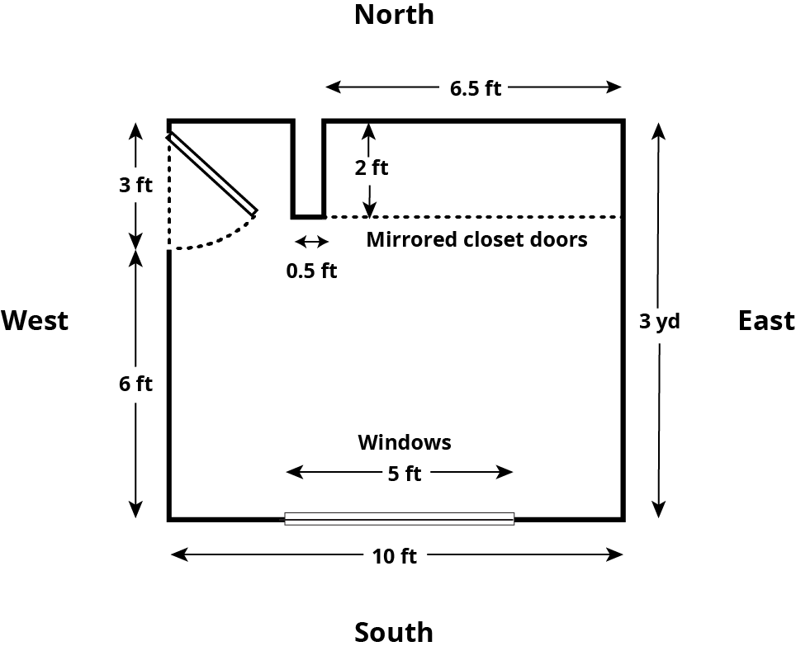
Imagine you are planning to repaint all the walls in this room, including inside the closet.
- The east wall is 3 yards long.
- The south wall is 10 feet long but has a window, 5 feet by 3 feet, that does not need to be painted.
- The west wall is 3 yards long but has a door, 7 feet tall and 3 feet wide, that does not need to be painted.
- The north wall includes a closet, 6.5 feet wide, with floor-to-ceiling mirrored doors that do not need to be painted. There is, however, a smaller wall between the west wall and the closet that does need to be painted on all sides. The wall is 0.5 feet wide and extends 2 feet into the room.
- The ceiling in this room is 8 feet high.
- All of the corners are right angles.
- If you paint all the walls in the room, how many square feet do you need to cover?
- An advertisement about the paint that you want to use reads: “Just 2 quarts covers 175 square feet!” If you need to apply two coats of paint on all the walls, how much paint do you need to buy?
- Paint can only be purchased in 1-quart, 1-gallon, and 5-gallon containers. How much will all supplies for the project cost if the cans of paint cost $10.90 for a quart, $34.90 for a gallon, and $165.00 for 5 gallons?
- You have a coupon for 20% off all quart-sized paint cans. How does that affect the cost of the project?

26.3: How Long It Takes to Paint
After buying the supplies, you start painting the east wall. It takes you 96 minutes to put two coats of paint on that wall (not including a lunch break between the two coats).
- Your friend stops by to see how you are doing and comments that you are 25% finished with the painting. Are they correct?
- Your friend offers to help you with the rest of the painting. It takes the two of you 150 more minutes of painting time to finish the entire room. How much time did your friend save you?
© CC BY Open Up Resources. Adaptations CC BY IM.

