Lesson 19: Dividing Numbers that Result in Decimals
Let’s find quotients that are not whole numbers.

19.1: Keep Dividing
Mai used base-ten diagrams to calculate $62÷5$. She started by representing 62.
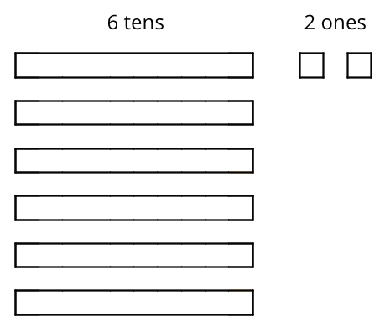
She then made 5 groups, each with 1 ten. There was 1 ten left. She unbundled it into 10 ones and distributed the ones across the 5 groups.
Here is Mai’s diagram for $62÷5$.
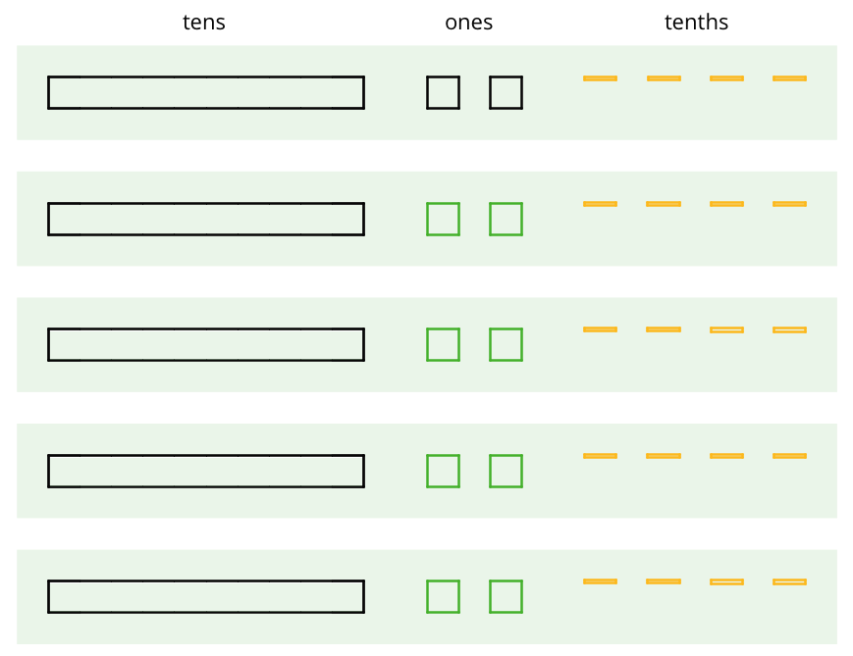
Discuss these questions with a partner and write down your answers:
- Mai should have a total of 12 ones, but her diagram shows only 10. Why?
- She did not originally have tenths, but in her diagram each group has 4 tenths. Why?
- What value has Mai found for $62÷5$? Explain your reasoning.

19.2: Using Long Division to Calculate Quotients
Here is how Lin calculated $62÷5$.
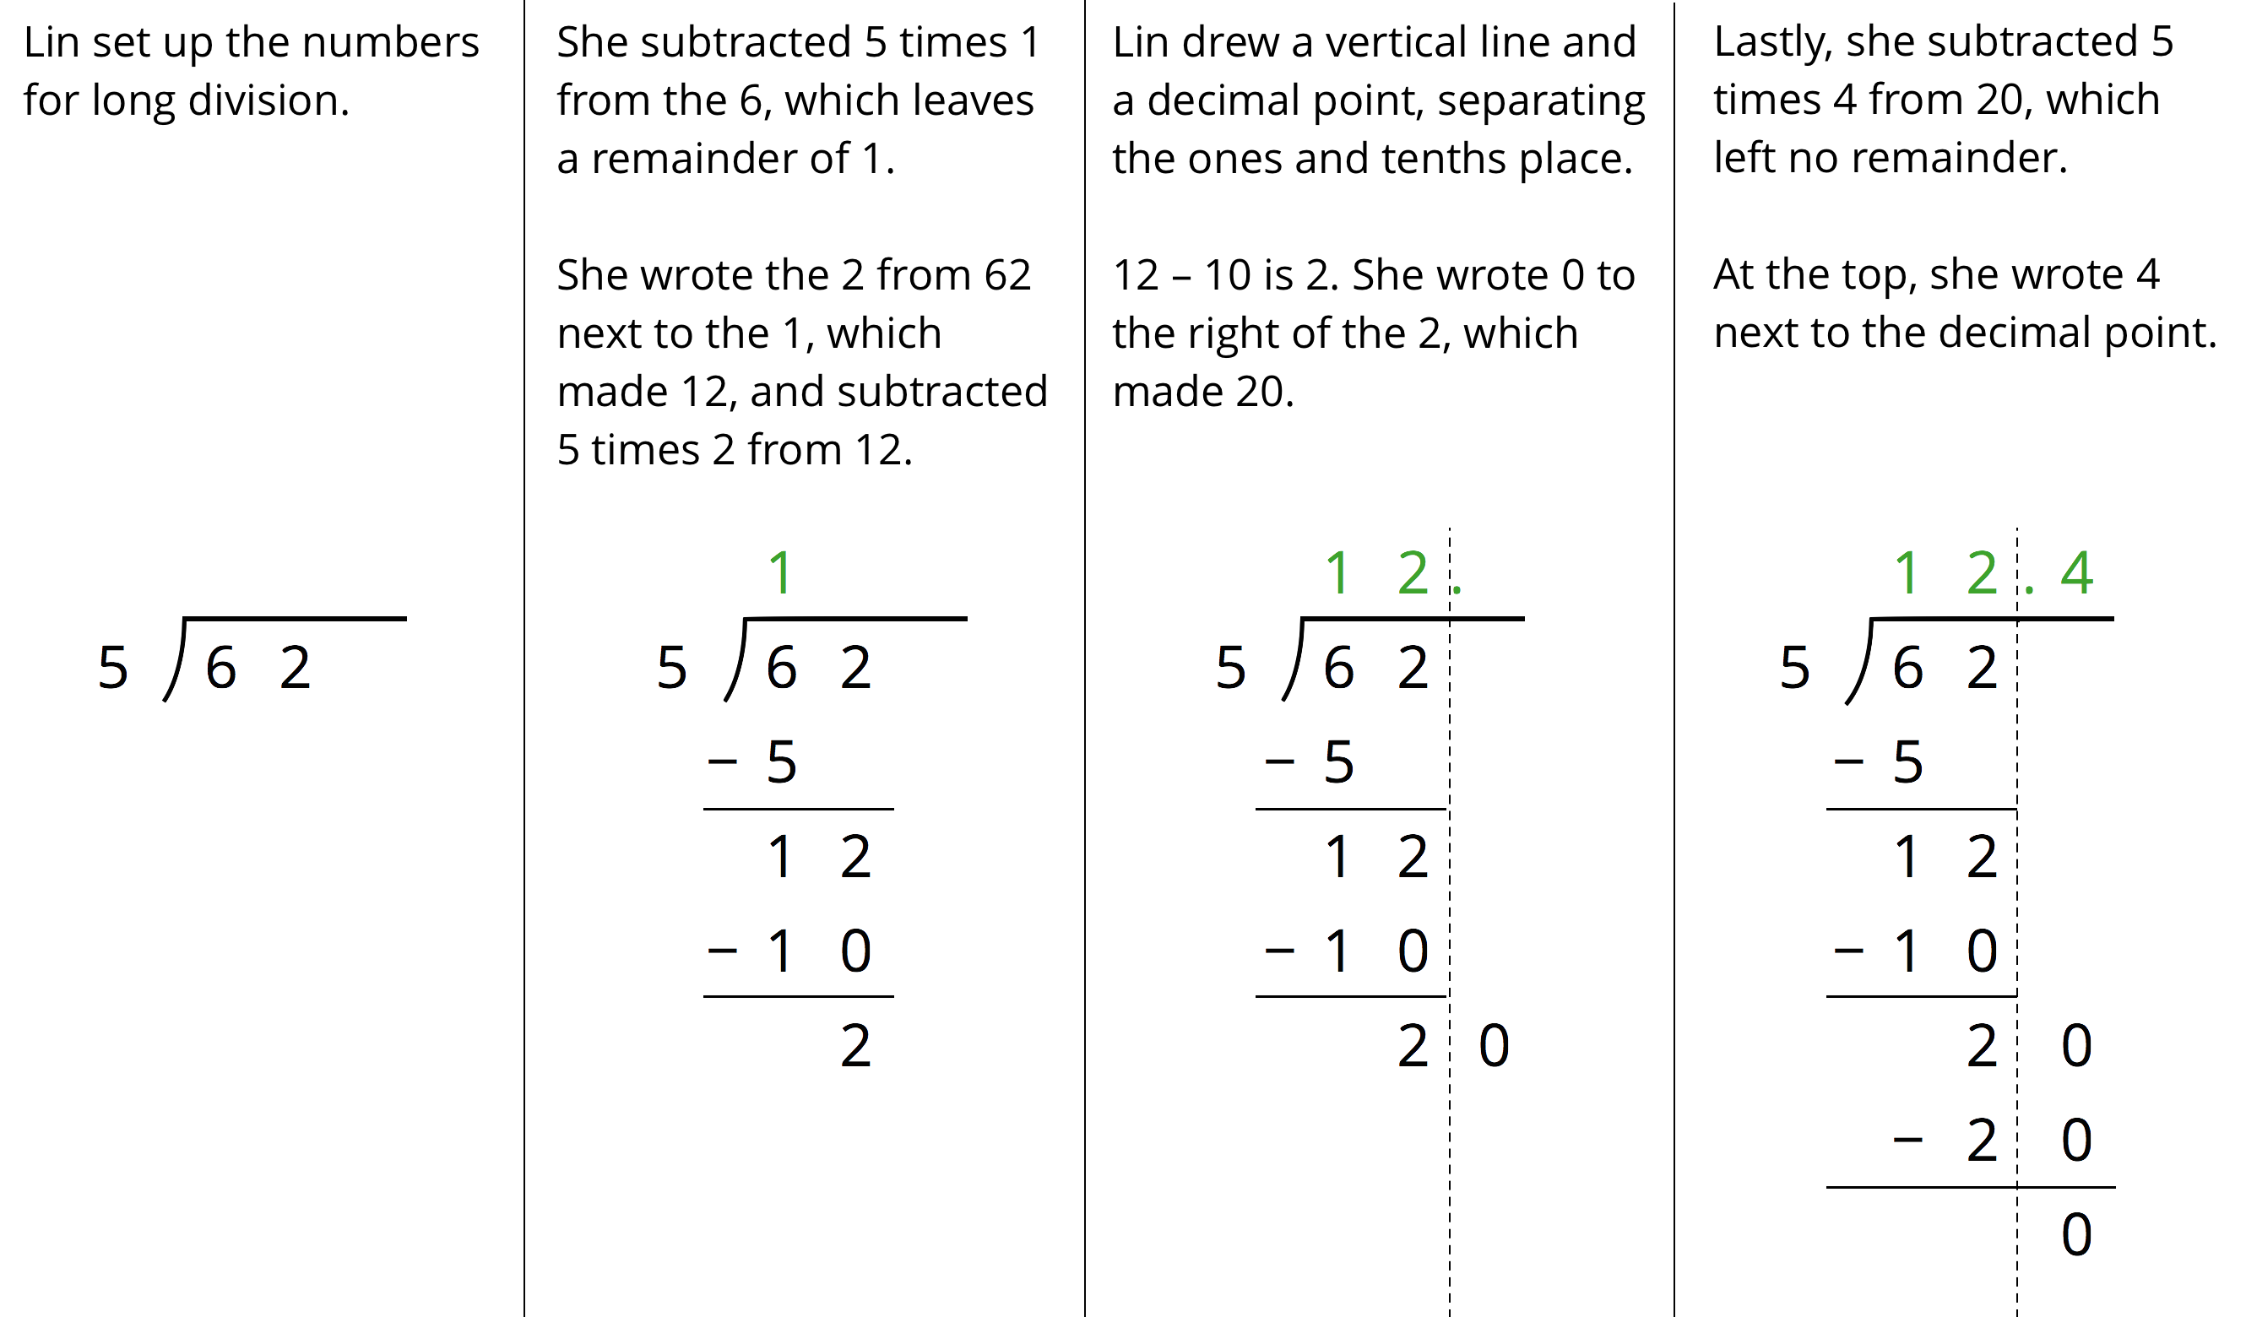
- Discuss with your partner:
  - Lin put a 0 after the remainder of 2. Why? Why does this 0 not change the value of the quotient?
  - Lin subtracted 5 groups of 4 from 20. What value does the 4 in the quotient represent?
  - What value did Lin find for $62÷5$?
- Use long division to find the value of each expression. Then pause so your teacher can review your work.
  - $126÷8$
  - $90÷12$
- Use long division to show that:
  - $5÷4$, or $\frac{5}{4}$, is 1.25.
  - $4÷5$, or $\frac{4}{5}$, is 0.8.
  - $1÷8$, or $\frac{1}{8}$, is 0.125.
  - $1÷25$, or $\frac{1}{25}$, is 0.04.
- Noah said we cannot use long division to calculate $10÷3$ because there will always be a remainder.
  - What do you think Noah meant by “there will always be a remainder”?
  - Do you agree with him? Explain your reasoning.

19.3: Using Diagrams to Represent Division
To find $53.8÷4$ using diagrams, Elena began by representing 53.8.
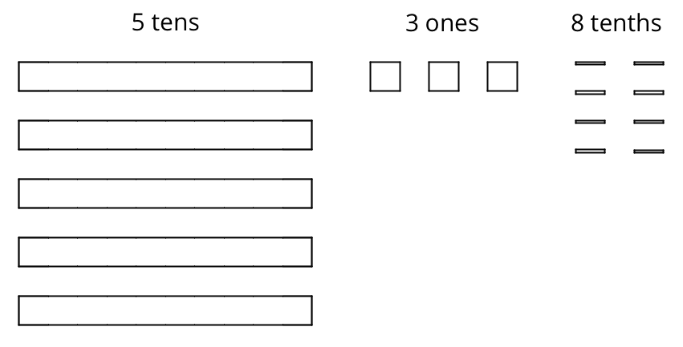
She placed 1 ten into each group, unbundled the remaining 1 ten into 10 ones, and went on distributing the units.
This diagram shows Elena’s initial placement of the units and the unbundling of 1 ten.
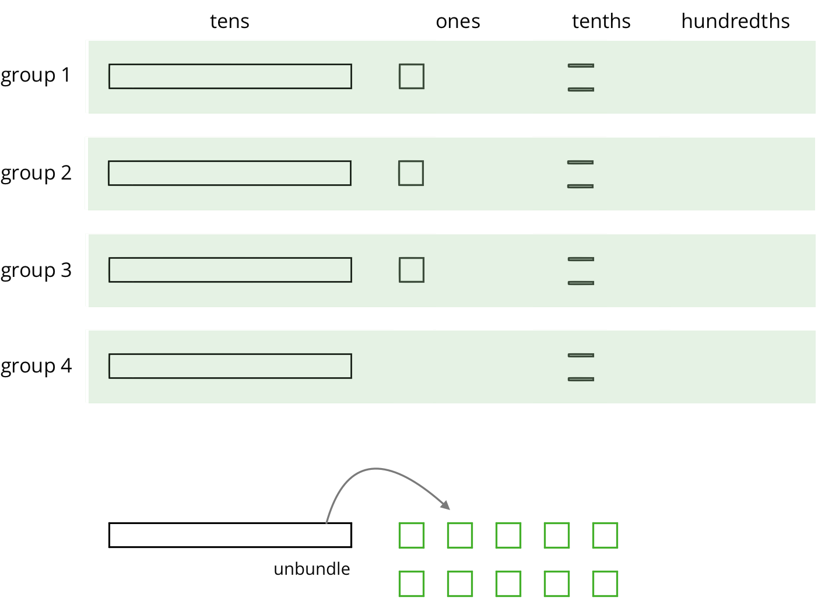
- Complete the diagram by continuing the division process. How would you use the available units to make 4 equal groups?
- As the units get placed into groups, show them accordingly and cross out those pieces from the bottom. If you unbundle a unit, draw the resulting pieces.
- What value did you find for $53.8÷4$? Be prepared to explain your reasoning.
- Use long division to find $53.8÷4$. Check your answer by multiplying it by the divisor 4.
- Use long division to find $77.4÷5$. If you get stuck, you can draw diagrams or use another method.

Are you ready for more?
A distant, magical land uses jewels for their bartering system. The jewels are valued and ranked in order of their rarity. Each jewel is worth 3 times the jewel immediately below it in the ranking. The ranking is red, orange, yellow, green, blue, indigo, and violet. So a red jewel is worth 3 orange jewels, a green jewel is worth 3 blue jewels, and so on.
A group of 4 craftsmen are paid 1 of each jewel. If they split the jewels evenly amongst themselves, which jewels does each craftsman get?

Lesson 19 Summary
Dividing a whole number by another whole number does not always produce a whole-number quotient. Let’s look at $86÷4$, which we can think of as dividing 86 into 4 equal groups.
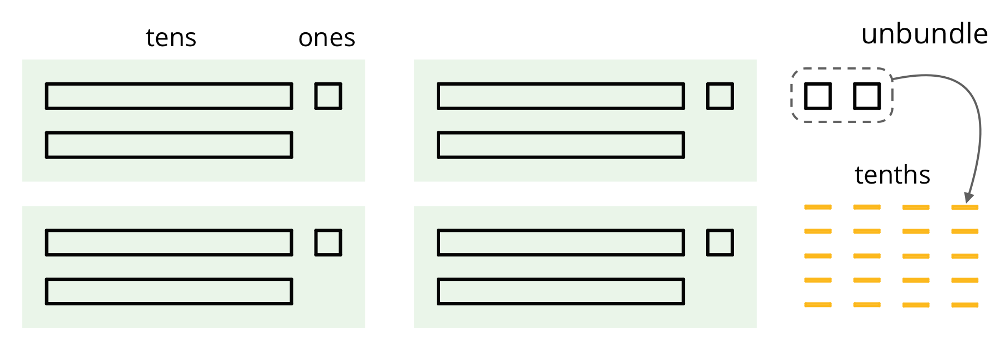
We can see in the base-ten diagram that there are 4 groups of 21 in 86 with 2 ones left over. To find the quotient, we need to distribute the 2 ones into the 4 groups. To do this, we can unbundle or decompose the 2 ones into 20 tenths, which enables us to put 5 tenths in each group.
Once the 20 tenths are distributed, each group will have 2 tens, 1 one, and 5 tenths, so $86÷4=21.5$.
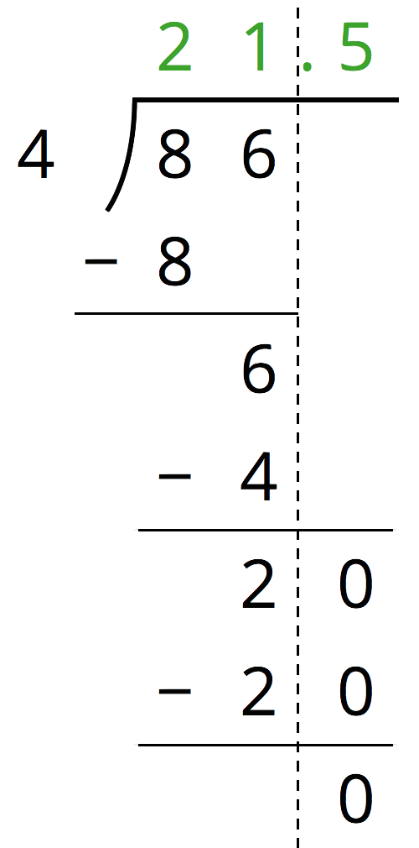
We can also calculate $86÷4$ using long division.
The calculation shows that, after removing 4 groups of 21, there are 2 ones remaining. We can continue dividing by writing a 0 to the right of the 2 and thinking of that remainder as 20 tenths, which can then be divided into 4 groups.
To show that the quotient we are working with now is in the tenth place, we put a decimal point to the right of the 1 (which is in the ones place) at the top. It may also be helpful to draw a vertical line to separate the ones and the tenths.
There are 4 groups of 5 tenths in 20 tenths, so we write 5 in the tenths place at the top. The calculation likewise shows $86÷4=21.5$.
© CC BY Open Up Resources. Adaptations CC BY IM.

