Lesson 14: Coordinate Proof
- Let’s use coordinates to prove theorems and to compute perimeter and area.

14.1: Which One Doesn’t Belong: Coordinate Quadrilaterals
Which one doesn’t belong?

A
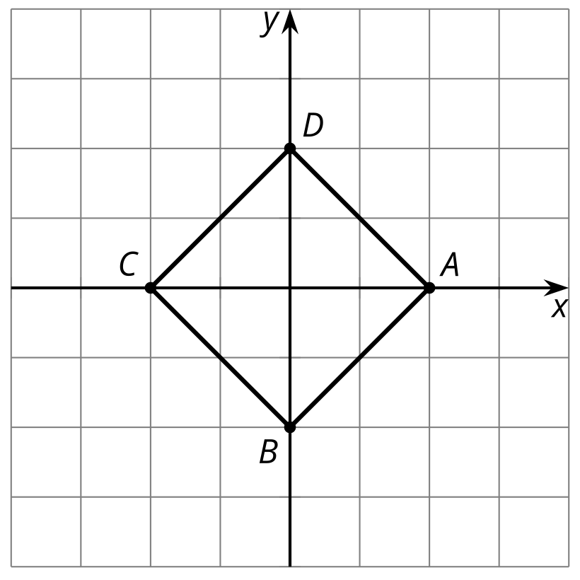

B
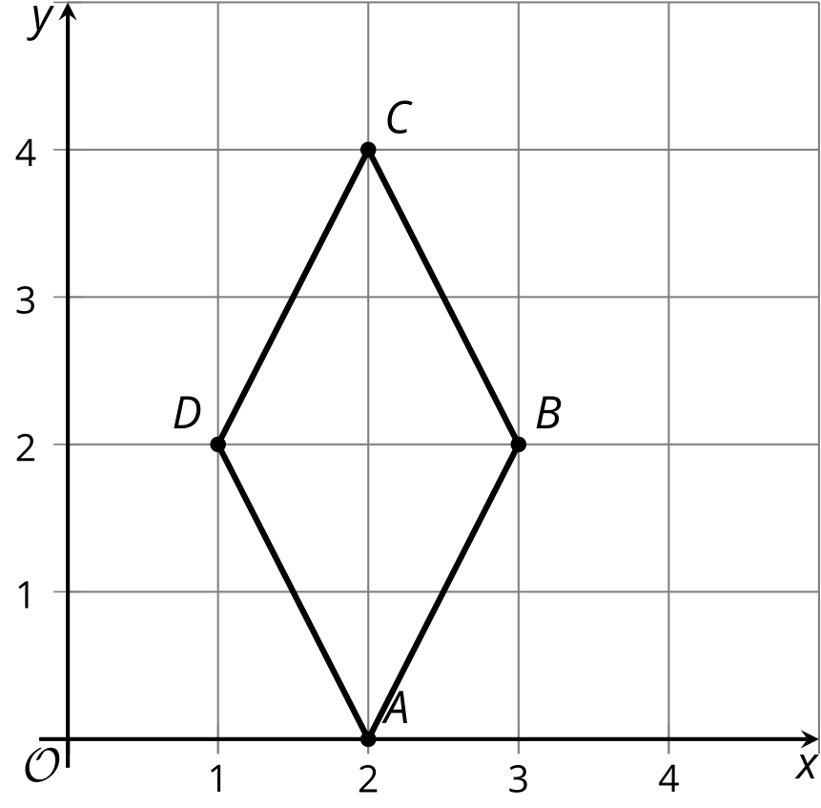

C
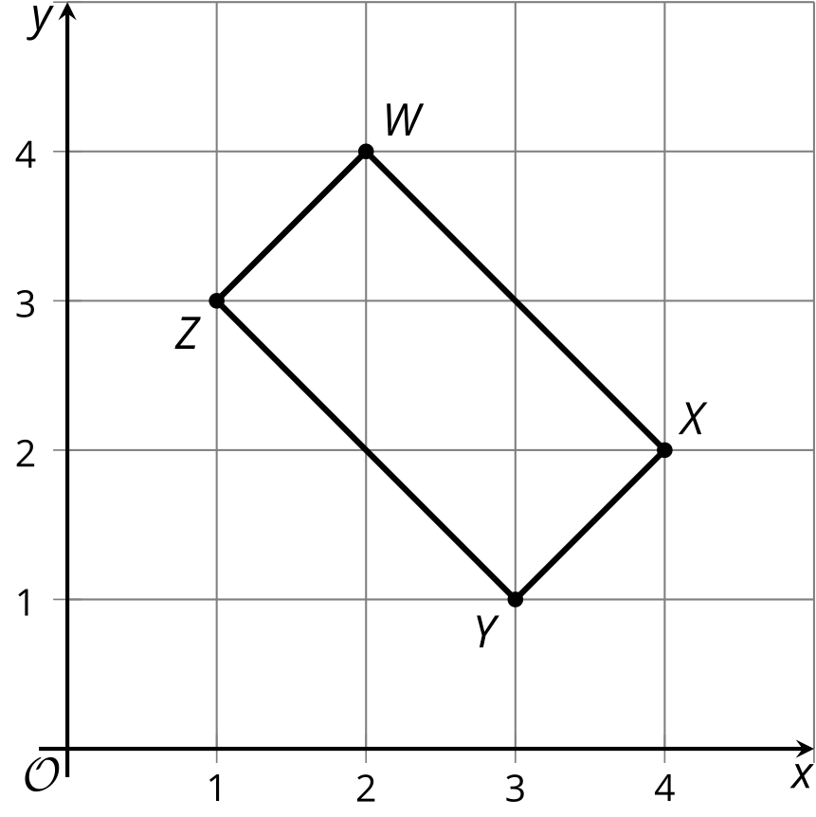

D
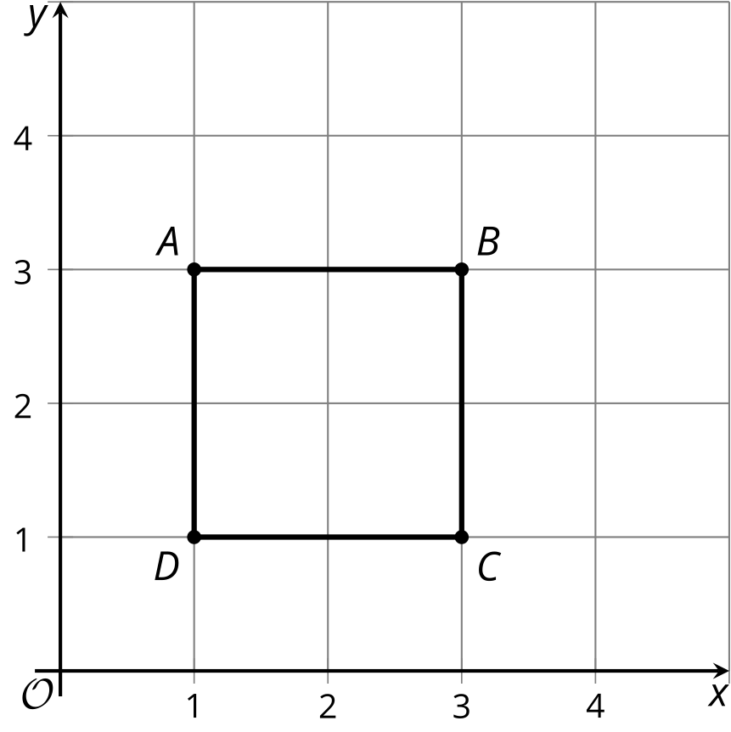

14.2: Name This Quadrilateral
A quadrilateral has vertices $\left(0,0\right),\left(4,3\right),\left(13,\text{-}9\right),$ and $\left(9,\text{-}12\right)$.
- What type of quadrilateral is it? Explain or show your reasoning.
- Find the perimeter of this quadrilateral.
- Find the area of this quadrilateral.

Are you ready for more?
- A parallelogram has vertices $\left(0,0\right),\left(5,1\right),\left(2,3\right)$, and $\left(7,4\right)$. Find the area of this parallelogram.
- Consider a general parallelogram with vertices $\left(0,0\right),\left(a,b\right),\left(c,d\right),$ and $\left(a+c,b+d\right),$ where $a,b,c,$ and $d$ are positive. Write an expression for its area in terms of $a,b,c,$ and $d$.

14.3: Circular Logic
The image shows a circle with several points plotted on the circle.
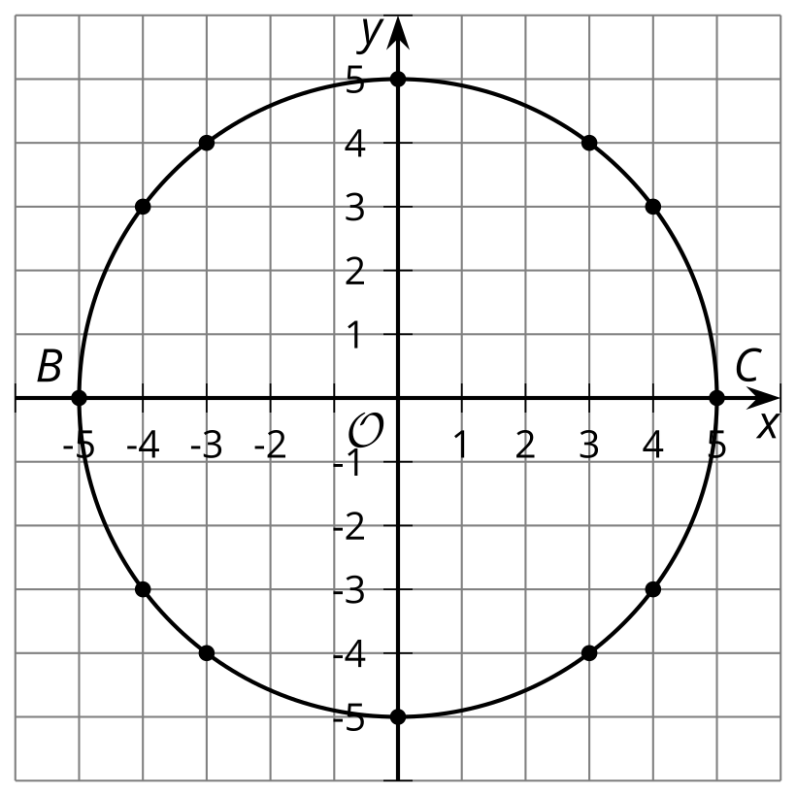
- What kind of segment is $BC$ in reference to the circle?
- Choose one of the plotted points on the circle and call it $D$. Each student in the group should choose a different point. Draw segments $BD$ and $DC$. What does the measure of angle $BDC$ appear to be?
- Calculate the slopes of segments $BD$ and $DC$. What do your results tell you?
- Compare your results to those of others in your group. What did they find?
- Based on your group’s results, write a conjecture that captures what you are seeing.

Lesson 14 Summary
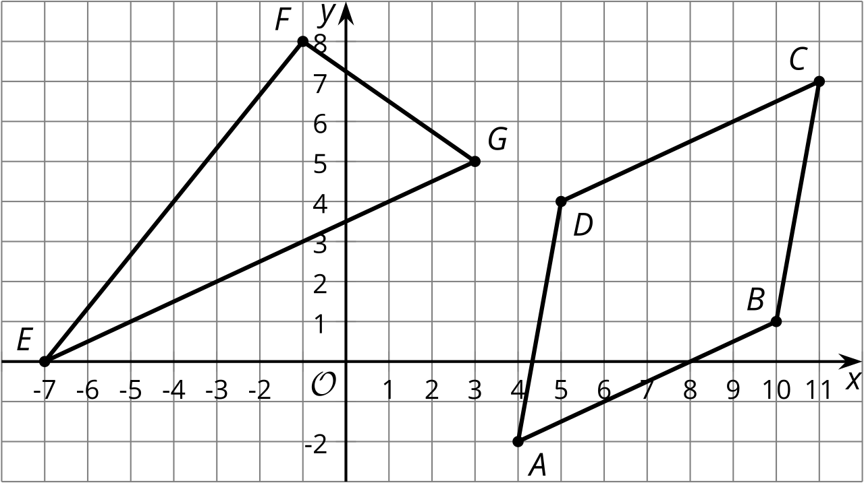
What kind of shape is quadrilateral $ABCD$? It looks like it might be a rhombus. To check, we can calculate the length of each side. Using the Pythagorean Theorem, we find that the lengths of segments $AB$ and $CD$ are $\sqrt{45}$ units, and the lengths of segments $BC$ and $DA$ are $\sqrt{37}$ units. All side lengths are between 6 and 7 units long, but they are not exactly the same. So our calculations show that $ABCD$ is not really a rhombus, even though at first glance we might think it is.
We did just show that two pairs of opposite sides of $ABCD$ are congruent. This means that $ABCD$ must be a parallelogram. Checking slopes confirms this. Sides $AB$ and $CD$ each have slope $\frac{1}{2}$. Sides $BC$ and $DA$ each have slope 6.
Can we find the area of triangle $EFG$? That seems tricky, because we don’t know the height of the triangle using $EG$ as the base. However, angle $EFG$ seems like it could be a right angle. In that case, we could use sides $EF$ and $FG$ as the base and height.
To see if $EFG$ is a right angle, we can calculate slopes. The slope of $EF$ is $\frac{8}{6}$ or $\frac{4}{3}$, and the slope of $FG$ is $\text{-}\frac{3}{4}$. Since the slopes are opposite reciprocals, the segments are perpendicular and angle $EFG$ is indeed a right angle. This means that we can think of $EF$ as the base and $FG$ as the height. The length of $EF$ is 10 units and the length of $FG$ is 5 units. So the area of triangle $EFG$ is 25 square units because $\frac{1}{2}⋅10⋅5=25$.
© CC BY 2019 by Illustrative Mathematics®

