Lesson 15 Practice Problems
- You find a crystal in the shape of a prism. Find the volume of the crystal.
- The point $B$ is directly underneath point $E$, and the following lengths are known:
  - From $A$ to $B$: 2 mm
  - From $B$ to $C$: 3 mm
  - From $A$ to $F$: 6 mm
  - From $B$ to $E$: 10 mm
  - From $C$ to $D$: 7 mm
  - From $A$ to $G$: 4 mm
- 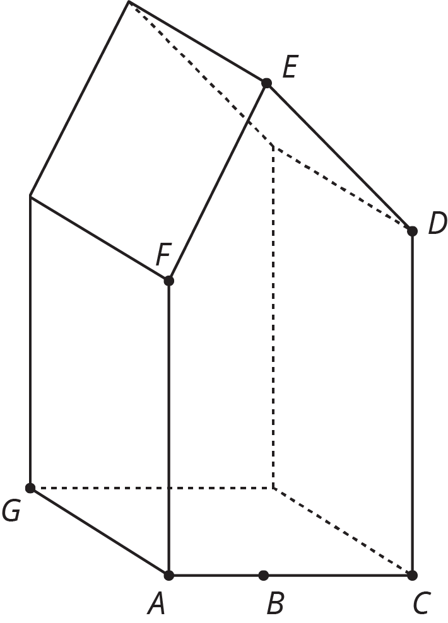

- A rectangular prism with dimensions 5 inches by 13 inches by 10 inches was cut to leave a piece as shown in the image. What is the volume of this piece? What is the volume of the other piece not pictured?
- 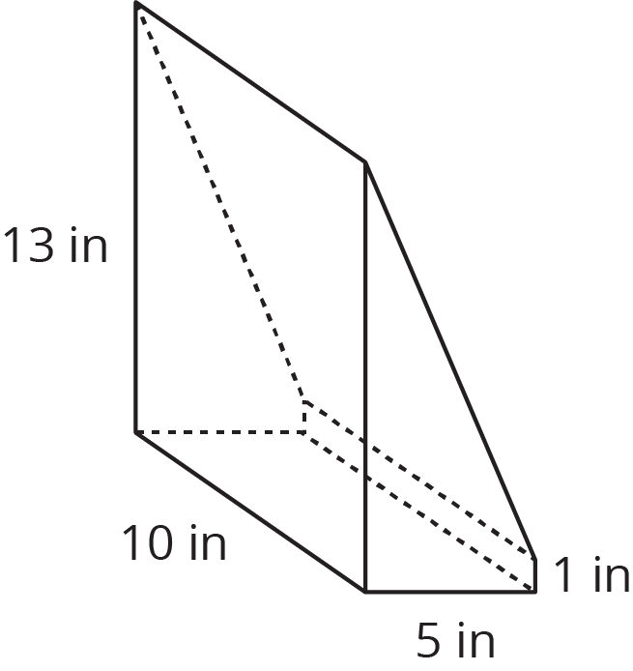
- A triangle has one side that is 7 cm long and another side that is 3 cm long.
  - Sketch this triangle and label your sketch with the given measures. (If you are stuck, try using a compass or cutting some straws to these two lengths.)
  - Draw one more triangle with these measures that is not identical to your first triangle.
  - Explain how you can tell they are not identical.
- (From Unit 1, Lesson 17.)
- Select all equations that represent a relationship between angles in the figure.
- 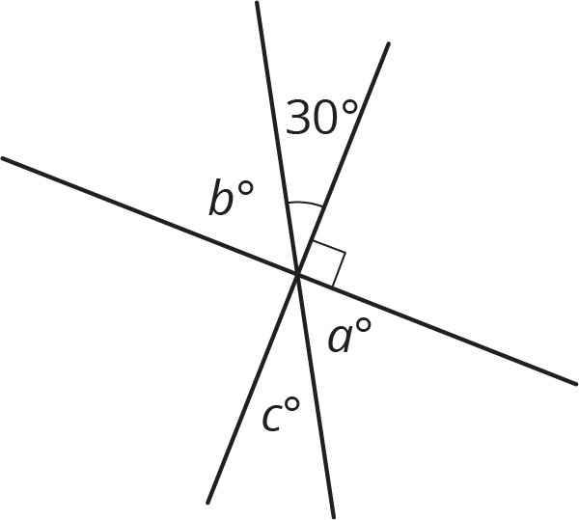
  - $90−30=b$
  - $30+b=a+c$
  - $a+c+30+b=180$
  - $a=30$
  - $a=c=30$
  - $90+a+c=180$
- (From Unit 1, Lesson 12.)
© CC BY Open Up Resources. Adaptations CC BY IM.

