Lesson 18: Using Long Division
Let’s divide whole numbers.

18.1: Using Base-Ten Diagrams to Calculate Quotients
Elena used base-ten diagrams to find $372÷3$. She started by representing 372.
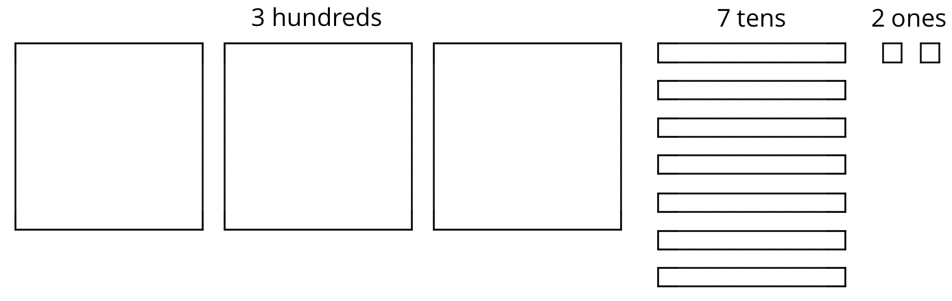
She made 3 groups, each with 1 hundred. Then, she put the tens and ones in each of the 3 groups. Here is her diagram for $372÷3$.
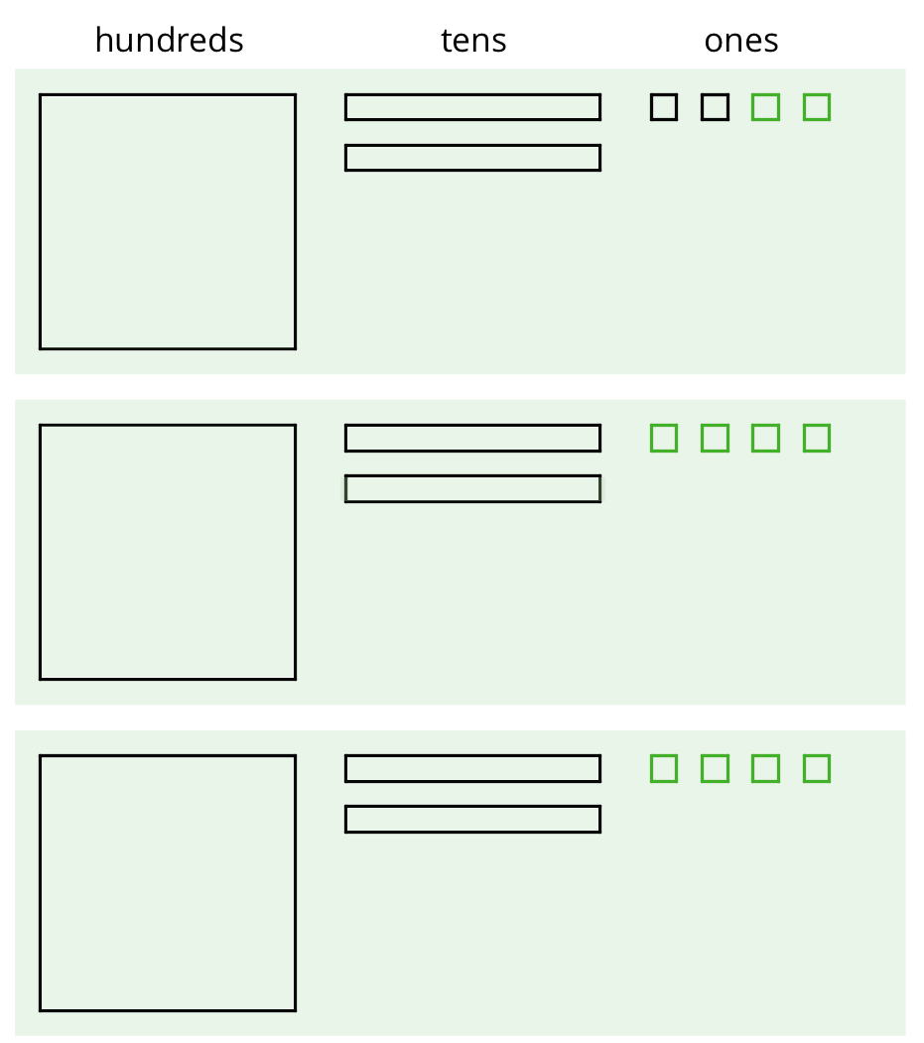
Discuss with a partner:
- Elena’s diagram for 372 has 7 tens. The one for $372÷3$ has only 6 tens. Why?
- Where did the extra ones (small squares) come from?

18.2: Using the Partial Quotients Method to Calculate Quotients
- Andre calculated $657÷3$ using a method that was different from Elena’s.
- 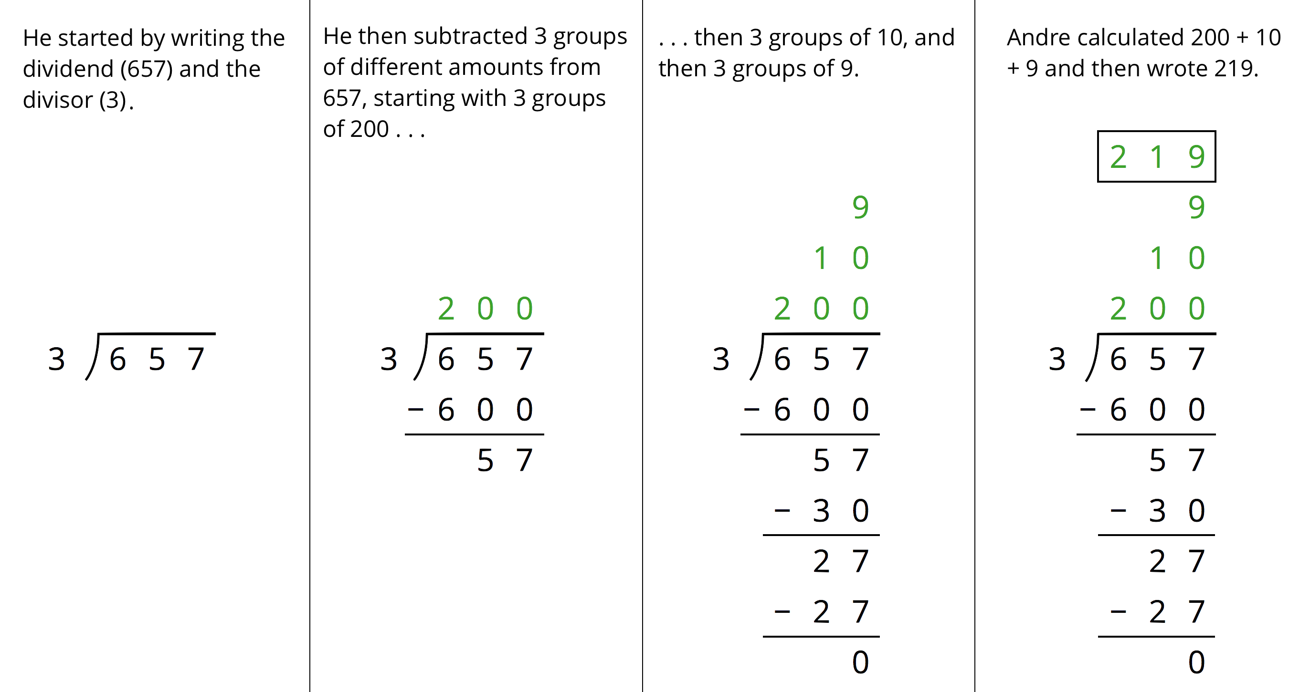
  - Andre subtracted 600 from 657. What does the 600 represent?
  - Andre wrote 10 above the 200, and then subtracted 30 from 57. How is the 30 related to the 10?
  - What do the numbers 200, 10, and 9 represent?
  - What is the meaning of the 0 at the bottom of Andre’s work?
- How might Andre calculate $896÷4$? Explain or show your reasoning.

18.3: Lin Uses Long Division
Lin has a method of calculating quotients that is different from Elena’s method and Andre’s method. Here is how she found the quotient of $657÷3$:
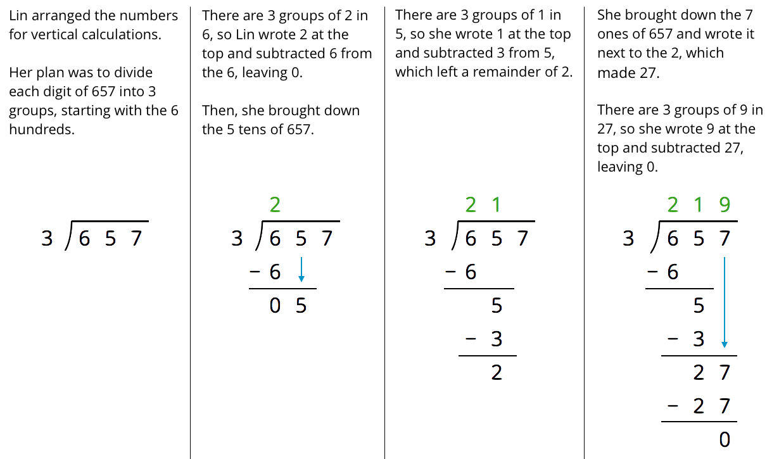
- Discuss with your partner how Lin’s method is similar to and different from drawing base-ten diagrams or using the partial quotients method.
  - Lin subtracted $3⋅2,$ then $3⋅1$, and lastly $3⋅9$. Earlier, Andre subtracted $3⋅200,$ then $3⋅10$, and lastly $3⋅9$. Why did they have the same quotient?
  - In the third step, why do you think Lin wrote the 7 next to the remainder of 2 rather than adding 7 and 2 to get 9?
- Lin’s method is called long division. Use this method to find the following quotients. Check your answer by multiplying it by the divisor.
  - $846÷3$
  - $1,​816÷4$
  - $768÷12$

18.4: Dividing Whole Numbers
- Find each quotient.
  - $633÷3$
  - $1001÷7$
  - $2996÷14$
- Here is Priya’s calculation of $906÷3$.
- 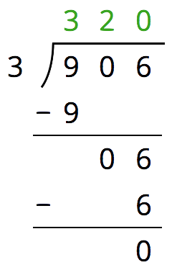
  - Priya wrote 320 for the value of $906÷3$. Check her answer by multiplying it by 3. What product do you get and what does it tell you about Priya’s answer?
  - Describe Priya’s mistake, then show the correct calculation and answer.

Lesson 18 Summary
We can find the quotient $345÷3$ in different ways.
One way is to use a base-ten diagram to represent the hundreds, tens, and ones and to create equal-sized groups.
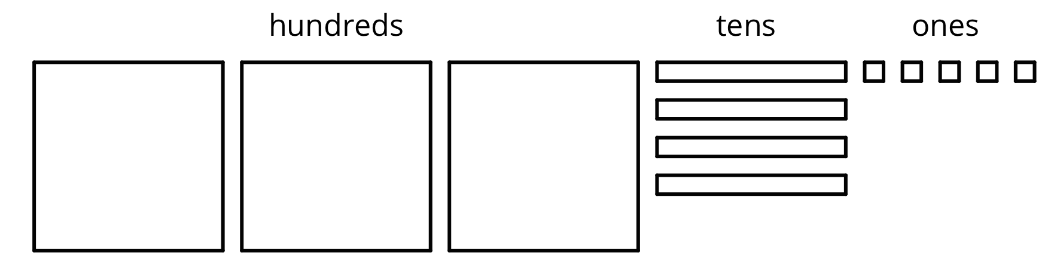
We can think of the division by 3 as splitting up 345 into 3 equal groups.
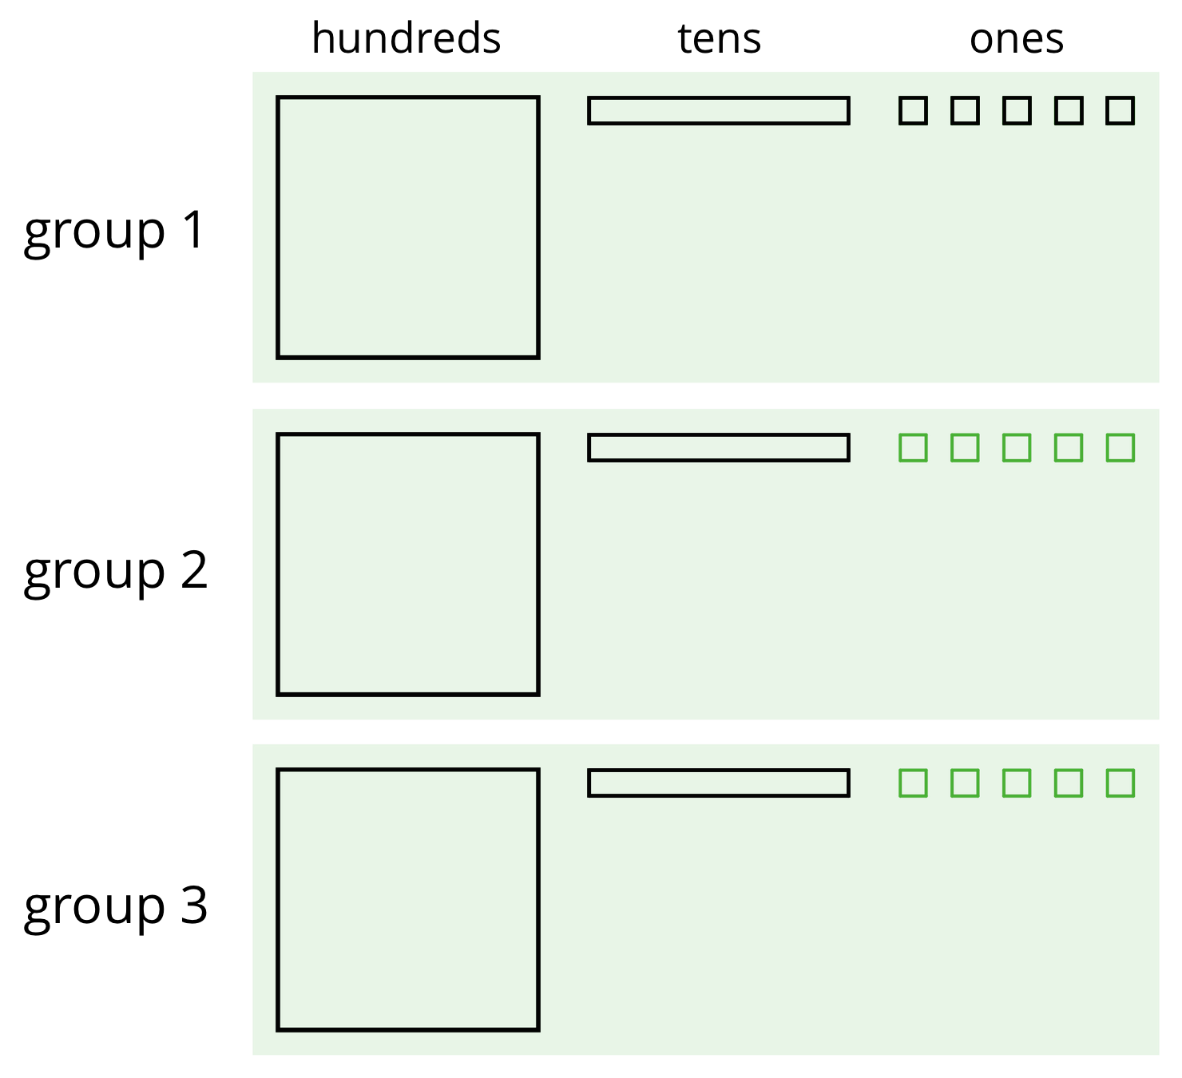
Each group has 1 hundred, 1 ten, and 5 ones, so $345÷3=115$. Notice that in order to split 345 into 3 equal groups, one of the tens had to be unbundled or decomposed into 10 ones.
Long division is another method for calculating quotients. It relies on place value to perform and record the division.
When we use long division, we work from left to right and with one digit at a time, starting with the leftmost digit of the dividend. We remove the largest group possible each time, using the placement of the digit to indicate the size of each group. Here is an example of how to find $345÷3$ using long division.
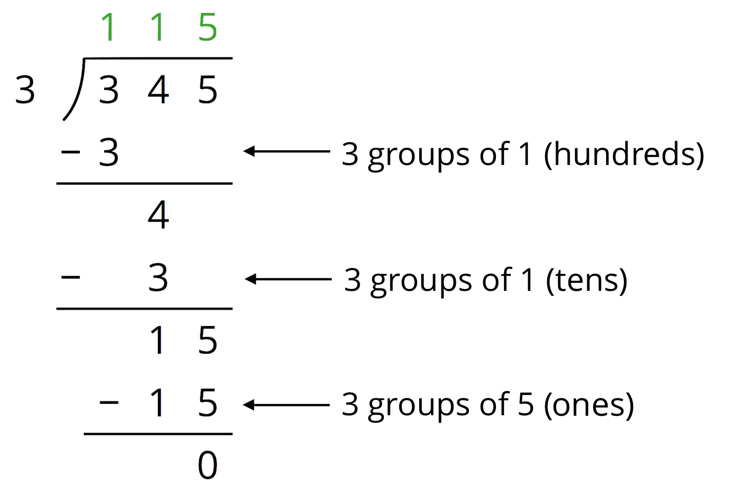
- We start by dividing 3 hundreds into 3 groups, which means 1 hundred in each group. Instead of writing 100, we simply write 1 in the hundreds place, knowing that it means 1 hundred.
- There are no remaining hundreds, so we work with the tens. We can make 3 groups of 1 ten in 4 tens, so we write 1 in the tens place above the 4 of 345. Subtracting 3 tens from 4 tens, we have a remainder of 1 ten.
- We know that 1 ten is 10 ones. Combining these with the 5 ones from 345, we have 15 ones. We can make 3 groups of 5, so we write 5 in the ones place.
In total, there are 3 groups of 1 hundred, 1 ten, and 5 ones in 345, so $345÷3=115$.
© CC BY Open Up Resources. Adaptations CC BY IM.

