Lesson 12: It’s All on the Line
- Let’s work with both parallel and perpendicular lines.

12.1: Parallel and Perpendicular
The image shows line $n$.
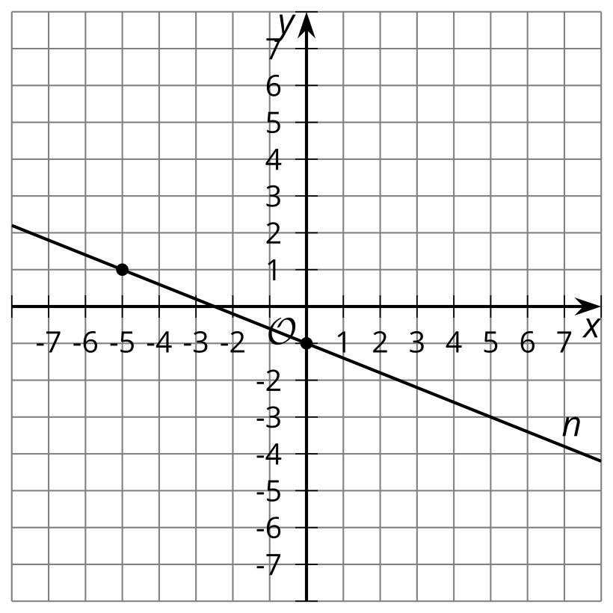
- Write an equation for the line that is perpendicular to $n$ and whose $y$-intercept is $\left(0,5\right)$. Graph this line.
- Write an equation for the line that is parallel to $n$ and that passes through the point $\left(3,1\right)$. Graph this line.

12.2: Info Gap: Lines
Your teacher will give you either a problem card or a data card. Do not show or read your card to your partner.
If your teacher gives you the data card:
- Silently read the information on your card.
- Ask your partner, “What specific information do you need?” and wait for your partner to ask for information. Only give information that is on your card. (Do not figure out anything for your partner!)
- Before telling your partner the information, ask, “Why do you need to know (that piece of information)?”
- Read the problem card, and solve the problem independently.
- Share the data card, and discuss your reasoning.
If your teacher gives you the problem card:
- Silently read your card and think about what information you need to answer the question.
- Ask your partner for the specific information that you need.
- Explain to your partner how you are using the information to solve the problem.
- When you have enough information, share the problem card with your partner, and solve the problem independently.
- Read the data card, and discuss your reasoning.
Pause here so your teacher can review your work. Ask your teacher for a new set of cards and repeat the activity, trading roles with your partner.
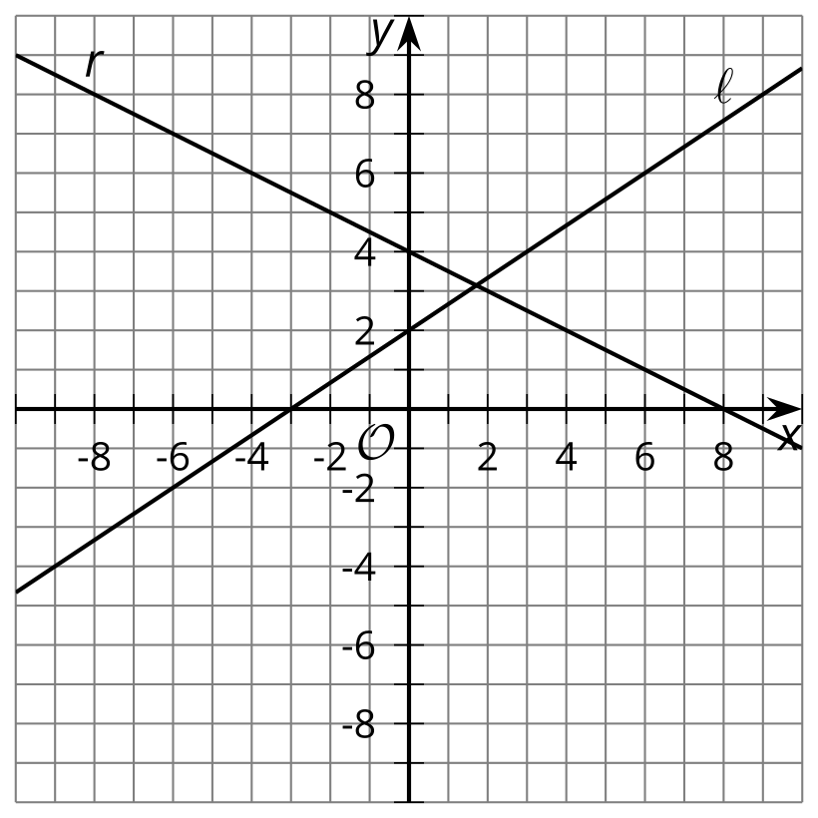

12.3: Three Lines
- Line $ℓ$ is represented by the equation $y=\frac{2}{3}x+3$. Write an equation of the line perpendicular to $ℓ$, passing through $\left(\text{-}6,4\right)$. Call this line $p$.
- Write an equation of the line perpendicular to $p$, passing through $\left(3,\text{-}2\right)$. Call this line $n$.
- What do you notice about lines $ℓ$ and $n$? Does this always happen? Show or explain your answer.

Are you ready for more?
Prove that the line $Ax+By=C$ is always perpendicular to the line that passes through $\left(A,B\right)$ and the origin.

Lesson 12 Summary
We can use the concepts of parallel and perpendicular lines to write equations of lines. The image shows line $ℓ$.
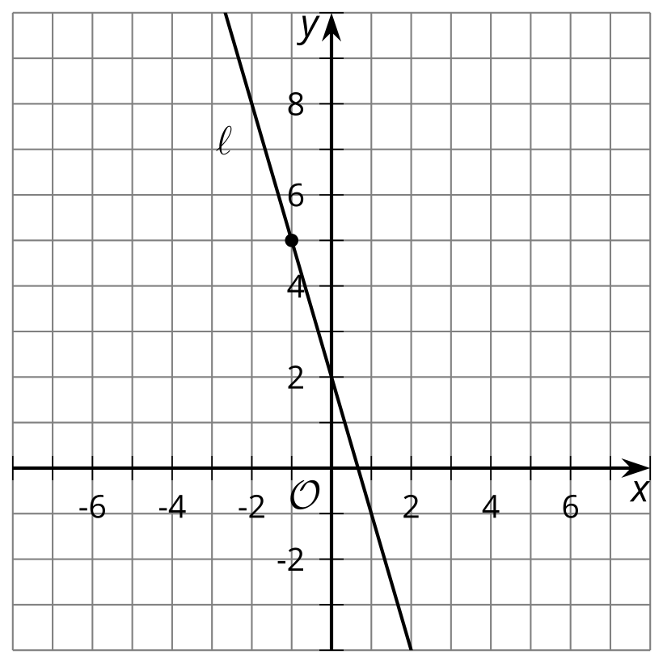
Suppose $n$ is the image of $ℓ$ when it is rotated 90 degrees using $\left(\text{-}1,5\right)$ as a center. What is an equation of line $n$?
The point $\left(\text{-}1,5\right)$ is on line $ℓ$. The center of rotation does not move when a figure is rotated, so $\left(\text{-}1,5\right)$ will also be on the image, line $n$. Because line $ℓ$ was rotated 90 degrees, lines $ℓ$ and $n$ are perpendicular. Their slopes must be opposite reciprocals. The slope of line $ℓ$ is -3, so the slope of $n$ is $\frac{1}{3}$. Now substitute the slope $\frac{1}{3}$ and the point $\left(\text{-}1,5\right)$ into point-slope form to get $y−5=\frac{1}{3}\left(x−\left(\text{-}1\right)\right)$.
© CC BY 2019 by Illustrative Mathematics®

