Unit 2 Lesson 9: Side-Side-Side Triangle Congruence

1 Dare to Be Different (Warm up)

Student Task Statement
Construct a triangle with the given side lengths on tracing paper.
Can you make a triangle that doesn’t look like anyone else’s?

2 Proving the Side-Side-Side Triangle Congruence Theorem

Student Task Statement
Priya was given this task to complete:
Use a sequence of rigid motions to take $STU$ onto $GHJ$. Given that segment $ST$ is congruent to segment $GH$, segment $TU$ is congruent to segment $HJ$, and segment $SU$ is congruent to segment $GJ$. For each step, explain how you know that one or more vertices will line up.
Help her finish the missing steps in her proof:
- $ST$ is the same length as $\underset{_}{}$, so they are congruent. Therefore, there is a rigid motion that takes $ST$ to $\underset{_}{}$.
- Apply this rigid motion to triangle $STU$. The image of $T$ will coincide with $\underset{_}{}$ , and the image of $S$ will coincide with $\underset{_}{}$.
- We cannot be sure that the image of $U$, which we will call $U^{′}$, coincides with $\underset{_}{}$ yet. If it does, then our rigid motion takes $STU$ to $GHJ$, proving that triangle $STU$ is congruent to triangle $GHJ$. If it does not, then we continue as follows.
- $HJ$ is congruent to the image of $\underset{_}{}$, because rigid motions preserve distance.
- Therefore, $H$ is equidistant from $U^{′}$ and $\underset{_}{}$.
- A similar argument shows that $G$ is equidistant from $U^{′}$ and $\underset{_}{}$ .
- $GH$ is the $\underset{_}{}$ of the segment connecting $U^{′}$ and $J$, because the $\underset{_}{}$ is determined by 2 points that are both equidistant from the endpoints of a segment.
- Reflection across the $\underset{_}{}$ of $U^{′}J$, takes $\underset{_}{}$ to $\underset{_}{}$.
- Therefore, after the reflection, all 3 pairs of vertices coincide, proving triangles $\underset{_}{}$ and $\underset{_}{}$ are congruent.
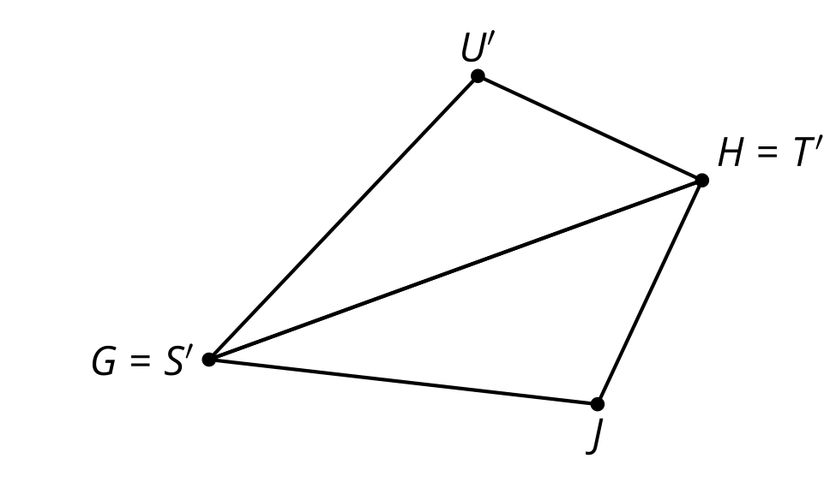
Now, help Priya by finishing a few-sentence summary of her proof. “To prove 2 triangles must be congruent if all 3 pairs of corresponding sides are congruent . . . .”

Activity Synthesis

$\overset{¯}{HU}≅\overset{¯}{HJ},\overset{¯}{UG}≅\overset{¯}{JG},\overset{¯}{HG}≅\overset{¯}{HG}$, so $△HUG≅△HJG$
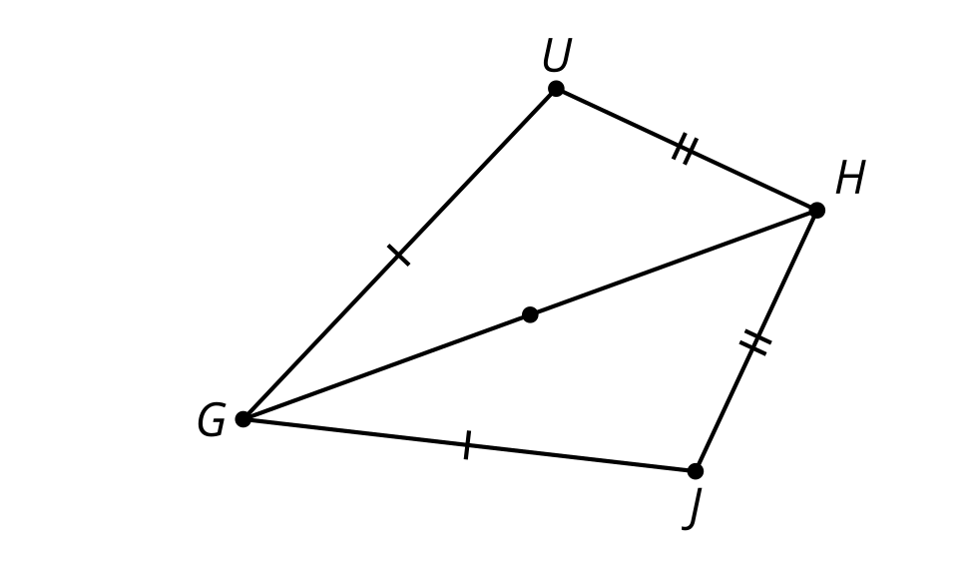

3 What Else Do We Know For Sure About Parallelograms?

Student Task Statement
Quadrilateral $ABCD$ is a parallelogram. By definition, that means that segment $AB$ is parallel to segment $CD$, and segment $BC$ is parallel to segment $AD$.
Prove that angle $B$ is congruent to angle $D$.
- Work on your own to make a diagram and write a rough draft of a proof.
- With your partner, discuss each other’s drafts.
  - What do you notice your partner understands about the problem?
  - What revision would help them move forward?
- Work together to revise your drafts into a clear proof that everyone in your class could follow and agree with.

Images for Activity Synthesis

$ABCD$ is a parallelogram so $∠A≅∠C,∠D≅∠B$
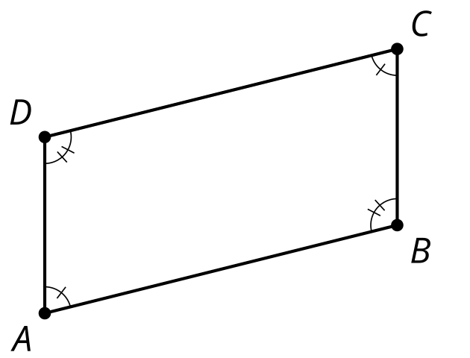
© CC BY 2019 by Illustrative Mathematics®

