Lesson 23: Solving Percentage Problems
Let's solve more percentage problems.

23.1: Number Talk: Decimals
Find the value of each expression mentally.
$\left(0.23\right)⋅100$
$50÷100$
$145⋅\frac{1}{100}$
$7÷100$

23.2: Info Gap: Music Devices
Your teacher will give you either a problem card or a data card. Do not show or read your card to your partner.
If your teacher gives you the problem card:
- Silently read your card and think about what information you need to be able to answer the question.
- Ask your partner for the specific information that you need.
- Explain how you are using the information to solve the problem.
- Continue to ask questions until you have enough information to solve the problem.
- Share the problem card and solve the problem independently.
- Read the data card and discuss your reasoning.
If your teacher gives you the data card:
- Silently read your card.
- Ask your partner “What specific information do you need?” and wait for them to ask for information.
- If your partner asks for information that is not on the card, do not do the calculations for them. Tell them you don’t have that information.
- Before sharing the information, ask “Why do you need that information?” Listen to your partner’s reasoning and ask clarifying questions.
- Read the problem card and solve the problem independently.
- Share the data card and discuss your reasoning.

23.3: Everything is On Sale
During a sale, every item in a store is 80% of its regular price.
- If the regular price of a T-shirt is $10, what is its sale price?
- The regular prices of five items are shown here. Find the sale price of each item.
 | - item 1 | - item 2 | - item 3 | - item 4 | - item 5
- regular price | - $1 | - $4 | - $10 | - $55 | - $120
- sale price
- You found 80% of many values. Was there a process you repeated over and over to find the sale prices? If so, describe it.
- 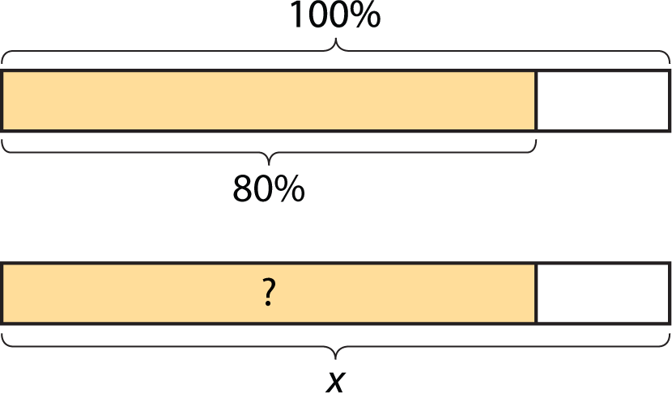
- Select all of the expressions that could be used to find 80% of $x$. Be prepared to explain your reasoning.
- $\frac{8}{100}⋅x$
- $\frac{80}{100}⋅x$
- $\frac{8}{10}⋅x$
- $\frac{4}{10}⋅x$
- $\frac{8}{5}⋅x$
- $\frac{4}{5}⋅x$
- $80⋅x$
- $8⋅x$
- $\left(0.8\right)⋅x$
- $\left(0.08\right)⋅x$

Lesson 23 Summary
A pot holds 36 liters of water. 25% of 36 liters is 9 liters. Here are two different representations that display this information:
- A double number line:
- 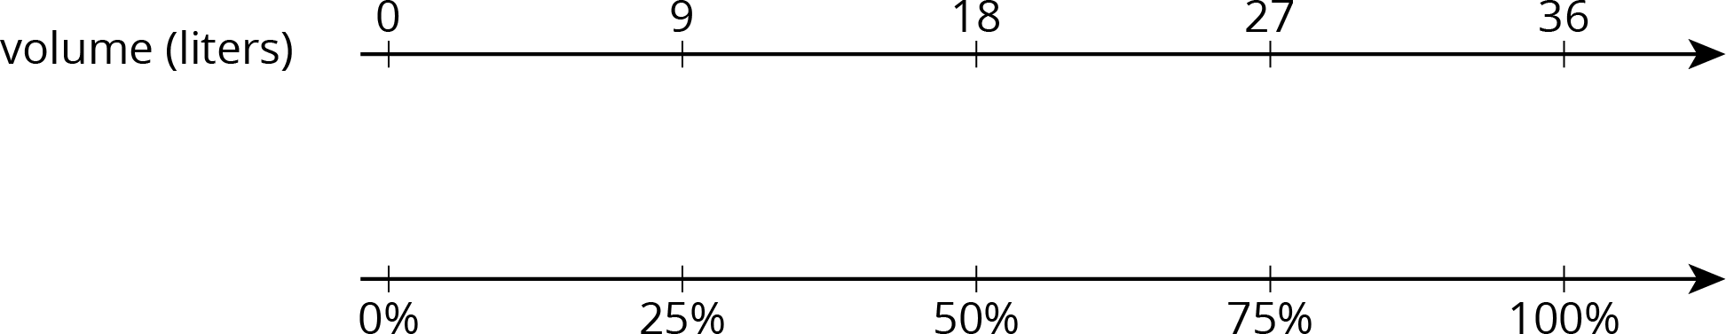
- We can divide the distance between 0 and 36 into four equal intervals to show that 9 is $\frac{1}{4}$ of 36, or 9 is 25% of 36.
- A table:
- 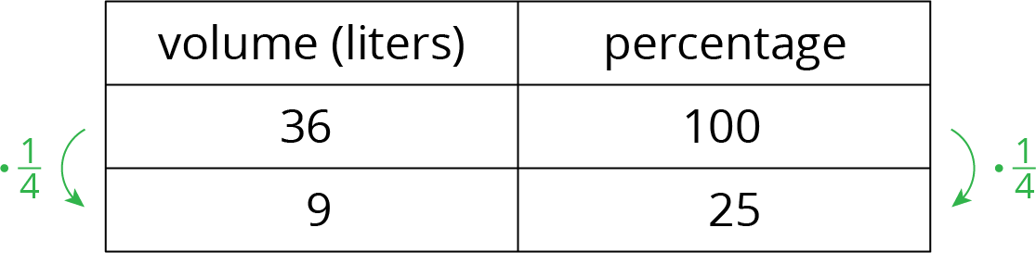
- In the case of the table, notice that the rows are multiplied by $\frac{1}{4}$ which is equivalent to $\frac{25}{100}$.
In general, to find $P\%$ of $x$, we can multiply: $\frac{P}{100}⋅x$.
- To find 49% of a number, we can multiply the number by $\frac{49}{100}$ or 0.49.
- To find 135% of a number, we can multiply the number by $\frac{135}{100}$ or 1.35.
- To find 6% of a number, we can multiply the number by $\frac{6}{100}$ or 0.06.
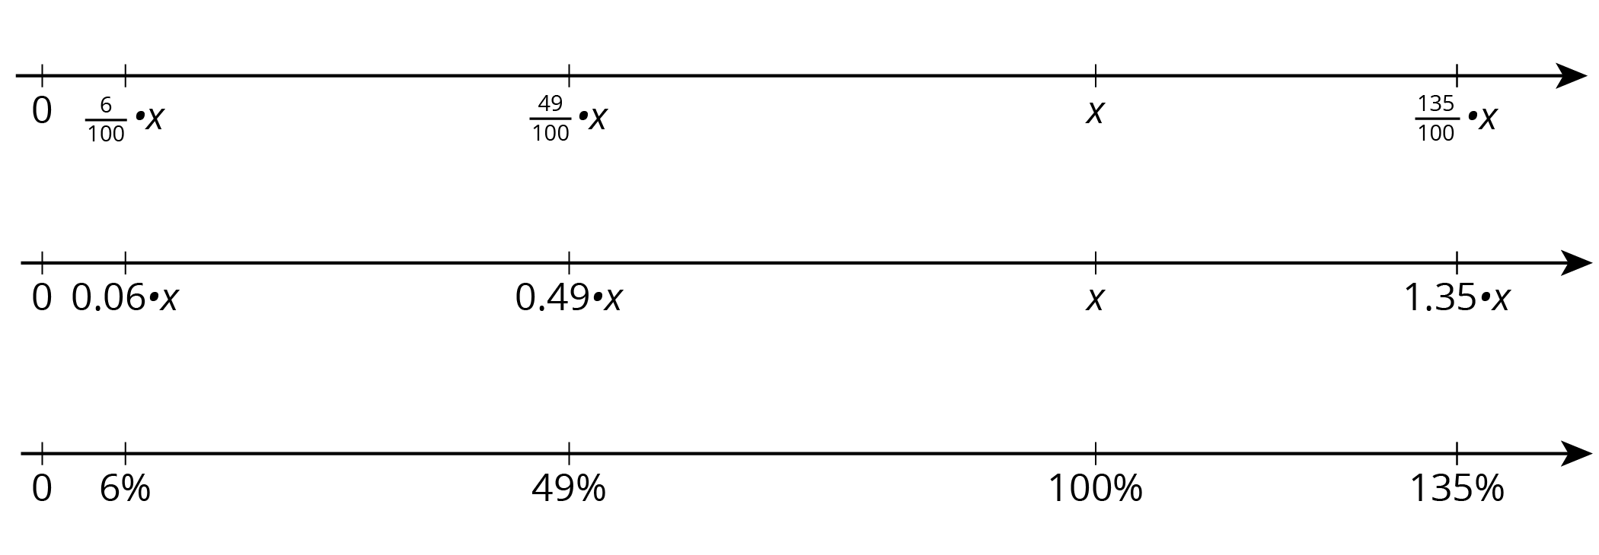
© CC BY Open Up Resources. Adaptations CC BY IM.

