Lesson 11: Slicing Solids
Let's see what shapes you get when you slice a three-dimensional object.

11.1: Prisms, Pyramids, and Polyhedra
Describe each shape as precisely as you can.
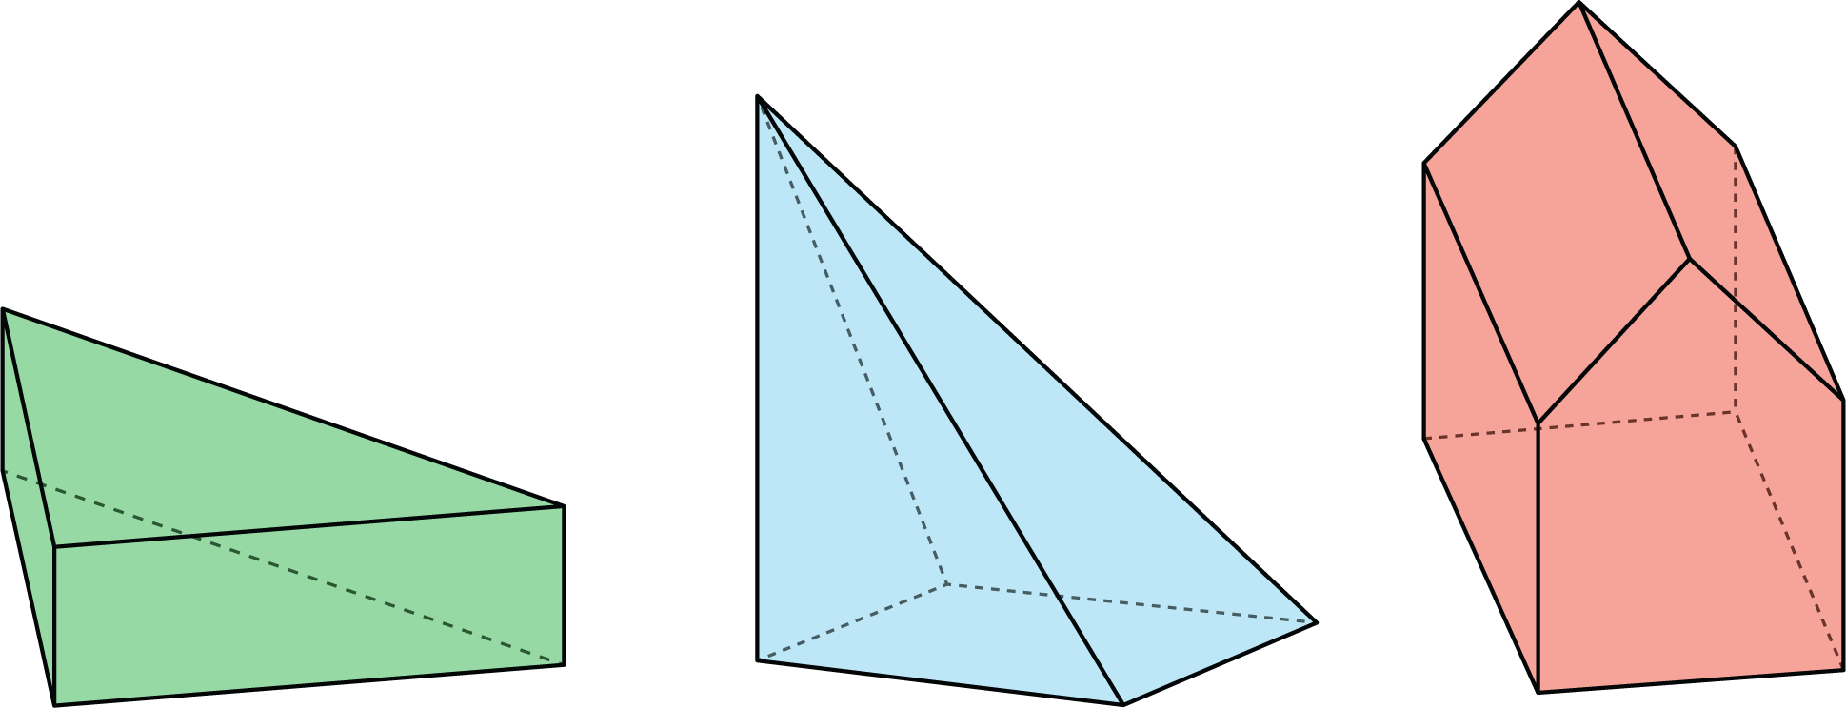

11.2: What's the Cross Section?
Here is a rectangular prism and a pyramid with the same base and same height.
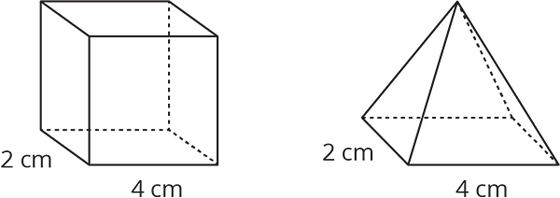
- Think about slicing each solid parallel to its base, halfway up. What shape would each cross section be? What is the same about the two cross sections? What is different?
- Think about slicing each solid parallel to its base, near the top. What shape would each cross section be? What is the same about the two cross sections? What is different?

Are you ready for more?
Describe the cross sections that would result from slicing each solid perpendicular to its base.

11.3: Card Sort: Cross Sections
Your teacher will give you a set of cards. Sort the images into groups that make sense to you. Be prepared to explain your reasoning.

11.4: Drawing Cross Sections
Draw and describe each cross section.
- Here is a picture of a rectangular prism, 4 units by 2 units by 3 units.
- 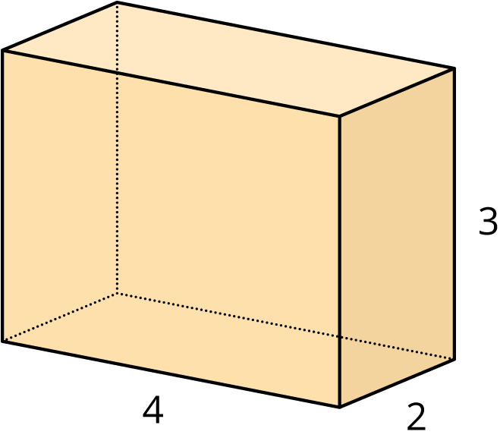
  - A plane cuts the prism parallel to the bottom and top faces.
  - 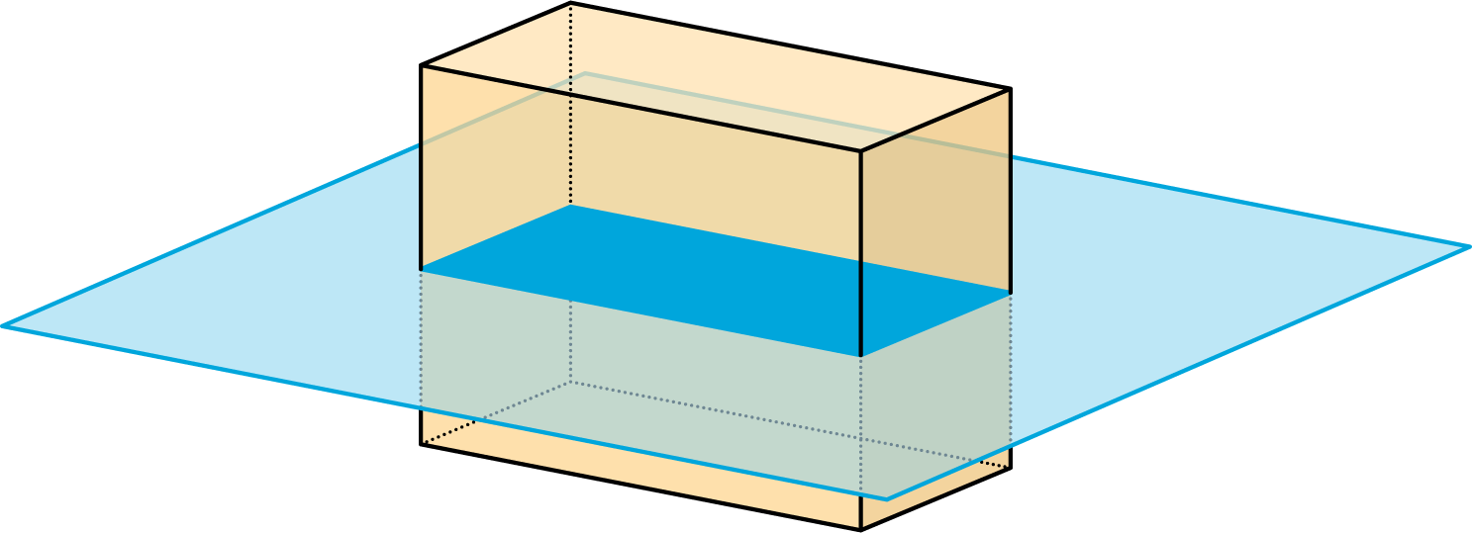
  - The plane moves up and cuts the prism at a different height.
  - 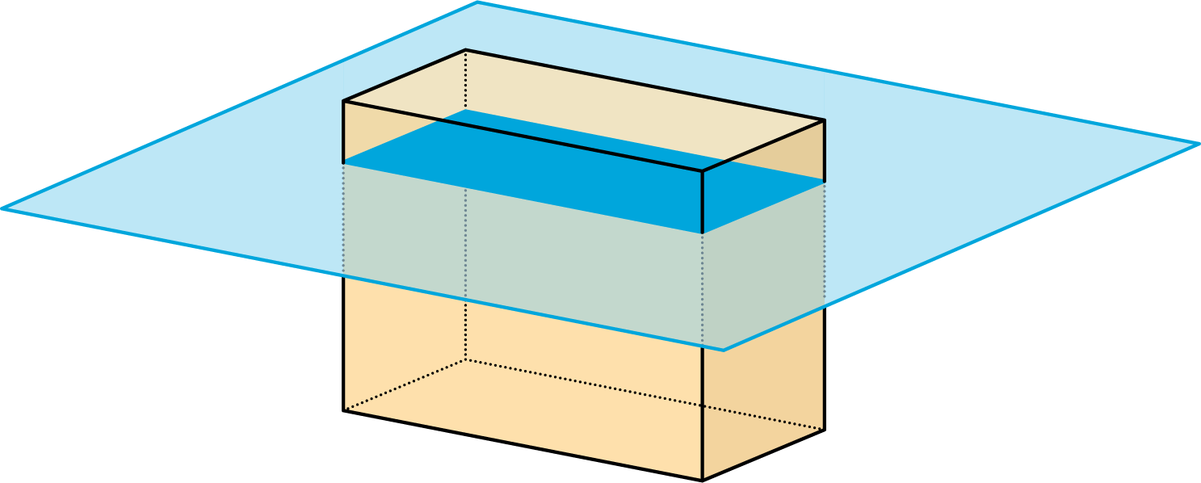
  - A vertical plane cuts the prism diagonally.
  - 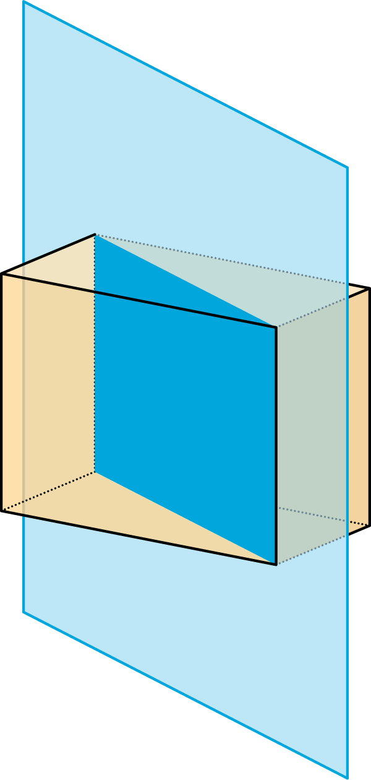
- A square pyramid has a base that is 4 units by 4 units. Its height is also 4 units.
  - A plane cuts the pyramid parallel to the base.
  - 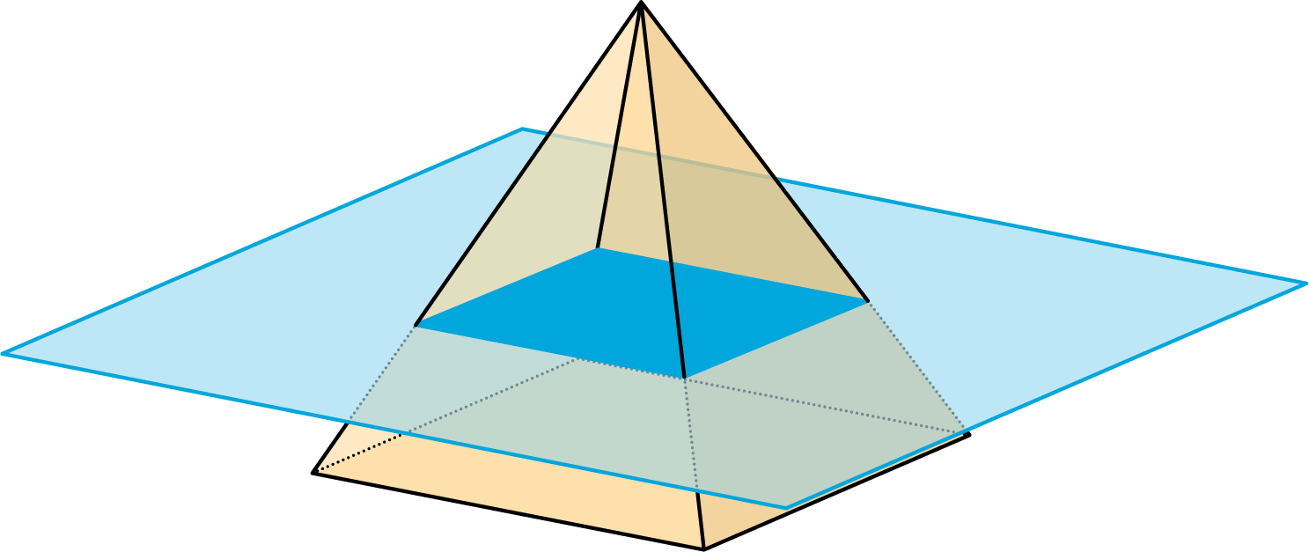
  - A vertical plane cuts the prism.
  - 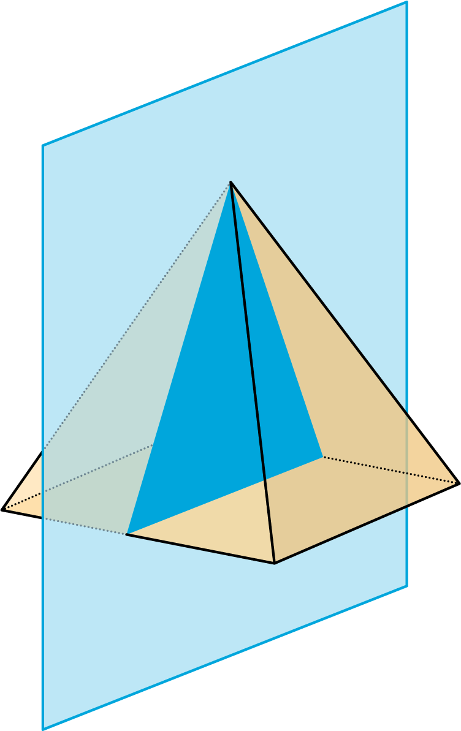
- A cube has an edge of length 4.
  - A plane cuts off the corner of the cube.
  - 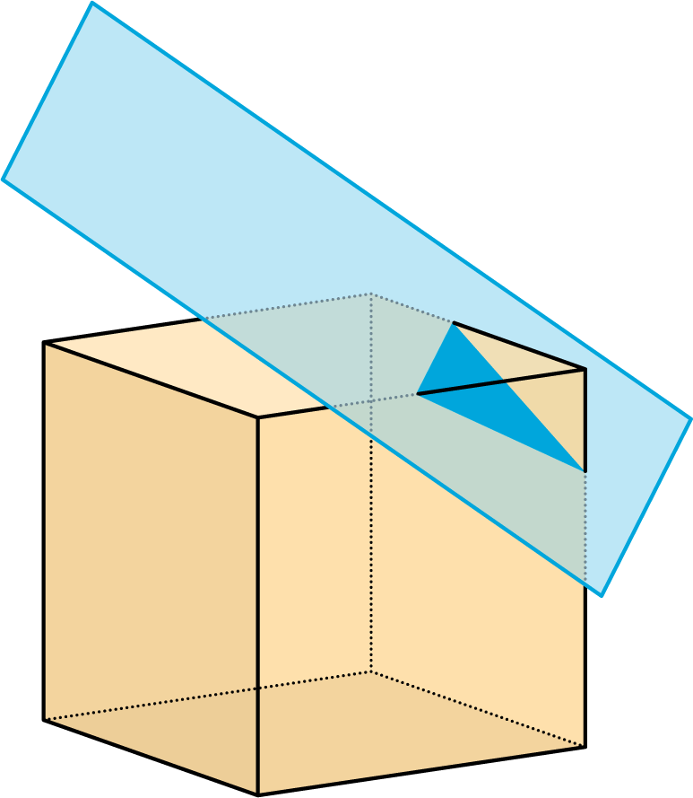
  - The plane moves farther from the corner and makes a cut through the middle of the cube.
  - 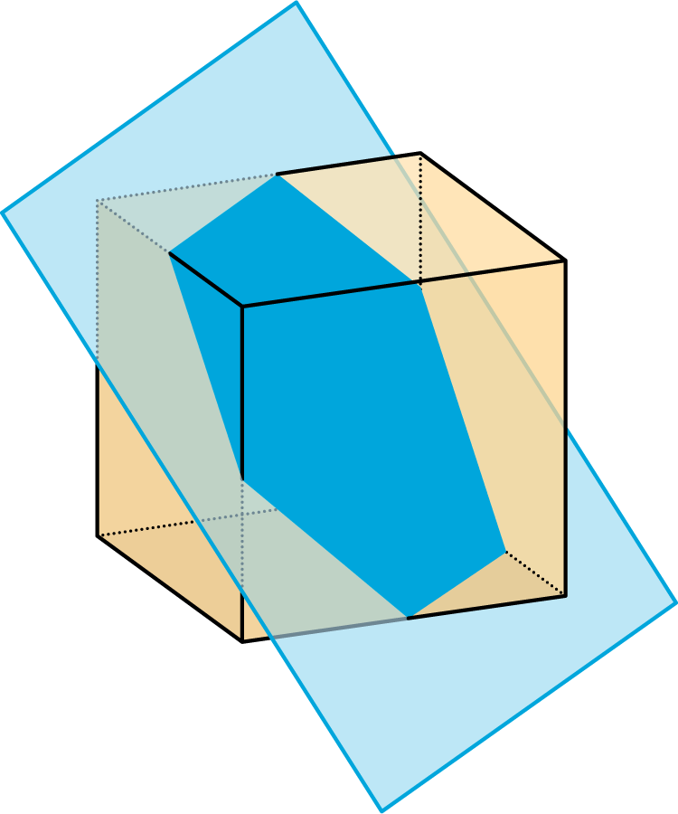

Lesson 11 Summary
When we slice a three-dimensional object, we expose new faces that are two dimensional. The two-dimensional face is a cross section. Many different cross sections are possible when slicing the same three-dimensional object.
Here are two peppers. One is sliced horizontally, and the other is sliced vertically, producing different cross sections.
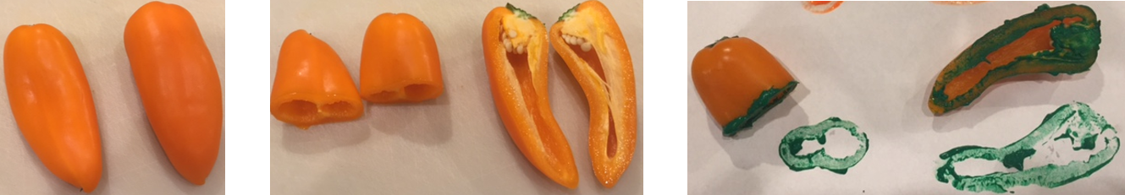
The imprints of the slices represent the two-dimensional faces created by each slice.
It takes practice imagining what the cross section of a three-dimensional object will be for different slices. It helps to experiment and see for yourself what happens!
© CC BY Open Up Resources. Adaptations CC BY IM.

