Unit 8 Lesson 13: What Makes a Good Sample?

1 Number Talk: Division by Powers of 10 (Warm up)

Student Task Statement
Find the value of each quotient mentally.
$34,​000÷10$
$340÷100$
$34÷10$
$3.4÷100$

2 Selling Paintings

Student Task Statement
Your teacher will assign you to work with either means or medians.
- A young artist has sold 10 paintings. Calculate the measure of center you were assigned for each of these samples:
  - The first two paintings she sold were for $50 and $350.
  - At a gallery show, she sold three paintings for $250, $400, and $1,200.
  - Her oil paintings have sold for $410, $400, and $375.
- Here are the selling prices for all 10 of her paintings:
- $50
- $200
- $250
- $275
- $280
- $350
- $375
- $400
- $410
- $1,200
- Calculate the measure of center you were assigned for all of the selling prices.
- Compare your answers with your partner. Were the measures of center for any of the samples close to the same measure of center for the population?

3 Sampling the Fish Market

Student Task Statement
The price per pound of catfish at a fish market was recorded for 100 weeks.
- Here are dot plots showing the population and three different samples from that population. What do you notice? What do you wonder?
- If the goal is to have the sample represent the population, which of the samples would work best? Which wouldn't work so well? Explain your reasoning.
Population
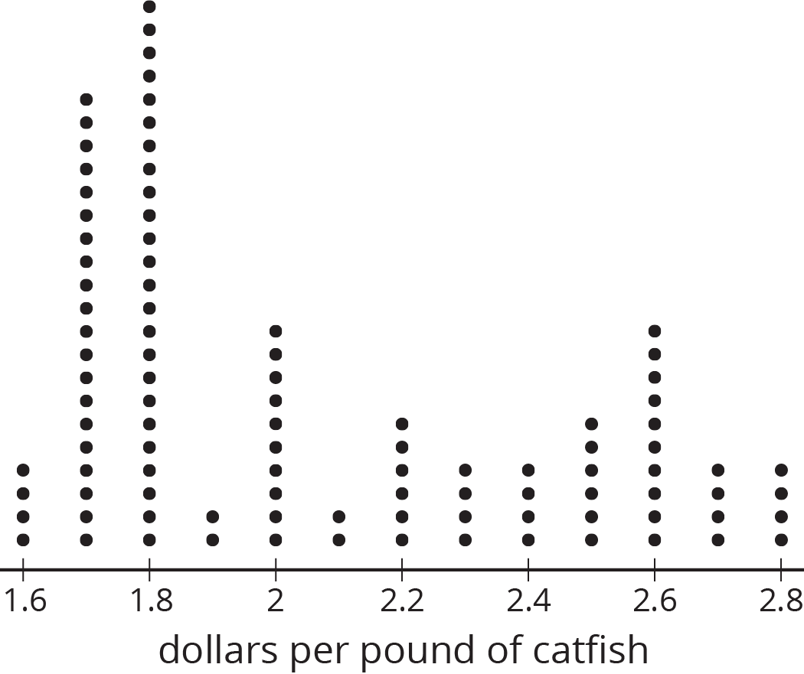
Sample 1
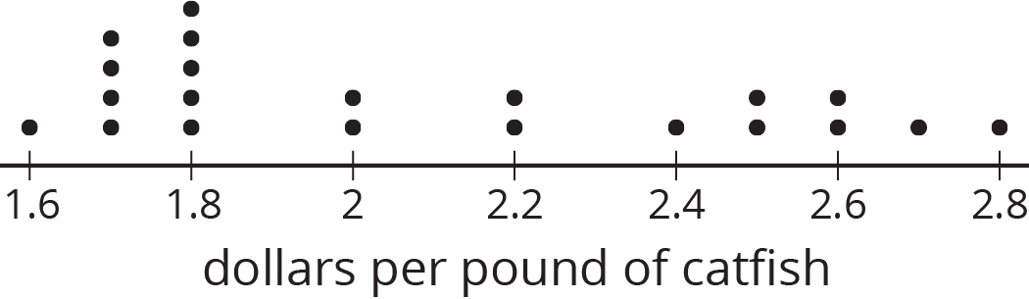
Sample 2
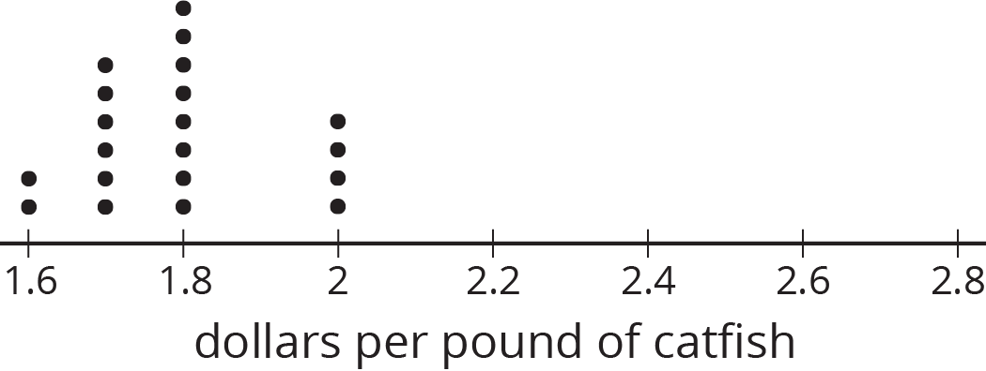
Sample 3
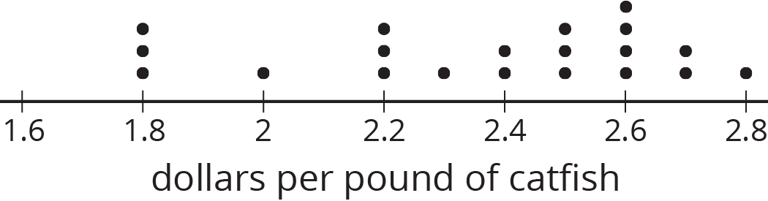

4 Auditing Sales (Optional)

Student Task Statement
An online shopping company tracks how many items they sell in different categories during each month for a year. Three different auditors each take samples from that data. Use the samples to draw dot plots of what the population data might look like for the furniture and electronics categories.
Auditor 1’s sample
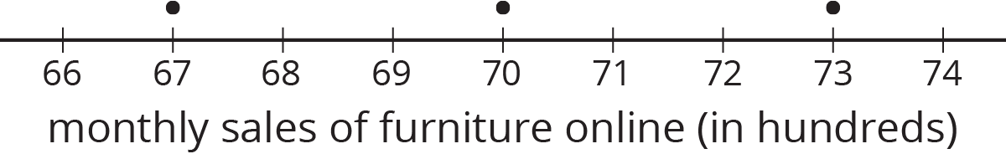
Auditor 2’s sample
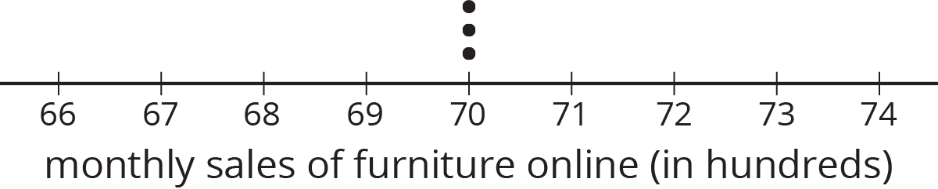
Auditor 3’s sample
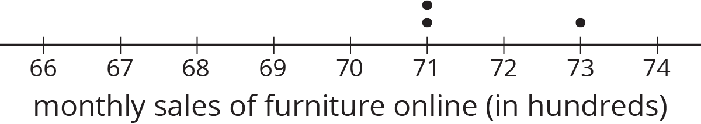
Population
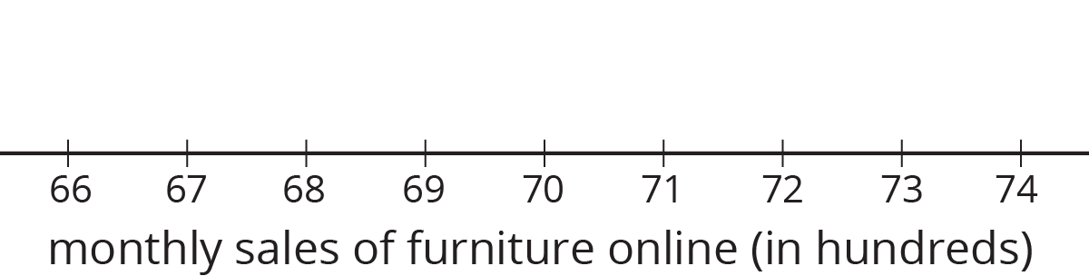

Auditor 1’s sample
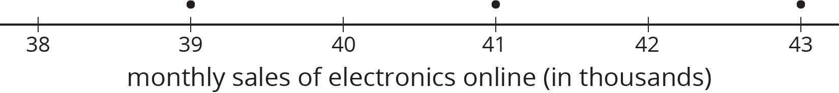
Auditor 2’s sample
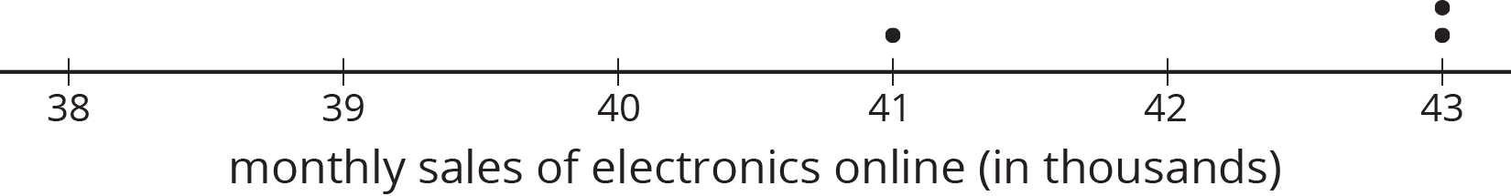
Auditor 3’s sample
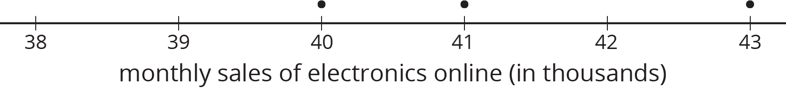
Population
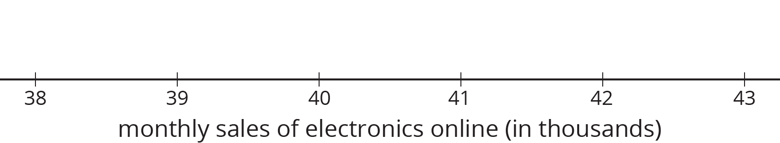

Activity Synthesis
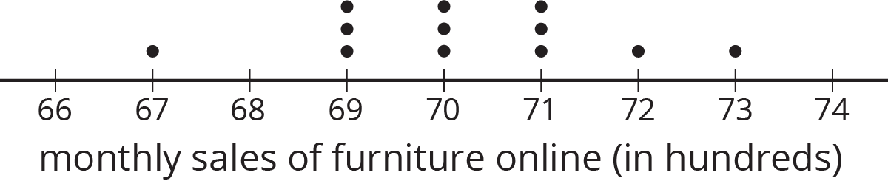
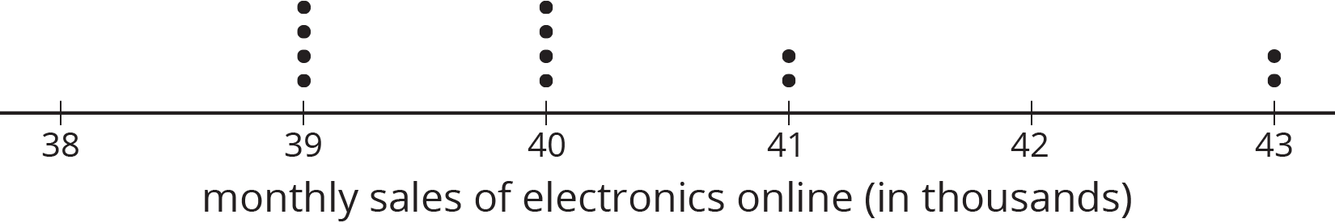
© CC BY Open Up Resources. Adaptations CC BY IM.

