Unit 1 Lesson 7: From Parallelograms to Triangles

1 Same Parallelograms, Different Bases (Warm up)

Student Task Statement
Here are two copies of a parallelogram. Each copy has one side labeled as the base $b$ and a segment drawn for its corresponding height and labeled $h$.
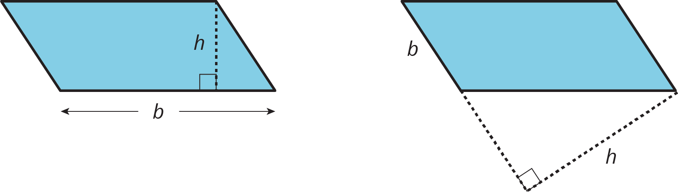
- The base of the parallelogram on the left is 2.4 centimeters; its corresponding height is 1 centimeter. Find its area in square centimeters.
- The height of the parallelogram on the right is 2 centimeters. How long is the base of that parallelogram? Explain your reasoning.

2 A Tale of Two Triangles (Part 1)

Student Task Statement
Two polygons are identical if they match up exactly when placed one on top of the other.
- Draw one line to decompose each polygon into two identical triangles, if possible. Use a straightedge to draw your line.
- 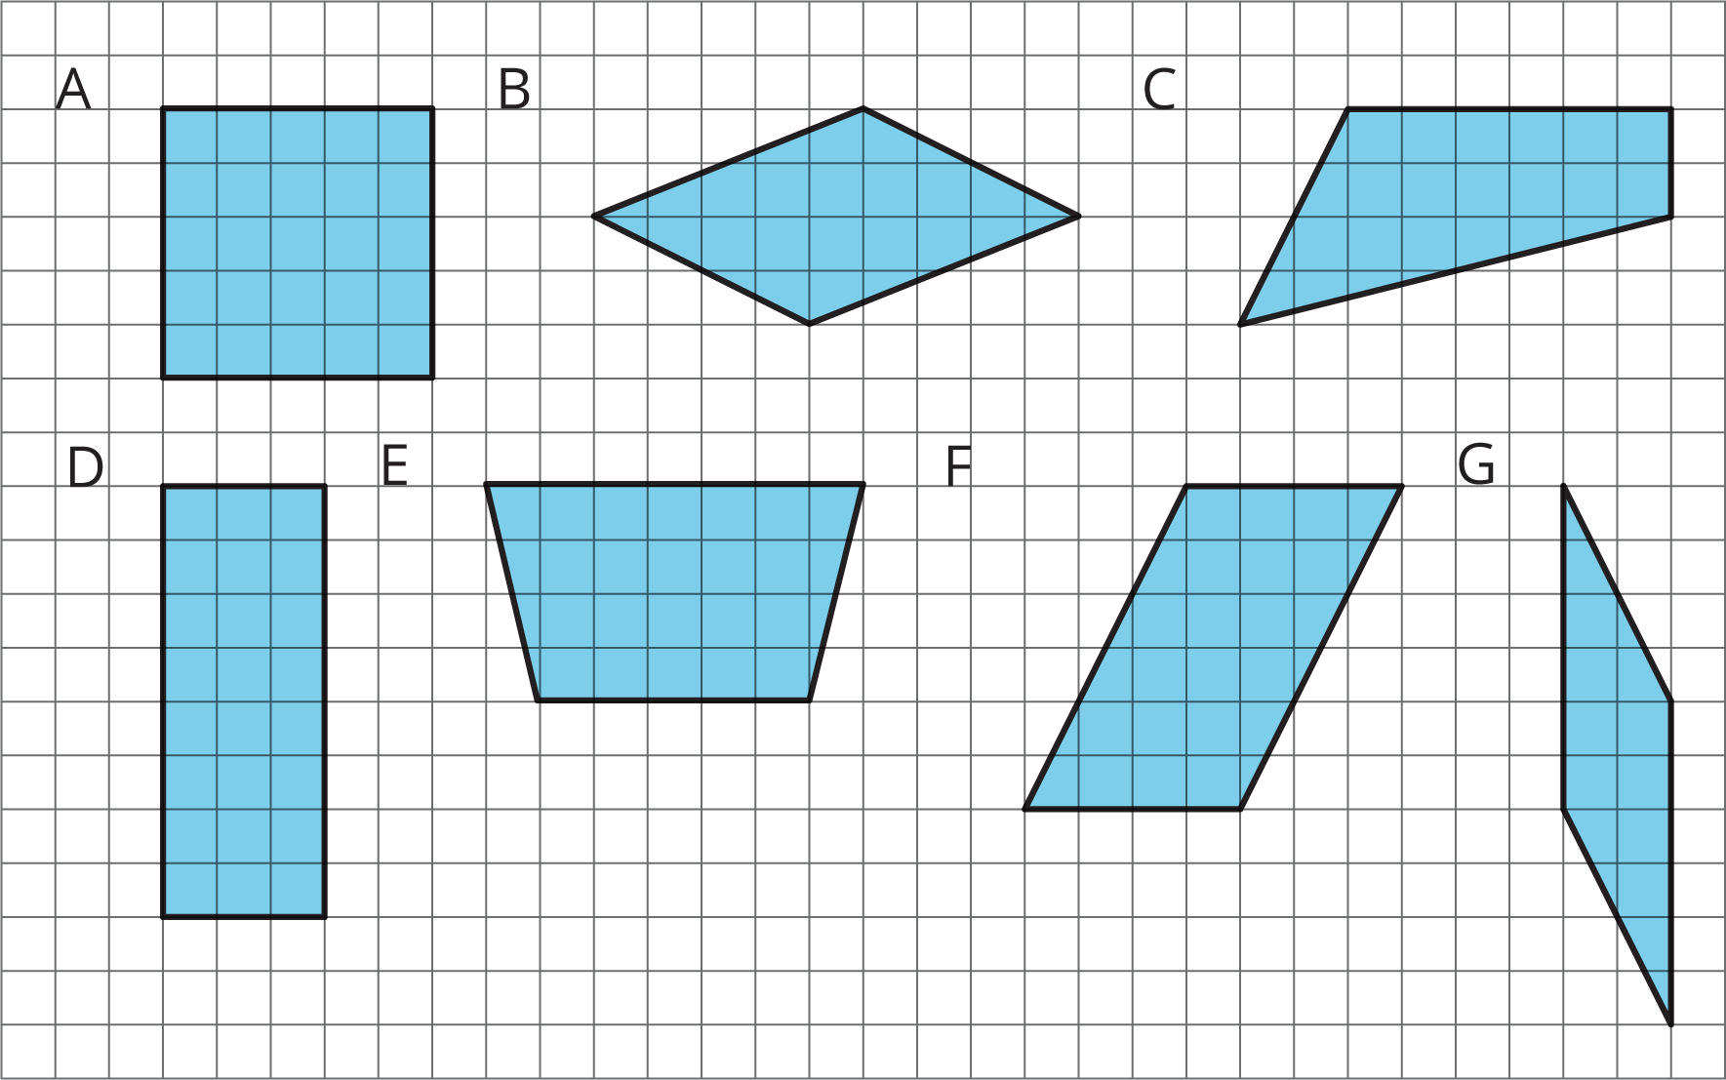
- Which quadrilaterals can be decomposed into two identical triangles?
- Pause here for a small-group discussion.
- Study the quadrilaterals that can, in fact, be decomposed into two identical triangles. What do you notice about them? Write a couple of observations about what these quadrilaterals have in common.

3 A Tale of Two Triangles (Part 2)

Images for Launch
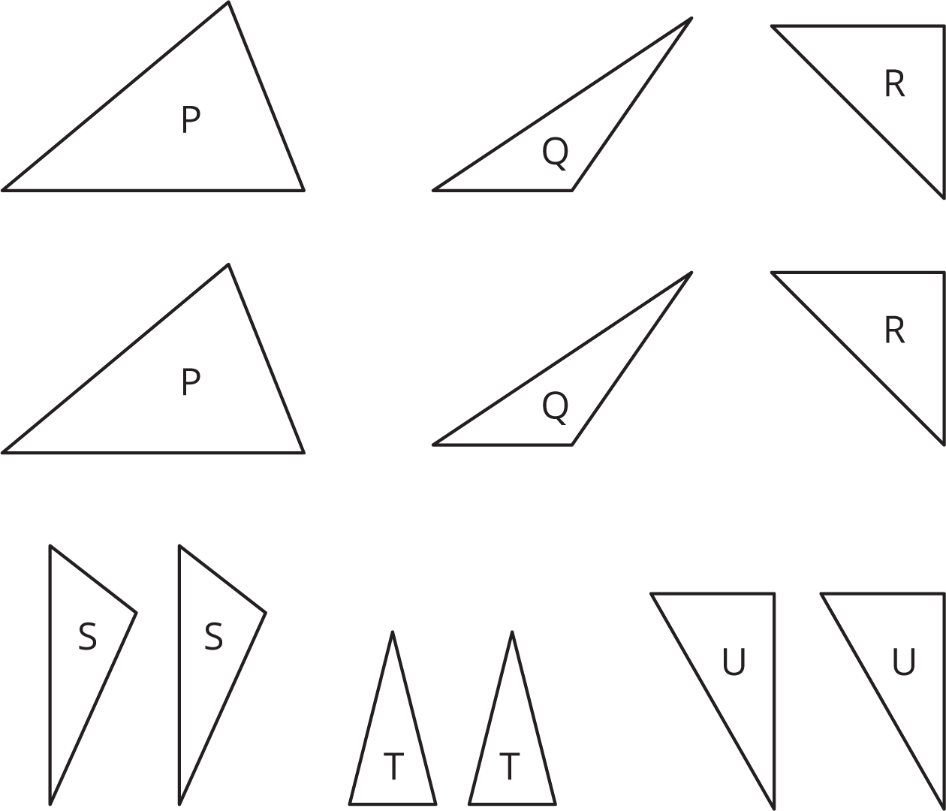

Student Task Statement
Your teacher will give your group several pairs of triangles. Each group member should take 1 or 2 pairs.

  - Which pair(s) of triangles do you have?
  - Can each pair be composed into a rectangle? A parallelogram?
- Discuss with your group your responses to the first question. Then, complete each statement with All, Some, or None. Sketch 1 or 2 examples to illustrate each completed statement.
  - ________________ of these pairs of identical triangles can be composed into a rectangle.
  - ________________ of these pairs of identical triangles can be composed into a parallelogram.
© CC BY Open Up Resources. Adaptations CC BY IM.

