Lesson 11: Perpendicular Lines in the Plane
- Let’s analyze the slopes of perpendicular lines.

11.1: Revisiting Transformations
The image shows quadrilateral $ABCD$.
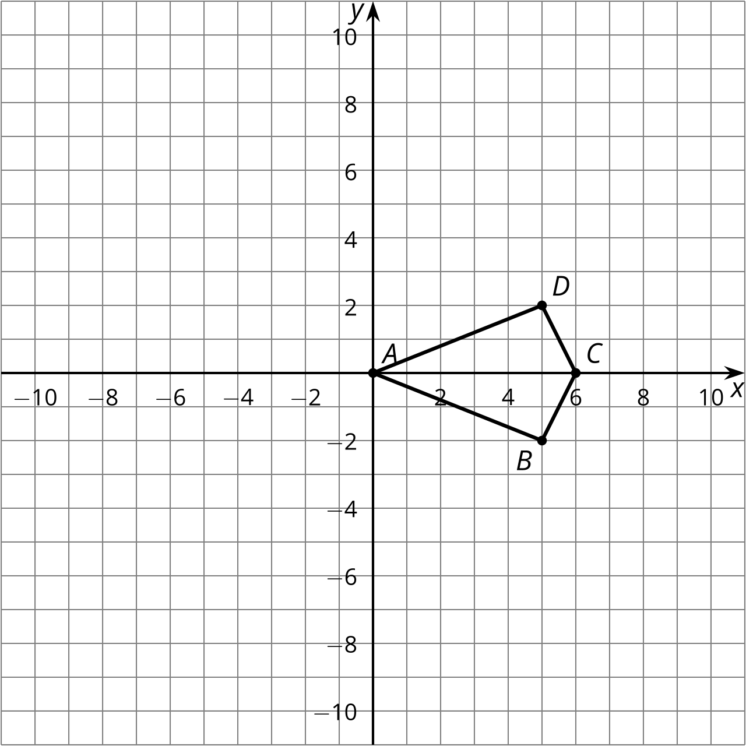
Apply the transformation rule $\left(x,y\right)→\left(\text{-}y,x\right)$ to quadrilateral $ABCD$. What is the effect of the transformation rule?

11.2: Make a Conjecture
- Complete the table with the slope of each segment from the warm-up.
 | - original figure slope | - image slope | - product
- $AB$
- $BC$
- $CD$
- $DA$
- The image in the warm-up is a 90-degree rotation of the original figure, so each line in the original figure is perpendicular to the corresponding line in the image. Use your slope calculations to make a conjecture about slopes of perpendicular lines.

11.3: Prove It
Let’s prove our conjecture about slopes of perpendicular lines for the case where the lines pass through the origin.
- Find the slope of a line passing through the point $\left(a,b\right)$ and the origin. Assume the line is not horizontal or vertical.
- Suppose the line is rotated using the transformation rule $\left(x,y\right)→\left(\text{-}y,x\right)$. Find the coordinates of the images of the points $\left(a,b\right)$ and the origin.
- How does the original line relate to the image?
- Find the slope of the image.
- Compare your slopes. What did you just prove?

Are you ready for more?
We can take any rhombus $EFGH$ and translate it so that the image of $E$ is $\left(0,0\right)$. We can then rotate using $\left(0,0\right)$ as a center so that the image of $F$ under this sequence is on the positive $x$-axis at some point $\left(c,0\right)$.
- Suppose these transformations take the point $H$ to some point $\left(a,b\right)$. What must the coordinates of $G$ be?
- For the values of $a,b,$ and $c$ in this problem, why is it true that $a^{2}+b^{2}=c^{2}$?
- Prove that the diagonals of the image are perpendicular.
- Prove that the diagonals of the image bisect each other.
- Why does this imply the diagonals of all rhombi are perpendicular bisectors of each other?

Lesson 11 Summary
The diagram shows triangle $ABC$ and its image, triangle $AB^{′}C^{′}$, under a 90-degree rotation counterclockwise using the origin as the center. Since the rotation was through 90 degrees, all line segments in the image are perpendicular to the corresponding segments in the original triangle. For example, segment $AC$ is horizontal, while segment $AC^{′}$ is vertical.
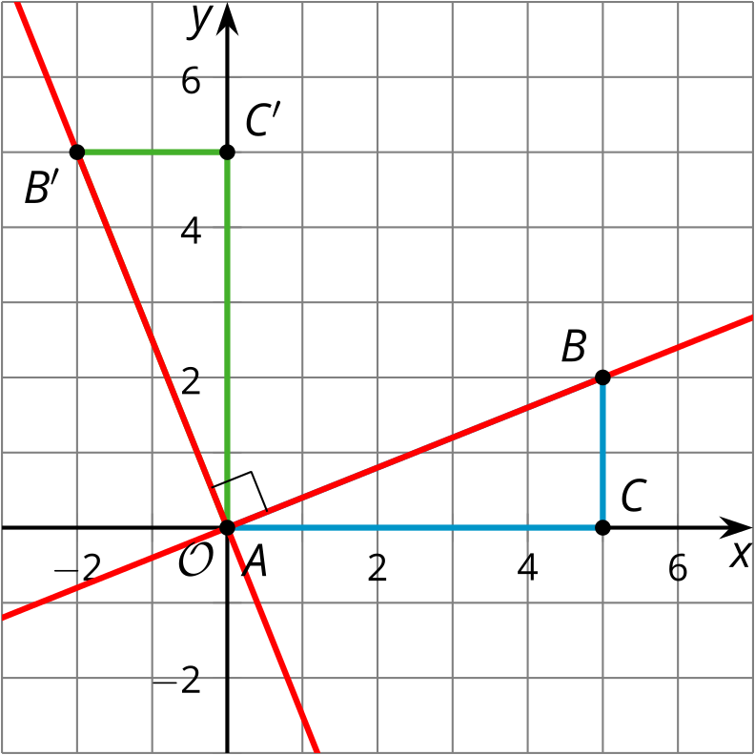
Look at segments $AB$ and $AB^{′}$, which, like the other pairs of segments, are perpendicular. The slope of segment $AB$ is $\frac{2}{5}$, while the slope of segment $AB^{′}$ is $\text{-}\frac{5}{2}$. Notice the relationship between the slopes: They are reciprocals of one another, and have opposite signs. The product of the slopes, $\frac{2}{5}⋅\left(\text{-}\frac{5}{2}\right)$, is -1. As long as perpendicular lines are not horizontal or vertical, their slopes will be opposite reciprocals and have a product of -1.
We can use this fact to help write equations of lines. For example, try writing the equation of a line that passes through the point $\left(23,\text{-}30\right)$ and is perpendicular to a line $ℓ$ represented by $y=3x+5$. The slope of line $ℓ$ is 3. The slope of any line perpendicular to line $ℓ$ is the opposite reciprocal of 3, or $\text{-}\frac{1}{3}$. Substitute the point $\left(23,\text{-}30\right)$ and the slope $\text{-}\frac{1}{3}$ into the point-slope form to get the equation $y−\left(\text{-}30\right)=\text{-}\frac{1}{3}\left(x−23\right)$.
© CC BY 2019 by Illustrative Mathematics®

