Lesson 12: Reasoning about Exponential Graphs (Part 1)
Let’s study and compare equations and graphs of exponential functions.

12.1: Spending Gift Money
Jada received a gift of $180. In the first week, she spent a third of the gift money. She continues spending a third of what is left each week thereafter. Which equation best represents the amount of gift money $g$, in dollars, she has after $t$ weeks? Be prepared to explain your reasoning.
- $g=180−\frac{1}{3}t$
- $g=180⋅{\left(\frac{1}{3}\right)}^{t}$
- $g=\frac{1}{3}⋅{180}^{t}$
- $g=180⋅{\left(\frac{2}{3}\right)}^{t}$

12.2: Equations and Their Graphs
- Each of the following functions $f$, $g$$,$ $h$, and $j$ represents the amount of money in a bank account, in dollars, as a function of time $x$, in years. They are each written in form $m\left(x\right)=a⋅b^{x}$.
$f\left(x\right)=50⋅2^{x}$
$g\left(x\right)=50⋅3^{x}$
$h\left(x\right)=50⋅{\left(\frac{3}{2}\right)}^{x}$
$j\left(x\right)=50⋅{\left(0.5\right)}^{x}$
  - Use graphing technology to graph each function on the same coordinate plane.
  - Explain how changing the value of $b$ changes the graph.
- Here are equations defining functions $p$, $q$, and $r$. They are also written in the form $m\left(x\right)=a⋅b^{x}$.
$p\left(x\right)=10⋅4^{x}$
$q\left(x\right)=40⋅4^{x}$
$r\left(x\right)=100⋅4^{x}$
  - Use graphing technology to graph each function and check your prediction.
  - Explain how changing the value of $a$ changes the graph.

Are you ready for more?
As before, consider bank accounts whose balances are given by the following functions:
$f\left(x\right)=10⋅3^{x} g\left(x\right)=3^{x+2} h\left(x\right)=\frac{1}{2}⋅3^{x+3}$
Which function would you choose? Does your choice depend on $x$?

12.3: Graphs Representing Exponential Decay
$m\left(x\right)=200⋅{\left(\frac{1}{4}\right)}^{x}$
$n\left(x\right)=200⋅{\left(\frac{1}{2}\right)}^{x}$
$p\left(x\right)=200⋅{\left(\frac{3}{4}\right)}^{x}$
$q\left(x\right)=200⋅{\left(\frac{7}{8}\right)}^{x}$
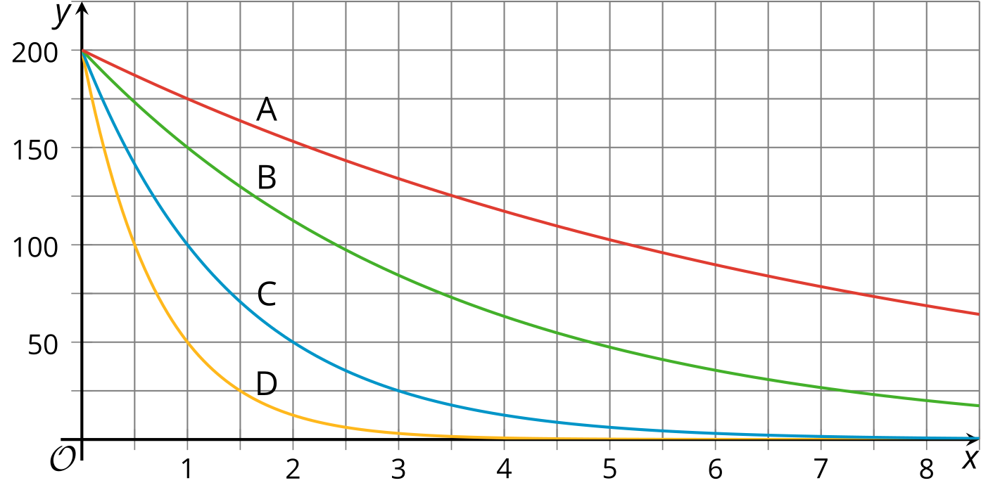
- Match each equation with a graph. Be prepared to explain your reasoning.
- Functions $f$ and $g$ are defined by these two equations: $f\left(x\right)=1,​000⋅{\left(\frac{1}{10}\right)}^{x}$ and $g\left(x\right)=1,​000⋅{\left(\frac{9}{10}\right)}^{x}$.
  - Which function is decaying more quickly? Explain your reasoning.
  - Use graphing technology to verify your response.

Lesson 12 Summary
An exponential function can give us information about a graph that represents it.
For example, suppose the function $q$ represents a bacteria population $t$ hours after it is first measured and $q\left(t\right)=5,​000⋅{\left(1.5\right)}^{t}$. The number 5,000 is the bacteria population measured, when $t$ is 0. The number 1.5 indicates that the bacteria population increases by a factor of 1.5 each hour.
A graph can help us see how the starting population (5,000) and growth factor (1.5) influence the population. Suppose functions $p$ and $r$ represent two other bacteria populations and are given by $p\left(t\right)=5,​000⋅2^{t}$ and $r\left(t\right)=5,​000⋅{\left(1.2\right)}^{t}$. Here are the graphs of $p$, $q$, and $r$.
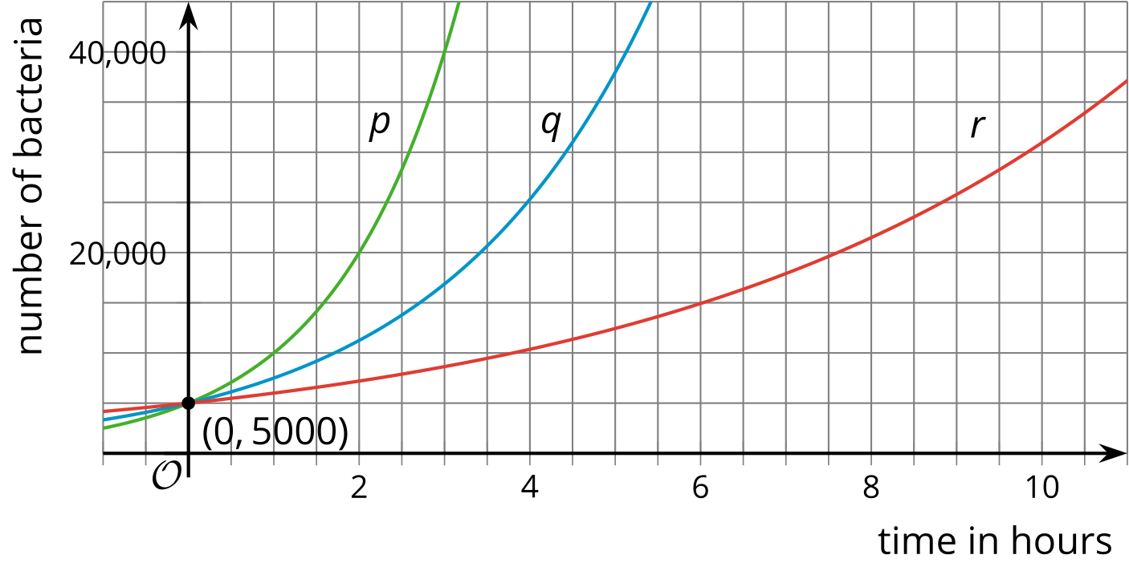
All three graphs start at $5,​000$ but the graph of $r$ grows more slowly than the graph of $q$ while the graph of $p$ grows more quickly. This makes sense because a population that doubles every hour is growing more quickly than one that increases by a factor of 1.5 each hour, and both grow more quickly than a population that increases by a factor of 1.2 each hour.
© CC BY 2019 by Illustrative Mathematics®

