Lesson 10: Parallel Lines in the Plane
- Let’s investigate parallel lines in the coordinate plane.

10.1: Translating Lines
- Draw any non-vertical line in the plane. Draw 2 possible translations of the line.
- 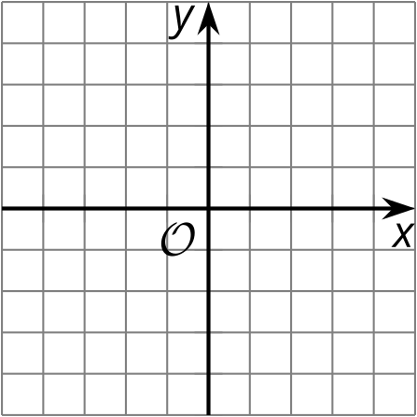
- Find the slope of your original line and the slopes of the images.

10.2: Priya’s Proof
Priya writes a proof saying:
Consider any 2 parallel lines. Assume they are not horizontal or vertical. Therefore they must pass through the $x$-axis as well as the $y$-axis. This forms 2 right triangles with a second congruent angle. Call the angle $θ$. The tangent of $θ$ is equal for both triangles. Therefore the lines have the same slope.
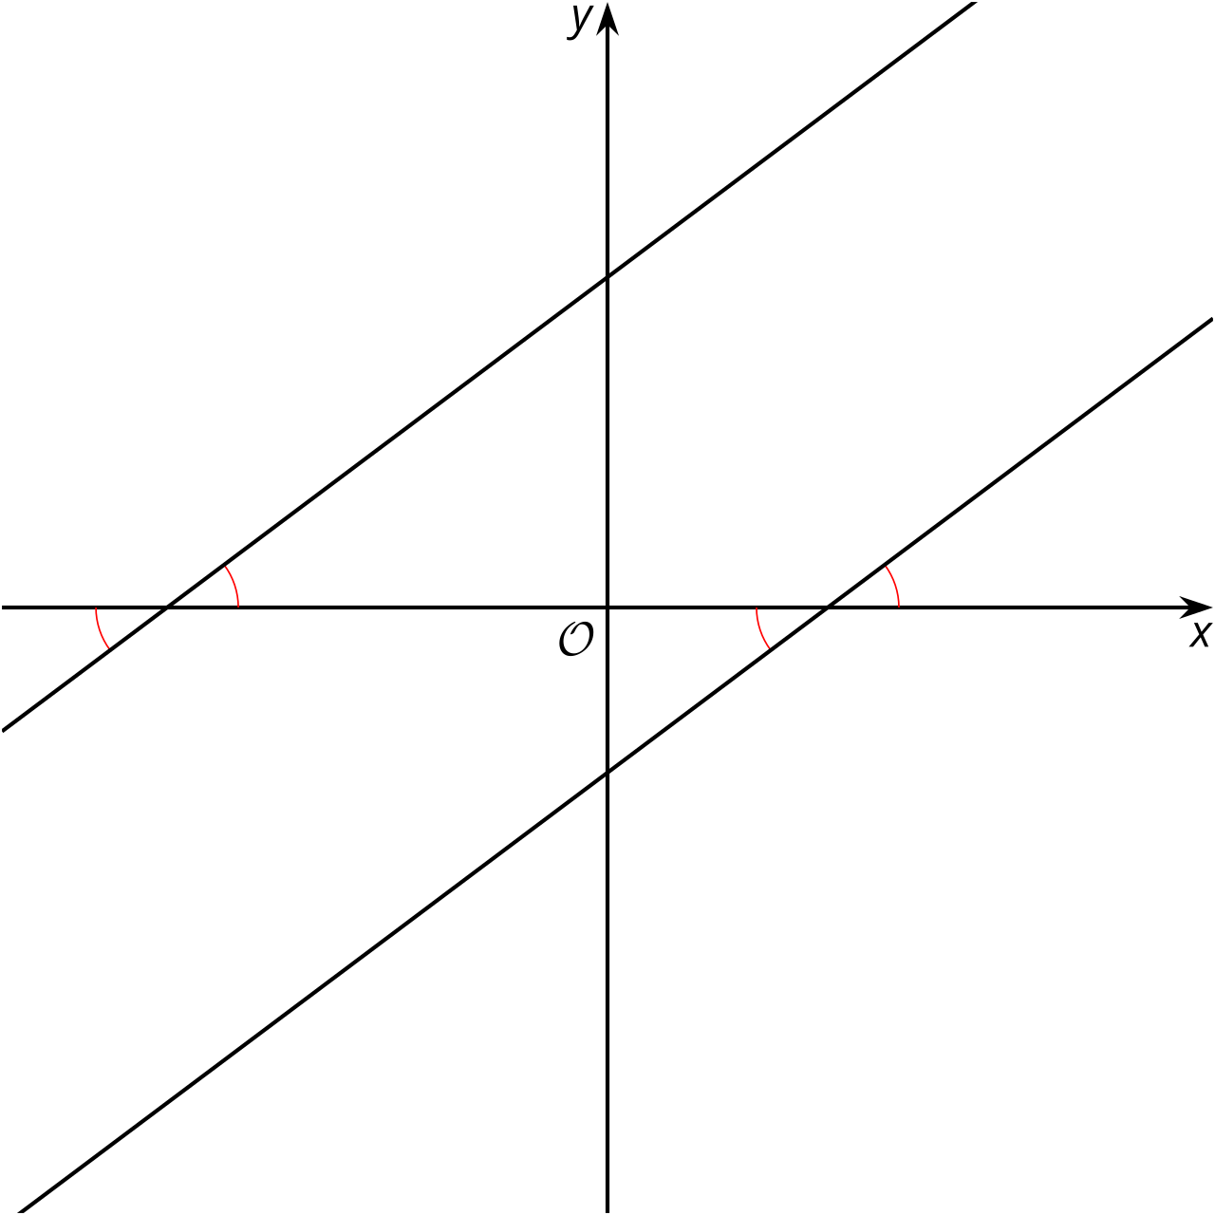
- How does Priya know the right triangles have a second congruent angle?
- Show or explain what it means that the tangent of $θ$ is equal for both triangles.
- How does this prove the slopes of parallel lines are equal?

10.3: Prove Your Parallelogram
- Write the equation of a line parallel to $y=2x+3$, passing through $\left(\text{-}4,1\right)$.
- Graph both lines described in the previous question.
- Draw a parallelogram using the 2 lines you graphed and using $\left(\text{-}4,1\right)$ as one of the vertices.
- Prove that your figure is a parallelogram.

Are you ready for more?
Prove algebraically that the translation $\left(x,y\right)→\left(x+p,y+q\right)$ takes the line $y=mx+b$ to a line with the same slope.

Lesson 10 Summary
The solid line has been translated in 2 different ways:
- by the directed line segment from $\left(2,2\right)$ to $\left(2,4\right)$ to produce the dashed line above
- by the directed line segment from $\left(2,2\right)$ to $\left(2,\text{-}2\right)$ to produce the dotted line below
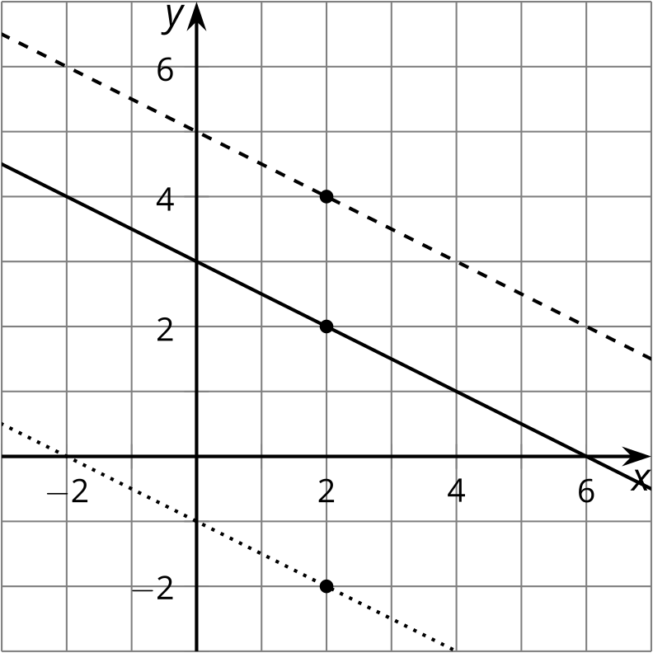
The 3 lines look parallel to one another, as we would expect. We know that translations of lines result in parallel lines.
What happens to the slopes of these lines? If we draw in the slope triangles that go through the origin, we can see right triangles. Since we know the lines are parallel, the corresponding pairs of angles in the triangles must be congruent by the Alternate Interior Angles Theorem. Triangles with congruent angles are similar, and similar slope triangles result in lines with the same slope. Here we see slopes of $\text{-}\frac{5}{10},\text{-}\frac{3}{6},$ and $\text{-}\frac{1}{2}$, which are all equal.
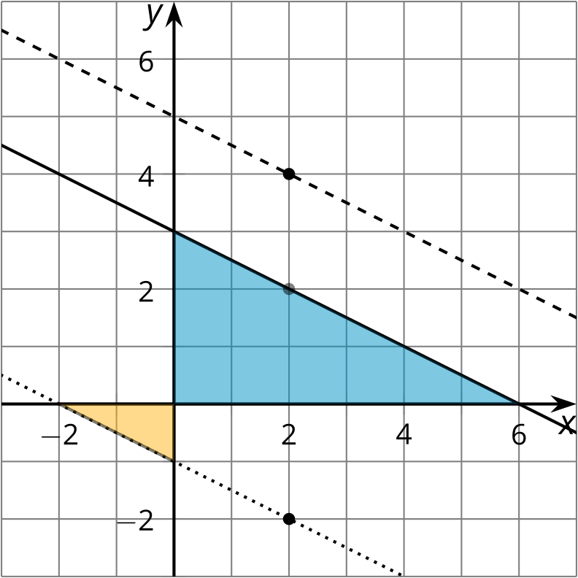
We can use similar reasoning to show that any 2 parallel lines that aren’t vertical have the same slope, and also that any 2 lines with the same slope are parallel.
What if we wanted to find the equation of a line parallel to these 3 lines that goes through the point $\left(6,\text{-}1\right)$? We know the line must have the same slope of $\text{-}\frac{1}{2}$. We can use point-slope form and get $y+1=\text{-}\frac{1}{2}\left(x−6\right)$.
© CC BY 2019 by Illustrative Mathematics®

