Unit 2 Lesson 7: Angle-Side-Angle Triangle Congruence

1 Notice and Wonder: Assertion (Warm up)

Images for Launch
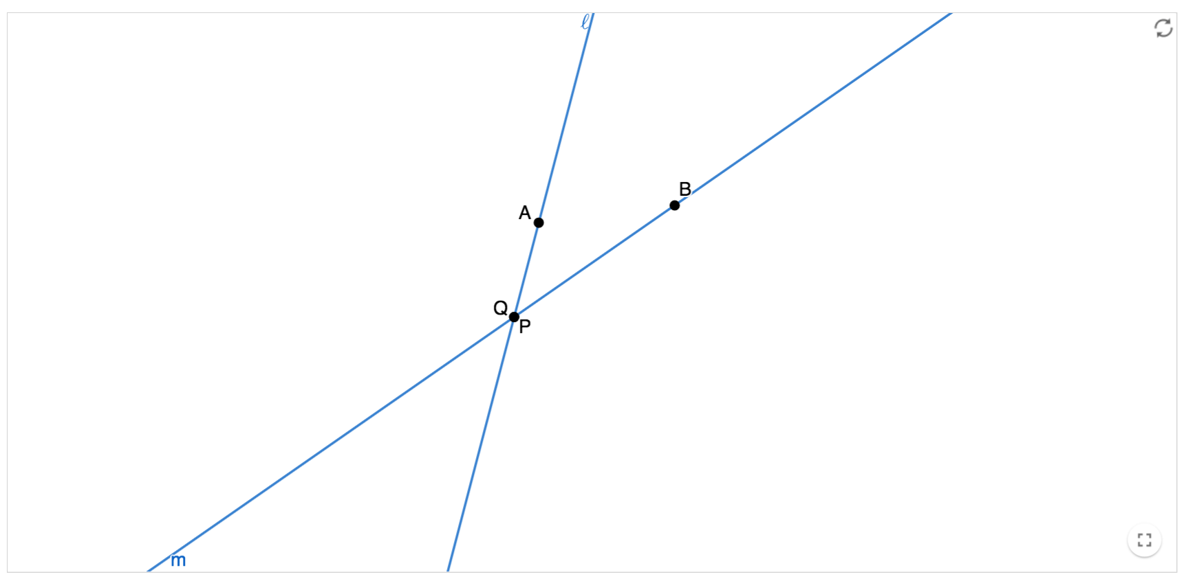

Student Task Statement
Assertion: Through 2 distinct points passes a unique line. Two lines are said to be distinct if there is at least 1 point that belongs to one but not the other. Otherwise, we say the lines are the same. Lines that have no point in common are said to be parallel.
Therefore, we can conclude: given 2 distinct lines, either they are parallel, or they have exactly 1 point in common.
What do you notice? What do you wonder?

2 Proving the Angle-Side-Angle Triangle Congruence Theorem

Student Task Statement
- Two triangles have 2 pairs of corresponding angles congruent, and the corresponding sides between those angles are congruent. Sketch 2 triangles that fit this description.
- Label the triangles $WXY$ and $DEF$, so that angle $W$ is congruent to angle $D$, angle $X$ is congruent to angle $E$, and side $WX$ is congruent to side $DE$.
- Use a sequence of rigid motions to take triangle $WXY$ onto triangle $DEF$. For each step, explain how you know that one or more vertices will line up.

Activity Synthesis
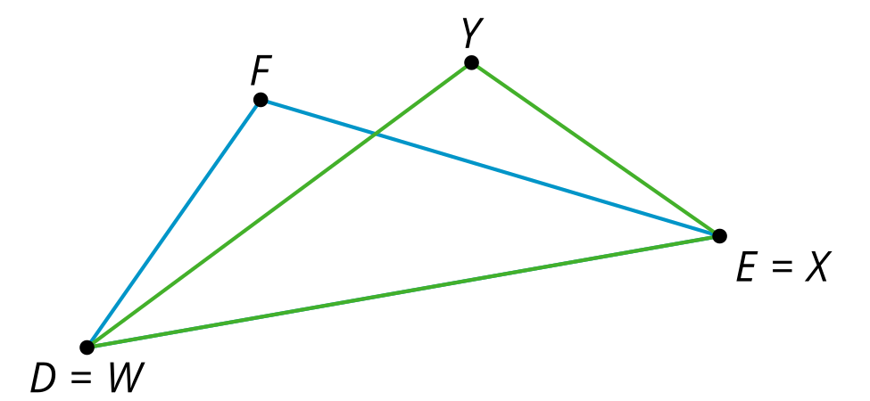

$∠A≅∠C,\overset{¯}{AE}≅\overset{¯}{EC},∠DEA≅∠BEC$, so $△DEA≅△BEC$
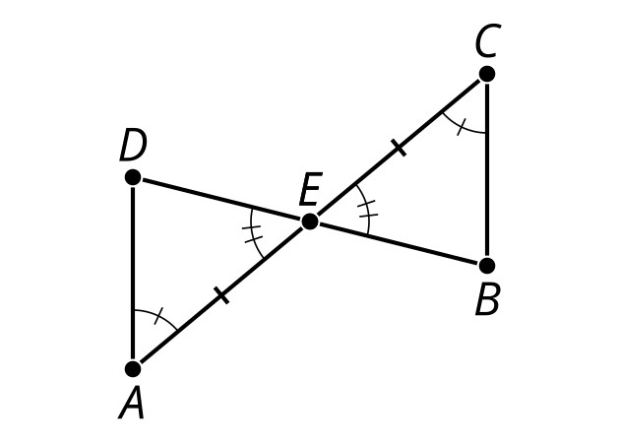

3 Find the Missing Angle Measures (Optional)

Student Task Statement
Lines $ℓ$ and $m$ are parallel. $a=42$. Find $b$, $c$, $d$, $e$, $f$, $g$, and $h$.

$ℓ∥m$
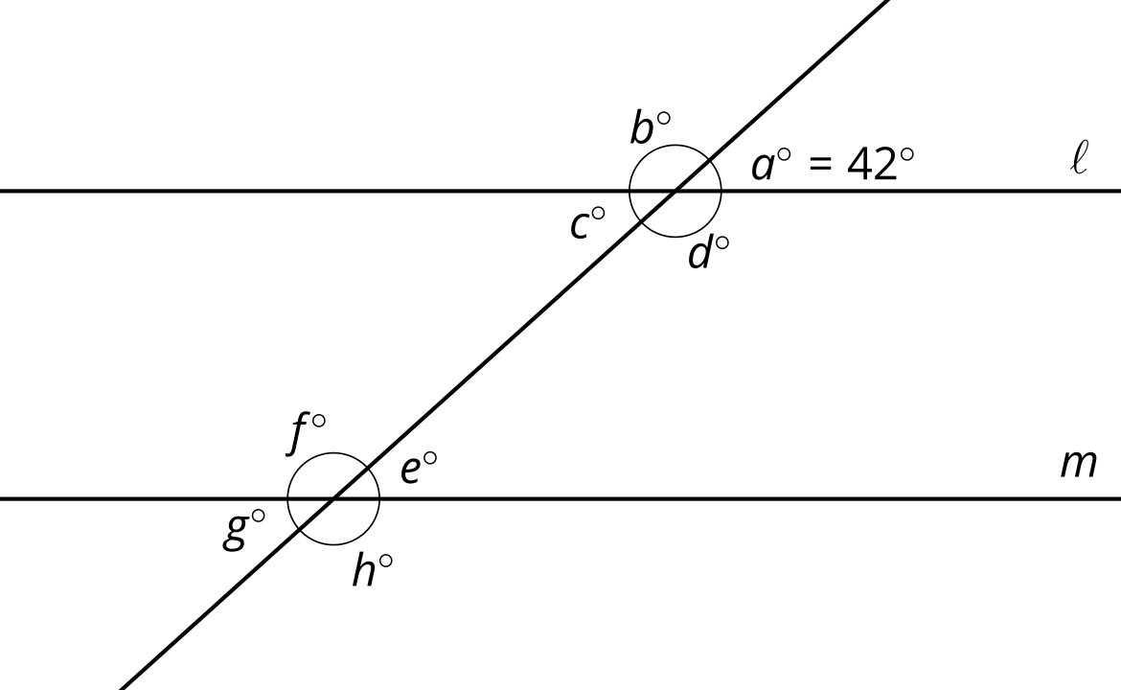

4 What Do We Know For Sure About Parallelograms?

Images for Launch

$\overset{¯}{NM}∥\overset{¯}{KL},\overset{¯}{NK}∥\overset{¯}{NL}$, so $MNKL$ is a parallelogram
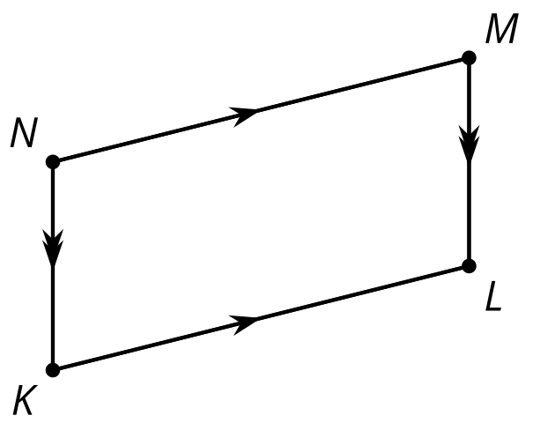

Student Task Statement
Quadrilateral $ABCD$ is a parallelogram. By definition, that means that segment $AB$ is parallel to segment $CD$, and segment $BC$ is parallel to segment $AD$.
- Sketch parallelogram $ABCD$ and then draw an auxiliary line to show how $ABCD$ can be decomposed into 2 triangles.
- Prove that the 2 triangles you created are congruent, and explain why that shows one pair of opposite sides of a parallelogram must be congruent.

Activity Synthesis

$MNKL$ is a parallelogram so $\overset{¯}{NM}≅\overset{¯}{KL},\overset{¯}{NK}≅\overset{¯}{ML}$
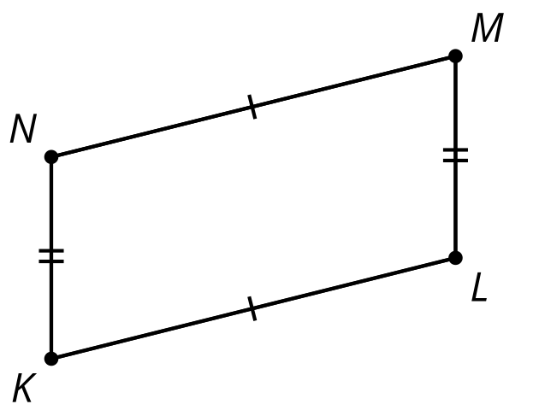
© CC BY 2019 by Illustrative Mathematics®

