Lesson 14 Practice Problems
- Here are graphs of functions $f$ and $g$.
- Each represents the height of an object being launched into the air as a function of time.
- 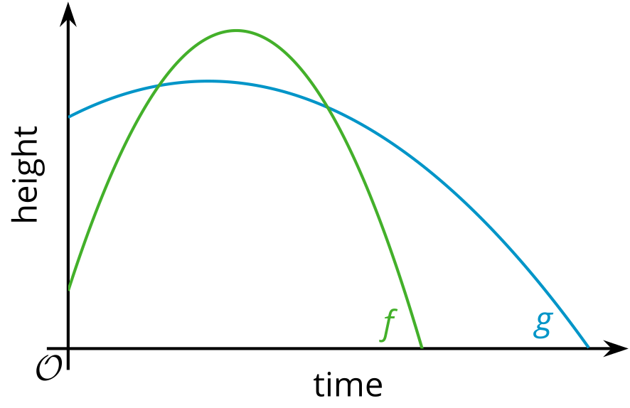
  - Which object was launched from a higher point?
  - Which object reached a higher point?
  - Which object was launched with the higher upward velocity?
  - Which object landed last?
- Technology required. The function $h$ given by $h\left(t\right)=\left(1−t\right)\left(8+16t\right)$ models the height of a ball in feet, $t$ seconds after it was thrown.
  - Find the zeros of the function. Show or explain your reasoning.
  - What do the zeros tell us in this situation? Are both zeros meaningful?
  - From what height is the ball thrown? Explain your reasoning.
  - About when does the ball reach its highest point, and about how high does the ball go? Show or explain your reasoning.
- The height in feet of a thrown football is modeled by the equation $f\left(t\right)=6+30t−16t^{2}$, where time $t$ is measured in seconds.
  - What does the constant 6 mean in this situation?
  - What does the $30t$ mean in this situation?
  - How do you think the squared term $\text{-}16t^{2}$ affects the value of the function $f$? What does this term reveal about the situation?
- The height in feet of an arrow is modeled by the equation $h\left(t\right)=\left(1+2t\right)\left(18−8t\right)$, where $t$ is seconds after the arrow is shot.
  - When does the arrow hit the ground? Explain or show your reasoning.
  - From what height is the arrow shot? Explain or show your reasoning.
- Two objects are launched into the air.
  - The height, in feet, of Object A is given by the equation $f\left(t\right)=4+32t−16t^{2}$.
  - The height, in feet, of the Object B is given by the equation $g\left(t\right)=2.5+40t−16t^{2}$. In both functions, $t$ is seconds after launch.
  - Which object was launched from a greater height? Explain how you know.
  - Which object was launched with a greater upward velocity? Explain how you know.

  - Predict the $x$- and $y$-intercepts of the graph of the quadratic function defined by the expression $\left(x+6\right)\left(x−6\right)$. Explain how you made your predictions.
  - Technology required. Check your predictions by graphing $y=\left(x+6\right)\left(x−6\right)$.
- (From Unit 6, Lesson 10.)
- Technology required. A student needs to get a loan of $12,000 for the first year of college. Bank A has an annual interest rate of 5.75%, Bank B has an annual interest rate of 7.81%, and Bank C has an annual rate of 4.45%.
  - If we graph the amount owed for each loan as a function of years without payment, predict what the three graphs would look like. Describe or sketch your prediction.
  - Use graphing technology to plot the graph of each loan balance.
  - Based on your graph, how much would the student owe for each loan when they graduate from college in four years?
  - Based on your graph, if no payments are made, how much would the student owe for each loan after 10 years?
- (From Unit 5, Lesson 15.)
- Technology required. The functions $f$ and $g$ are given by $f\left(x\right)=13x+6$ and $g\left(x\right)=0.1⋅{\left(1.4\right)}^{x}$.
  - Which function eventually grows faster, $f$ or $g$? Explain how you know.
  - Use graphing technology to decide when the graphs of $f$ and $g$ meet.
- (From Unit 5, Lesson 19.)
© CC BY 2019 by Illustrative Mathematics®

