Lesson 8 Practice Problems
- Priya is buying raisins and almonds to make trail mix. Almonds cost $5.20 per pound and raisins cost $2.75 per pound. Priya spent $11.70 buying almonds and raisins. The relationship between pounds of almonds $a$, pounds of raisins $r$, and the total cost is represented by the equation $5.20a+2.75r=11.70$.
- How many pounds of raisins did Priya buy if she bought the following amounts of almonds:
  - 2 pounds of almonds
  - 1.06 pounds of almonds
  - 0.64 pounds of almonds
  - $a$ pounds of almonds
- Here is a linear equation in two variables: $2x+4y−31=123$.
- Solve the equation, first for $x$ and then for $y$.
- A chef bought $17.01 worth of ribs and chicken. Ribs cost 1.89 per pound and chicken costs 0.90 per pound. The equation $0.9c+1.89r=17.01$ represents the relationship between the quantities in this situation.
- Show that each of the following equations is equivalent to $0.9c+1.89r=17.01$. Then, explain when it might be helpful to write the equation in these forms.
  - $c=18.9−2.1r$
  - $r=\text{-}\frac{10}{21}c+9$
- A car traveled 180 miles at a constant rate.
  - Complete the table to show the rate at which the car was traveling if it completed the same distance in each number of hours.
  - Write an equation that would make it easy to find the rate at which the car was traveling in miles per hour $r$, if it traveled for $t$ hours.
- travel time  (hours) | - rate of travel  (miles per hour)
- 5
- 4.5
- 3
- 2.25
- Bananas cost $0.50 each, and apples cost $1.00 each.
- Select all the combinations of bananas and apples that Elena could buy for exactly $3.50.
  - 2 bananas and 2 apples
  - 3 bananas and 2 apples
  - 1 banana and 2 apples
  - 1 banana and 3 apples
  - 5 bananas and 2 apples
  - 5 bananas and 1 apple
- (From Unit 2, Lesson 4.)
- A group of 280 elementary school students and 40 adults are going on a field trip. They are planning to use two different types of buses to get to the destination. The first type of bus holds 50 people and the second type of bus holds 56 people.
- Andre says that 3 of the first type of bus and 3 of the second type of bus will hold all of the students and adults going on the field trip. Is Andre correct? Explain your reasoning.
- (From Unit 2, Lesson 4.)
- Elena says that equations A and B are not equivalent.
  - Equation A: $13−5x=48$
  - Equation B: $5x=35$
- Write a convincing explanation as to why this is true.
- (From Unit 2, Lesson 7.)
- To grow properly, each tomato plant needs 1.5 square feet of soil and each broccoli plant needs 2.25 square feet of soil. The graph shows the different combinations of broccoli and tomato plants in an 18 square foot plot of soil.
- 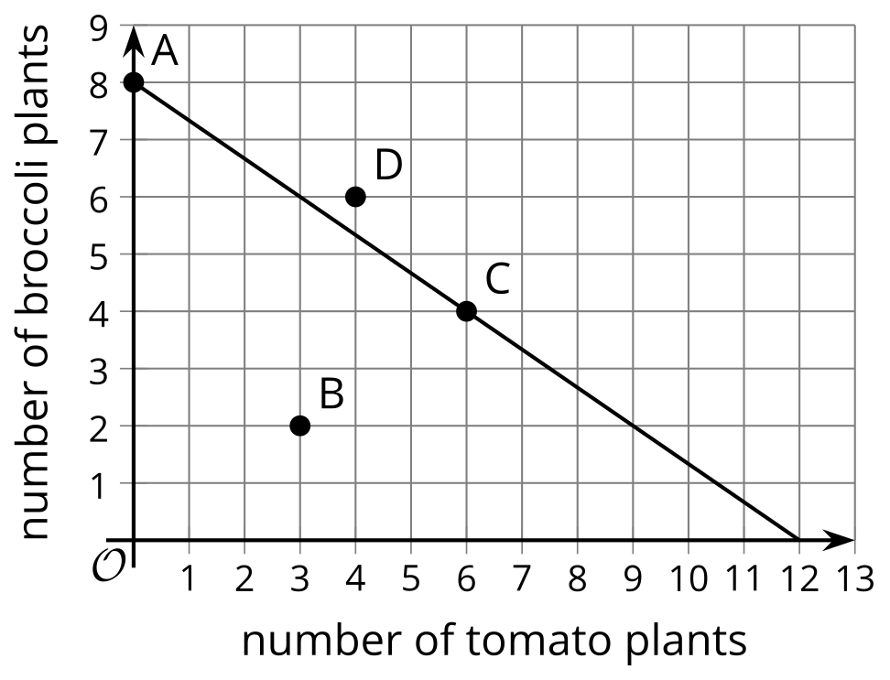
- Match each point to the statement that describes it.
  - Point A
  - Point B
  - Point C
  - Point D
  - The soil is fully used when 6 tomato plants and 4 broccoli plants are planted.
  - Only broccoli was planted, but the plot is fully used and all plants can grow properly.
  - After 3 tomato plants and 2 broccoli plants were planted, there is still extra space in the plot.
  - With 4 tomato plants and 6 broccoli plants planted, the plot is overcrowded.
- (From Unit 2, Lesson 5.)
- Select all the equations that are equivalent to the equation $3x−4=5$.
  - $3x=9$
  - $3x−4+4=5+4$
  - $x−4=2$
  - $x=9$
  - $\text{-}4=5−3x$
- (From Unit 2, Lesson 6.)
- Han is solving an equation. He took steps that are acceptable but ended up with equations that are clearly not true.
- $\begin{matrix}5x+6 & =7x+5−2x & & \text{original equation} \\ 5x+6 & =7x−2x+5 & & \text{apply the commutative property} \\ 5x+6 & =5x+5 & & \text{combine like terms} \\ 6 & =5 & & \text{subtract }5x\text{ from each side}\end{matrix}$
- What can Han conclude as a result of these acceptable steps?
  - There’s no value of $x$ that can make the equation $5x+6=7x+5−2x$ true.
  - Any value of $x$ can make the equation $5x+6=7x+5−2x$ true.
  - $x=6$ is a solution to the equation $5x+6=7x+5−2x$.
  - $x=5$ is a solution to the equation $5x+6=7x+5−2x$.
- (From Unit 2, Lesson 7.)
© CC BY 2019 by Illustrative Mathematics®

