Unit 4 Lesson 1: Number Puzzles

1 Notice and Wonder: A Number Line (Warm up)

Student Task Statement
What do you notice? What do you wonder?
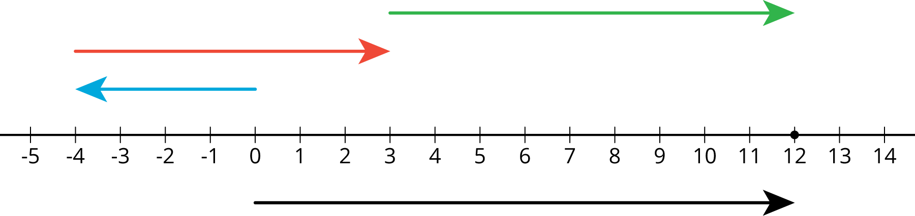

2 Telling Temperatures

Student Task Statement
Solve each puzzle. Show your thinking. Organize it so it can be followed by others.
- The temperature was very cold. Then the temperature doubled.
Then the temperature dropped by 10 degrees. Then the temperature increased by 40 degrees. The temperature is now 16 degrees. What was the starting temperature?
- Lin ran twice as far as Diego. Diego ran 300 m farther than Jada. Jada ran $\frac{1}{3}$ the distance that Noah ran. Noah ran 1200 m. How far did Lin run?

3 Making a Puzzle

Student Task Statement
Write another number puzzle with at least three steps. On a different piece of paper, write a solution to your puzzle.

Trade puzzles with your partner and solve theirs. Make sure to show your thinking.

With your partner, compare your solutions to each puzzle. Did they solve them the same way you did? Be prepared to share with the class which solution strategy you like best.
© CC BY Open Up Resources. Adaptations CC BY IM.

